Assignment -01

1. Implement a singly connected linear linked list in C. Your program should typically implement insert and delete at all possible locations with proper check(s) as applicable. Include a display function as well and use it to show the content of your list after every operation. Include calls to insert and delete from the main.
2. Implement a singly connected circular linked list in C. Your program should typically implement insert and delete at all possible locations with proper check(s) as applicable. Include a display function as well and use it to show the content of your list after every operation. Include calls to insert and delete from the main.
3. Implement a doubly connected linear linked list in C. Your program should typically implement insert and delete at all possible locations with proper check(s) as applicable. Include a display function as well and use it to show the content of your list after every operation. Include calls to insert and delete from the main.
4. Implement a doubly connected circular linked list in C. Your program should typically implement insert and delete at all possible locations with proper check(s) as applicable. Include a display function as well and use it to show the content of your list after every operation. Include calls to insert and delete from the main. (For Bonus)

Solutions

Code (1):

# include <stdio.h>

# include <stdlib.h>

struct node{

char data;

struct node *next;

};

typedef struct node snode;

//checking for underflow

int isEmpty(snode **head_ref)

{

if(*head_ref == NULL)

return 1;

else

return 0;

}

//insert node at beginning

int insert_beg(snode **head_ref){

char d,temp;

printf("\nEnter the data to be inserted:\t");

scanf("%c", &d);

scanf("%c", &temp);

snode *new_node = malloc(sizeof(snode));

new_node->data=d;

new_node->next=NULL;

if(isEmpty(head_ref)){

*head_ref = new_node;

(*head_ref)->next = NULL;

}

else{

new_node->next =*head_ref;

(*head_ref) = new_node;

}

printf("\n Insertion successful" );

return 0;

}

//inserting node at end

int insert_end(snode **head_ref){

char d,temp;

printf("\nEnter the data to be inserted:\t");

scanf("%c", &d);

scanf("%c", &temp);

snode *new_node = malloc(sizeof(snode));

new_node->data=d;

new_node->next=NULL;

if(isEmpty(head_ref)){

*head_ref = new_node;

(*head_ref)->next = NULL;

}

else{

snode *s=*head_ref;

while(s->next!=NULL){

s=s->next;

}

s->next=new_node;

}

printf("\n Insertion successful" );

}

//inserting at any position

int insert_pos(snode **head_ref){

char d,temp;

printf("\nEnter the data to be inserted:\t");

scanf("%c", &d);

scanf("%c", &temp);

snode *new_node = malloc(sizeof(snode));

new_node->data=d;

new_node->next=NULL;

if(isEmpty(head_ref)){

printf("Empty list. Creating new list and entering data at first position\n");

*head_ref= new_node;

(*head_ref)->next =NULL;

}

else{

snode *s=*head_ref;

int pos,i=1;

printf("Enter position to insert node at:\n");

scanf("%d",&pos);

scanf("%c", &temp);

if(pos==1)

{

new_node->next=*head_ref;

*head_ref=new_node;

}

else{

while( (s->next!=NULL) && (i<pos-1)){

s=s->next;

i+=1;

}

if(i==pos-1){

snode *t=s->next;

s->next=new_node;

s->next->next=t;

printf("\n Insertion successful");

}

else

printf("\n Position is out of bounds. Insertion failed.");

}

}

}

//deleting from any position

int del(snode **head_ref){

int pos;

char temp;

printf("\n Enter the position of the node to be deleted:");

scanf("%d", &pos);

scanf("%c",&temp);

if(isEmpty(head_ref)){

printf("List does not exist. Node cannot be deleted");

}

else{

if(pos==1){

snode *t = *head_ref;

(*head_ref) = (*head_ref)->next;

printf("\n Deletion successful. %c deleted from position %d",t->data,pos);

free(t);

}

else{

snode *s=*head_ref;

int i=1;

while( (s->next!=NULL) && (i<pos-1)){

s=s->next;

i+=1;

}

if(i==pos-1){

snode *t=s->next;

s->next=s->next->next;

printf("\n Deletion successful. %c deleted from position %d",t->data,pos);

free(t);

}

else

printf("\n Position out of bounds. Deletion failed.");

}

}

}

//displaying the list

int display(snode **head_ref){

if (isEmpty(head_ref)){

printf("\n List is empty. Nothing to display.");

}

else{

printf("\n Displaying list:\n");

printf("\n *******************************\n");

snode *s = *head_ref;

while(s->next!=NULL){

printf("%c ->",s->data);

s=s->next;

}

printf("%c ",s->data);

printf("\n *******************************\n");

}

return 0;

}

int main(){

snode *head=malloc(sizeof(snode));

head=NULL;

//function calls

insert_beg(&head);

display(&head);

insert_beg(&head);

display(&head);

insert_end(&head);

display(&head);

insert_end(&head);

display(&head);

insert_pos(&head);

display(&head);

insert_pos(&head);

display(&head);

del(&head);

display(&head);

del(&head);

display(&head);

return 0;

}

Outputs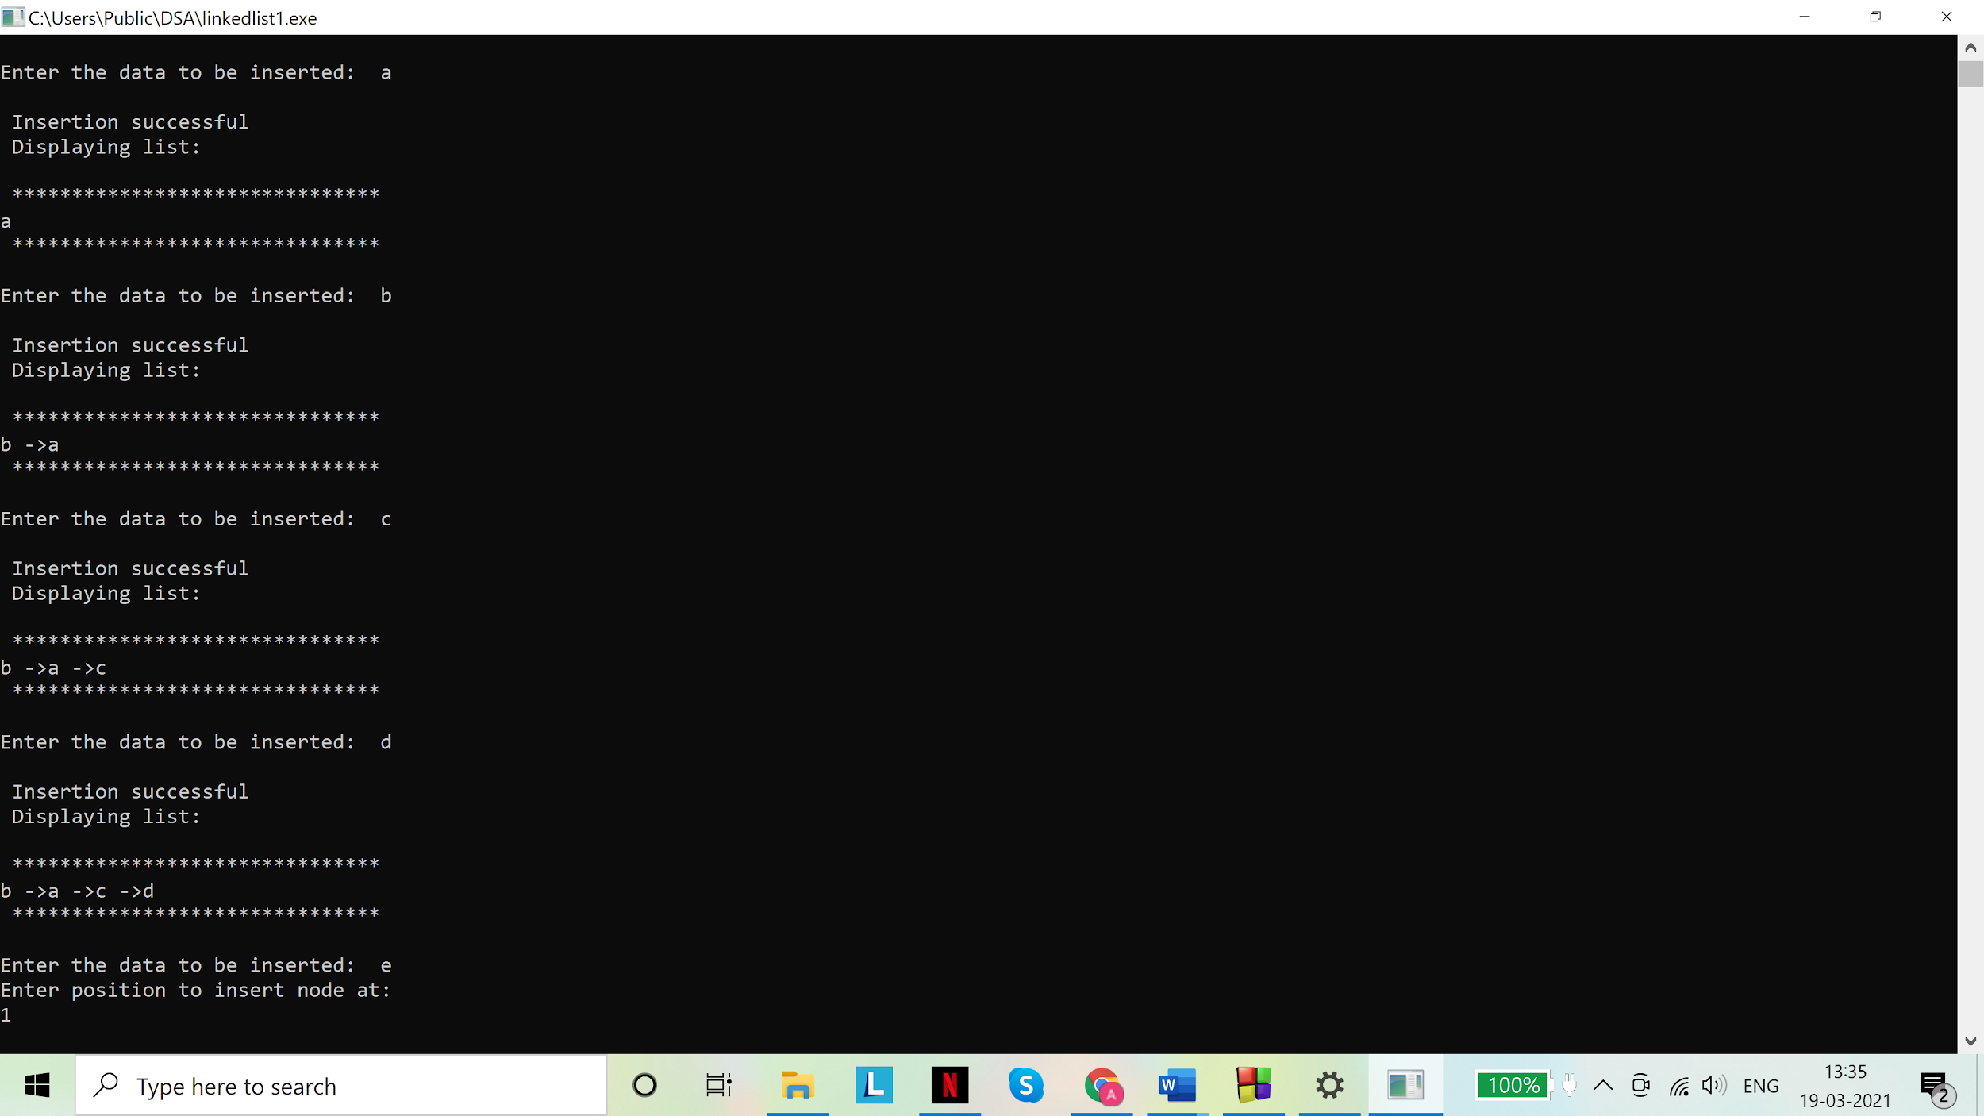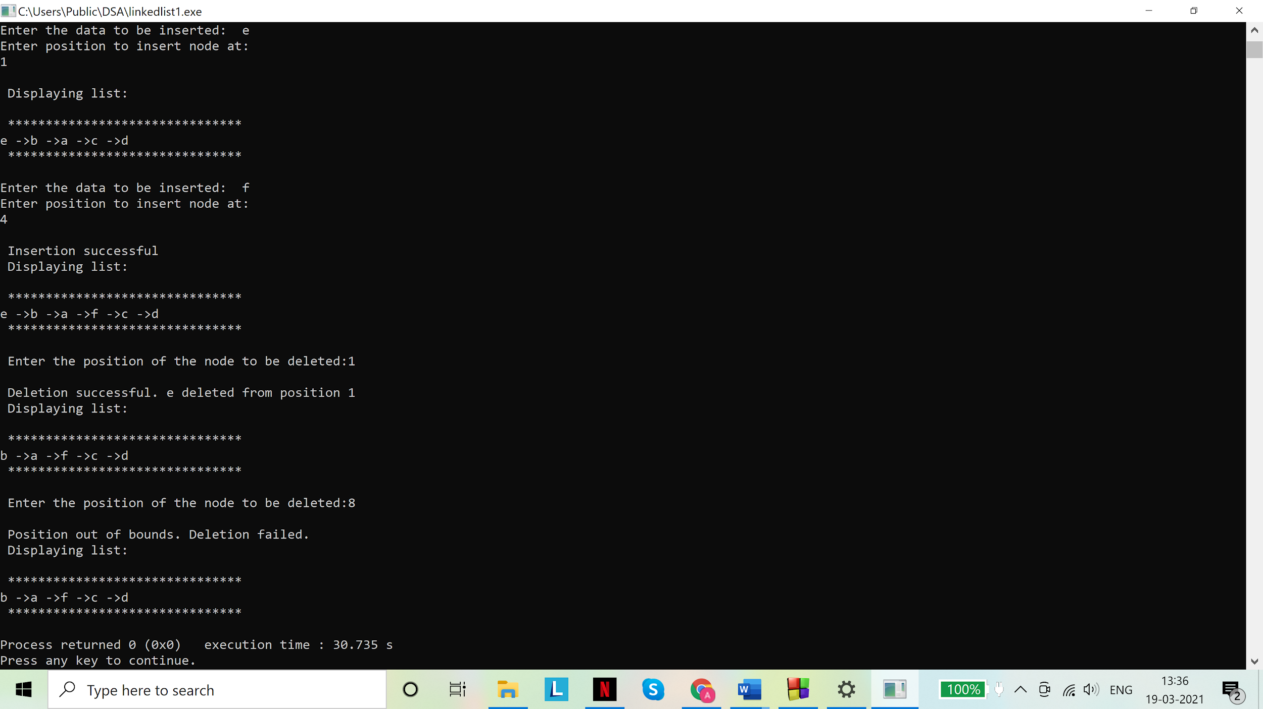

Code (2):

# include <stdio.h>

# include <stdlib.h>

struct node{

char data;

struct node *next;

};

typedef struct node snode;

//checking for underflow

int isEmpty(snode **head_ref)

{

if(*head_ref == NULL)

return 1;

else

return 0;

}

//insert node at beginning

int insert_beg(snode **head_ref){

char d,temp;

printf("\nEnter the data to be inserted:\t");

scanf("%c", &d);

scanf("%c", &temp);

snode *new_node = malloc(sizeof(snode));

new_node->data=d;

new_node->next=NULL;

if(isEmpty(head_ref)){

*head_ref = new_node;

(*head_ref)->next = *head_ref;

}

else{

snode *s=*head_ref;

while(s->next!=*head_ref)

{

s=s->next;

}

s->next =new_node;

new_node->next=*head_ref;

*head_ref=new_node;

}

printf("\n Insertion successful" );

return 0;

}

//inserting node at end

int insert_end(snode **head_ref){

char d,temp;

printf("\nEnter the data to be inserted:\t");

scanf("%c", &d);

scanf("%c", &temp);

snode *new_node = malloc(sizeof(snode));

new_node->data=d;

new_node->next=NULL;

if(isEmpty(head_ref)){

*head_ref = new_node;

(*head_ref)->next = *head_ref;

}

else{

snode *s=*head_ref;

while(s->next!=*head_ref){

s=s->next;

}

s->next=new_node;

new_node->next=*head_ref;

}

printf("\n Insertion successful" );

}

//inserting at any position

int insert_pos(snode **head_ref){

char d,temp;

printf("\nEnter the data to be inserted:\t");

scanf("%c", &d);

scanf("%c", &temp);

snode *new_node = malloc(sizeof(snode));

new_node->data=d;

new_node->next=NULL;

if(isEmpty(head_ref)){

printf("Empty list. Creating new list and entering data at first position\n");

*head_ref= new_node;

(*head_ref)->next =*head_ref;

}

else{

snode *s=*head_ref;

int pos,i=1;

printf("Enter position to insert node at:\n");

scanf("%d",&pos);

scanf("%c", &temp);

if(pos==1)

{

snode *s=*head_ref;

while(s->next!=*head_ref)

{

s=s->next;

}

s->next =new_node;

new_node->next=*head_ref;

*head_ref=new_node;

}

else{

while( (s->next!=*head_ref) && (i<pos-1)){

s=s->next;

i+=1;

}

if(i==pos-1){

snode *t=s->next;

s->next=new_node;

s->next->next=t;

printf("\n Insertion successful");

}

else

printf("\n Position is out of bounds. Insertion failed.");

}

}

}

//deleting from any position

int del(snode **head_ref){

int pos;

char temp;

printf("\n Enter the position of the node to be deleted:");

scanf("%d", &pos);

scanf("%c",&temp);

if(isEmpty(head_ref)){

printf("List does not exist. Node cannot be deleted");

}

else{

if(pos==1)//deleting the first node requires the last node to be linked to the new first node

{

snode *s=*head_ref;

while(s->next!=*head_ref){

s=s->next;

}

snode *t = *head_ref;

(*head_ref) = (*head_ref)->next;

s->next=*head_ref;

printf("\n Deletion successful. %c deleted from position %d",t->data,pos);

free(t);

}

else{

snode *s=*head_ref;

int i=1;

while( (s->next!=*head_ref) && (i<pos-1)){

s=s->next;

i+=1;

}

if(i==pos-1){

snode *t=s->next;

s->next=s->next->next;

printf("\n Deletion successful. %c deleted from position %d",t->data,pos);

free(t);

}

else

printf("\n Position out of bounds. Deletion failed.");

}

}

}

//displaying the list

int display(snode **head_ref){

if (isEmpty(head_ref)){

printf("\n List is empty. Nothing to display.");

}

else{

printf("\n Displaying list:\n");

printf("\n *******************************\n");

snode *s = *head_ref;

while(s->next!=*head_ref){

printf("%c ->",s->data);

s=s->next;

}

printf("%c ",s->data);

printf("\n *******************************\n");

}

return 0;

}

int main(){

snode *head=malloc(sizeof(snode));

head=NULL;

//function calls

insert_beg(&head);

display(&head);

insert_beg(&head);

display(&head);

insert_end(&head);

display(&head);

insert_end(&head);

display(&head);

insert_pos(&head);

display(&head);

insert_pos(&head);

display(&head);

del(&head);

display(&head);

del(&head);

display(&head);

return 0;

}

Outputs: 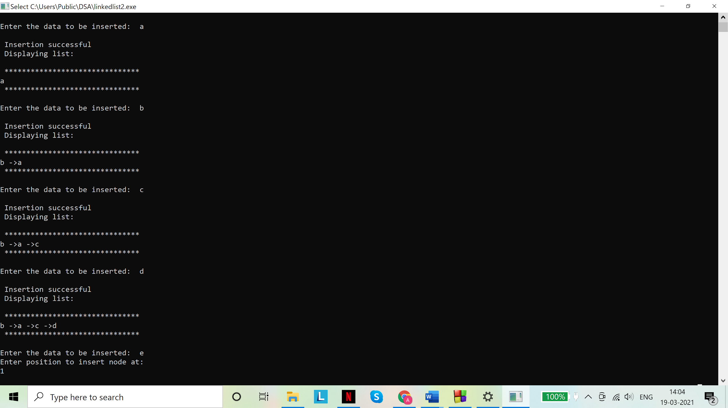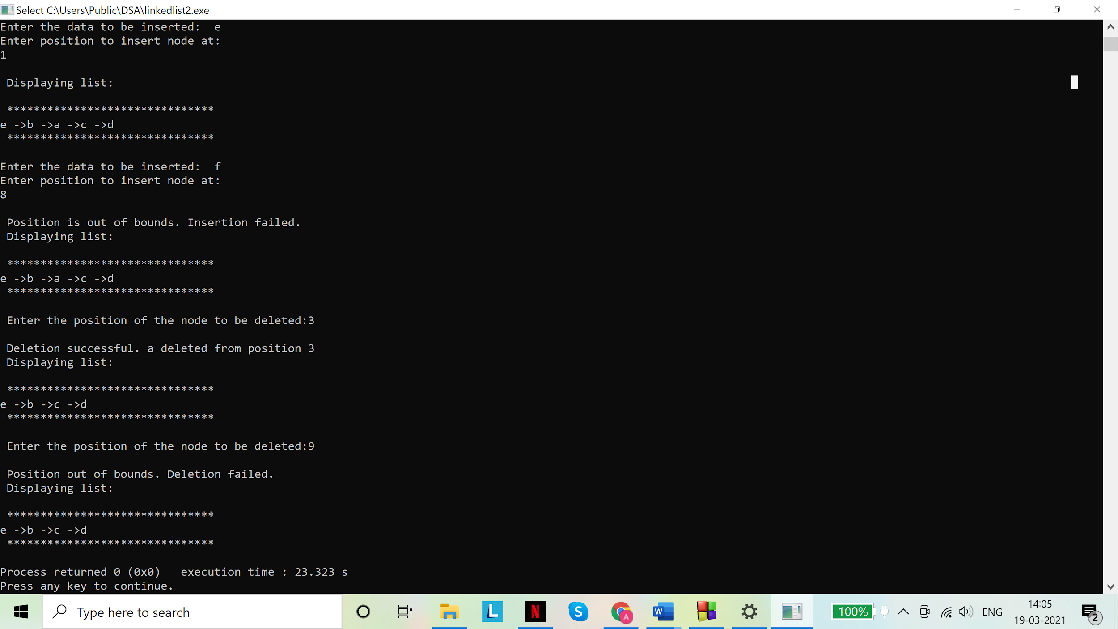

Code (3):

# include <stdio.h>

# include <stdlib.h>

struct node{

char data;

struct node *next;

struct node *prev;

};

typedef struct node snode;

//checking for underflow

int isEmpty(snode **head_ref)

{

if(*head_ref == NULL)

return 1;

else

return 0;

}

//insert node at beginning

int insert_beg(snode **head_ref,snode **tail_ref){

char d,temp;

printf("\nEnter the data to be inserted:\t");

scanf("%c", &d);

scanf("%c", &temp);

snode *new_node = malloc(sizeof(snode));

new_node->data=d;

new_node->next=new_node->prev=NULL;

if(isEmpty(head_ref)){

*head_ref = new_node;

(*head_ref)->next=(*head_ref)->prev = NULL;

*tail_ref=*head_ref;

}

else{

new_node->next =*head_ref;

(*head_ref)->prev=new_node;

(*head_ref) = new_node;

}

printf("\n Insertion successful" );

return 0;

}

//inserting node at end

int insert_end(snode **head_ref,snode **tail_ref){

char d,temp;

printf("\nEnter the data to be inserted:\t");

scanf("%c", &d);

scanf("%c", &temp);

snode *new_node = malloc(sizeof(snode));

new_node->data=d;

new_node->next=new_node->prev=NULL;

if(isEmpty(head_ref)){

*head_ref = new_node;

(*head_ref)->next =(*head_ref)->prev= NULL;

*tail_ref=*head_ref;

}

else{

(*tail_ref)->next=new_node;

new_node->prev=*tail_ref;

*tail_ref=new_node;

}

printf("\n Insertion successful" );

}

//inserting at any position

int insert_pos(snode **head_ref,snode **tail_ref){

char d,temp;

printf("\nEnter the data to be inserted:\t");

scanf("%c", &d);

scanf("%c", &temp);

snode *new_node = malloc(sizeof(snode));

new_node->data=d;

new_node->next=new_node->prev=NULL;

if(isEmpty(head_ref)){

printf("Empty list. Creating new list and entering data at first position\n");

*head_ref= new_node;

(*head_ref)->next =(*head_ref)->prev=NULL;

*tail_ref=*head_ref;

}

else{

snode *s=*head_ref;

int pos,i=1;

printf("Enter position to insert node at:\n");

scanf("%d",&pos);

scanf("%c", &temp);

if(pos==1)

{

new_node->next=*head_ref;

(*head_ref)->prev=new_node;

*head_ref=new_node;

}

else{

while( (s->next!=NULL) && (i<pos-1)){

s=s->next;

i+=1;

}

if(i==pos-1){

snode *t=s->next;

s->next=new_node;

new_node->prev=s;

new_node->next=t;

t->prev=new_node;

printf("\n Insertion successful");

}

else

printf("\n Position is out of bounds. Insertion failed.");

}

}

}

//deleting from any position

int del(snode **head_ref,snode **tail_ref){

int pos;

char temp;

printf("\n Enter the position of the node to be deleted:");

scanf("%d", &pos);

scanf("%c",&temp);

if(isEmpty(head_ref)){

printf("List does not exist. Node cannot be deleted");

}

else{

if(pos==1){

snode *t = *head_ref;

(*head_ref) = (*head_ref)->next;

(*head_ref)->prev=NULL;

printf("\n Deletion successful. %c deleted from position %d",t->data,pos);

free(t);

}

else{

snode *s=*head_ref;

int i=1;

while( (s->next!=NULL) && (i<pos-1)){

s=s->next;

i+=1;

}

if(i==pos-1){

snode *t=s->next;

snode *a=s->next->next;

s->next=a;

a->prev=s;

printf("\n Deletion successful. %c deleted from position %d",t->data,pos);

free(t);

}

else

printf("\n Position out of bounds. Deletion failed.");

}

}

}

//displaying the list

int display(snode **head_ref,snode **tail_ref){

if (isEmpty(head_ref)){

printf("\n List is empty. Nothing to display.");

}

else{

printf("\n Displaying list [forward]:\n");

printf("\n *******************************\n");

snode *s = *head_ref;

while(s->next!=NULL){

printf("%c ->",s->data);

s=s->next;

}

printf("%c ",s->data);

printf("\n *******************************\n");

printf("\n Displaying list [backward]:\n");

printf("\n *******************************\n");

s = *tail_ref;

while(s->prev!=NULL){

printf("%c ->",s->data);

s=s->prev;

}

printf("%c ",s->data);

printf("\n *******************************\n");

}

return 0;

}

int main(){

snode *head=malloc(sizeof(snode));

head=NULL;

snode *tail=malloc(sizeof(snode));

tail=NULL;

//function calls

insert_beg(&head,&tail);

display(&head,&tail);

insert_beg(&head,&tail);

display(&head,&tail);

insert_end(&head,&tail);

display(&head,&tail);

insert_end(&head,&tail);

display(&head,&tail);

insert_pos(&head,&tail);

display(&head,&tail);

insert_pos(&head,&tail);

display(&head,&tail);

del(&head,&tail);

display(&head,&tail);

del(&head,&tail);

display(&head,&tail);

return 0;

}

Outputs: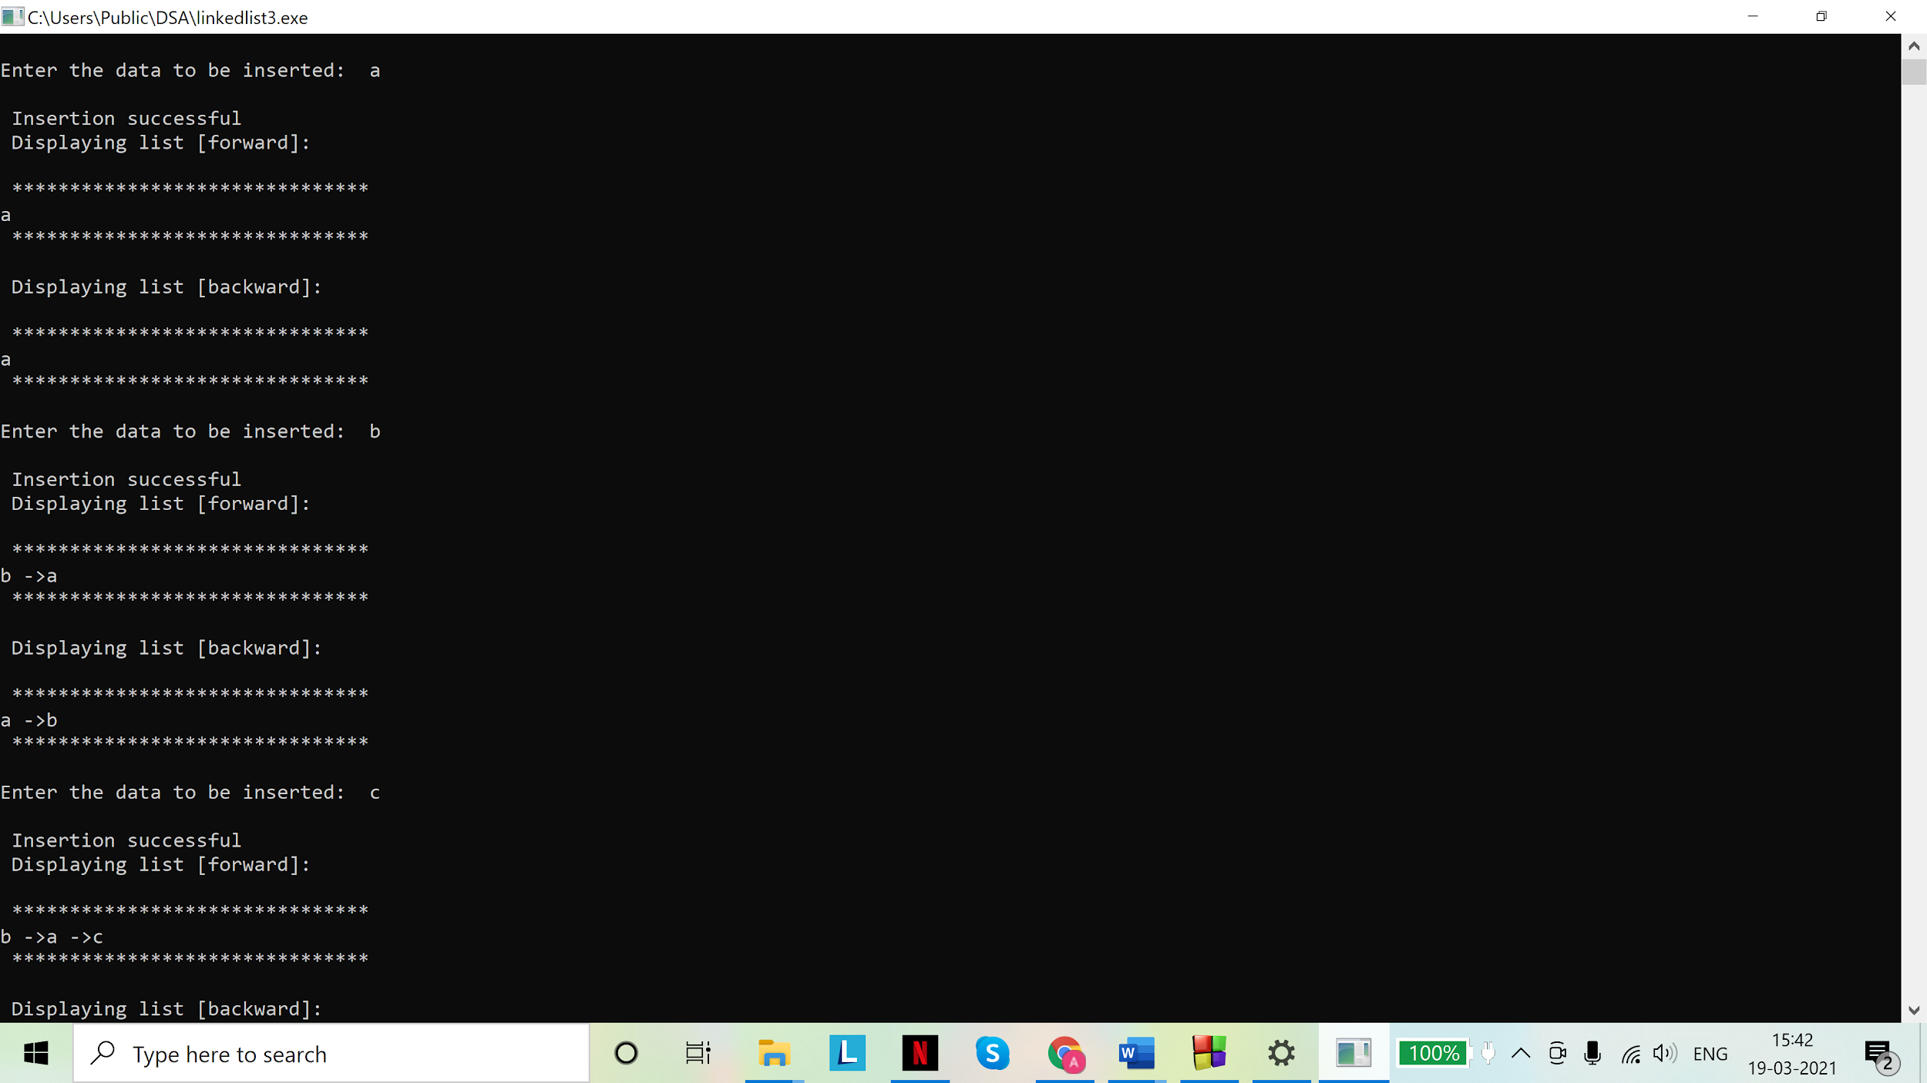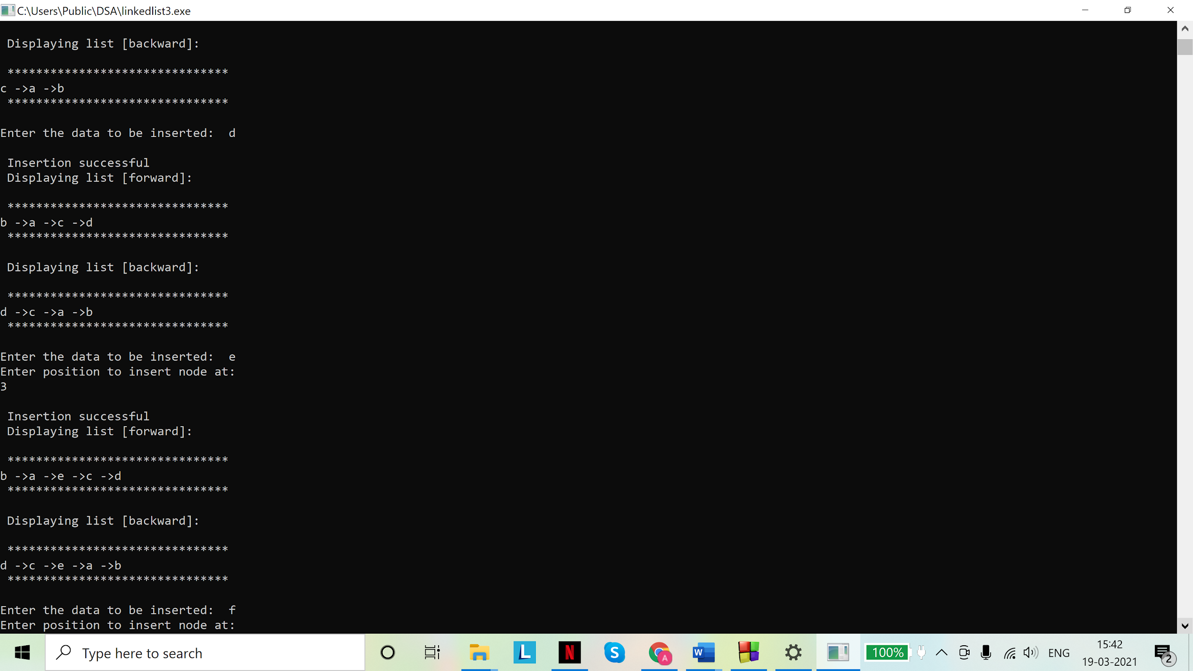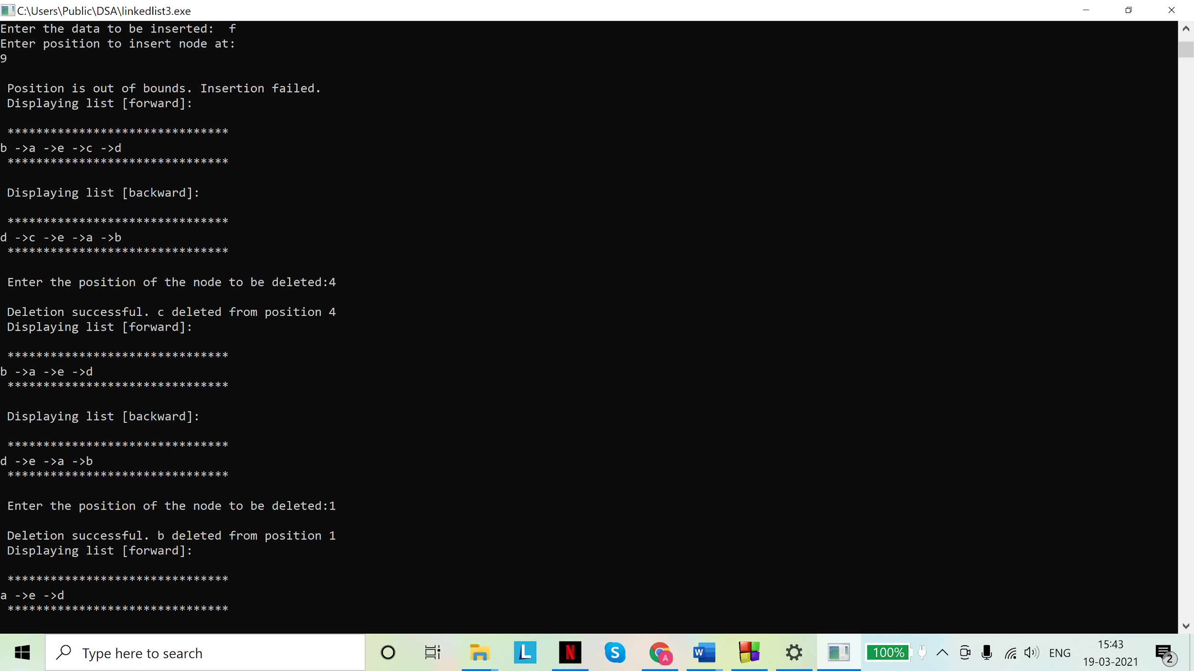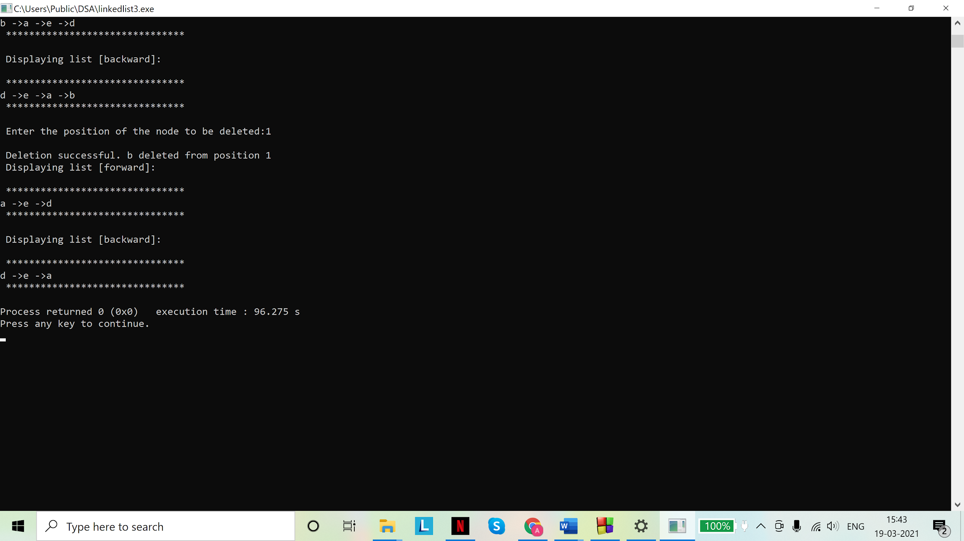

Code (4):

# include <stdio.h>

# include <stdlib.h>

struct node{

char data;

struct node *next;

struct node *prev;

};

typedef struct node snode;

//checking for underflow

int isEmpty(snode **head_ref)

{

if(*head_ref == NULL)

return 1;

else

return 0;

}

//insert node at beginning

int insert_beg(snode **head_ref, snode **tail_ref){

char d,temp;

printf("\nEnter the data to be inserted:\t");

scanf("%c", &d);

scanf("%c", &temp);

snode *new_node = malloc(sizeof(snode));

new_node->data=d;

new_node->next=new_node->prev=NULL;

if(isEmpty(head_ref)){

*head_ref = new_node;

(*head_ref)->next =(*head_ref)->prev= *head_ref;

*tail_ref=*head_ref;

}

else{

(*tail_ref)->next=new_node;

new_node->prev=(*tail_ref);

new_node->next=*head_ref;

(*head_ref)->prev=new_node;

*head_ref=new_node;

}

printf("\n Insertion successful" );

return 0;

}

//inserting node at end

int insert_end(snode **head_ref, snode **tail_ref){

char d,temp;

printf("\nEnter the data to be inserted:\t");

scanf("%c", &d);

scanf("%c", &temp);

snode *new_node = malloc(sizeof(snode));

new_node->data=d;

new_node->next=new_node->prev=NULL;

if(isEmpty(head_ref)){

*head_ref = new_node;

(*head_ref)->next=(*head_ref)->prev = *head_ref;

*tail_ref=*head_ref;

}

else{

(*tail_ref)->next=new_node;

new_node->prev=*tail_ref;

*tail_ref=new_node;

(*tail_ref)->next=*head_ref;

(*head_ref)->prev=*tail_ref;

}

printf("\n Insertion successful" );

}

//inserting at any position

int insert_pos(snode **head_ref,snode **tail_ref){

char d,temp;

printf("\nEnter the data to be inserted:\t");

scanf("%c", &d);

scanf("%c", &temp);

snode *new_node = malloc(sizeof(snode));

new_node->data=d;

new_node->next=new_node->prev=NULL;

if(isEmpty(head_ref)){

printf("Empty list. Creating new list and entering data at first position\n");

*head_ref= new_node;

(*head_ref)->next =(*head_ref)->prev=*head_ref;

*tail_ref=*head_ref;

}

else{

snode *s=*head_ref;

int pos,i=1;

printf("Enter position to insert node at:\n");

scanf("%d",&pos);

scanf("%c", &temp);

if(pos==1)

{

snode *s=*head_ref;

while(s->next!=*head_ref)

{

s=s->next;

}

s->next =new_node;

new_node->prev=s;

new_node->next=*head_ref;

*head_ref=new_node;

}

else{

while( (s->next!=*head_ref) && (i<pos-1)){

s=s->next;

i+=1;

}

if(i==pos-1){

snode *t=s->next;

s->next=new_node;

new_node->prev=s;

new_node->next=t;

t->prev=new_node;

printf("\n Insertion successful");

}

else

printf("\n Position is out of bounds. Insertion failed.");

}

}

}

//deleting from any position

int del(snode **head_ref,snode **tail_ref){

int pos;

char temp;

printf("\n Enter the position of the node to be deleted:");

scanf("%d", &pos);

scanf("%c",&temp);

if(isEmpty(head_ref)){

printf("List does not exist. Node cannot be deleted");

}

else{

if(pos==1)//deleting the first node requires the last node to be linked to the new first node

{

snode *t = *head_ref;//to be displayed

(*head_ref) = (*head_ref)->next;

(*tail_ref)->next=*head_ref;

(*head_ref)->prev=*tail_ref;

printf("\n Deletion successful. %c deleted from position %d",t->data,pos);

free(t);

}

else{

snode *s=*head_ref;

int i=1;

while( (s->next!=*head_ref) && (i<pos-1)){

s=s->next;

i+=1;

}

if(i==pos-1){

snode *t=s->next;

snode *a=s->next->next;

s->next=a;

a->prev=s;

printf("\n Deletion successful. %c deleted from position %d",t->data,pos);

free(t);

}

else

printf("\n Position out of bounds. Deletion failed.");

}

}

}

//displaying the list

int display(snode **head_ref,snode **tail_ref){

if (isEmpty(head_ref)){

printf("\n List is empty. Nothing to display.");

}

else{

printf("\n Displaying list [forward]:\n");

printf("\n *******************************\n");

snode *s = *head_ref;

while(s->next!=*head_ref){

printf("%c ->",s->data);

s=s->next;

}

printf("%c ",s->data);

printf("\n *******************************\n");

printf("\n Displaying list [backward]:\n");

printf("\n *******************************\n");

s = *tail_ref;

while(s->prev!=*tail_ref){

printf("%c ->",s->data);

s=s->prev;

}

printf("%c ",s->data);

printf("\n *******************************\n");

}

return 0;

}

int main(){

snode *head=malloc(sizeof(snode));

head=NULL;

snode *tail=malloc(sizeof(snode));

tail=NULL;

//function calls

insert_beg(&head,&tail);

display(&head,&tail);

insert_beg(&head,&tail);

display(&head,&tail);

insert_end(&head,&tail);

display(&head,&tail);

insert_end(&head,&tail);

display(&head,&tail);

insert_pos(&head,&tail);

display(&head,&tail);

insert_pos(&head,&tail);

display(&head,&tail);

del(&head,&tail);

display(&head,&tail);

del(&head,&tail);

display(&head,&tail);

return 0;

}

Outputs: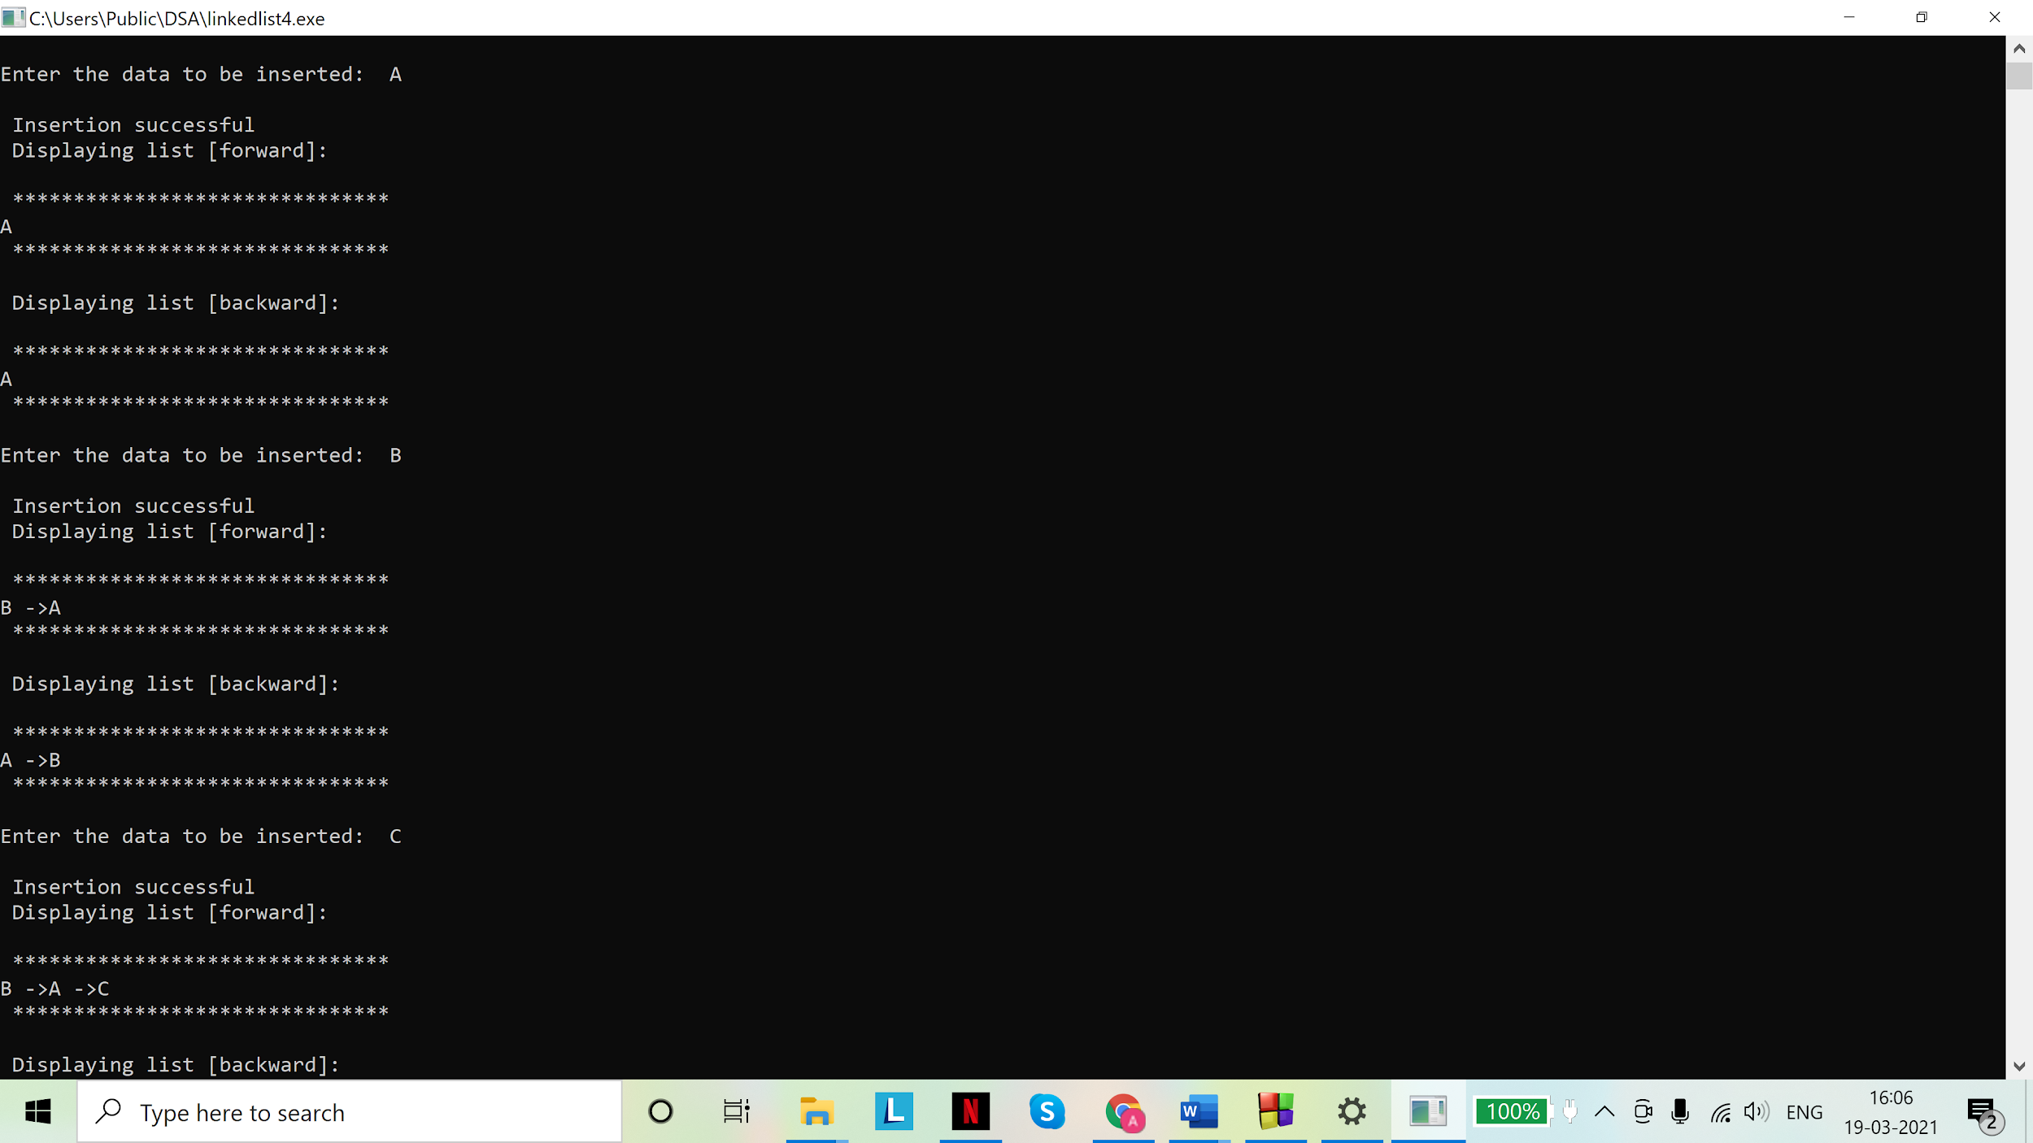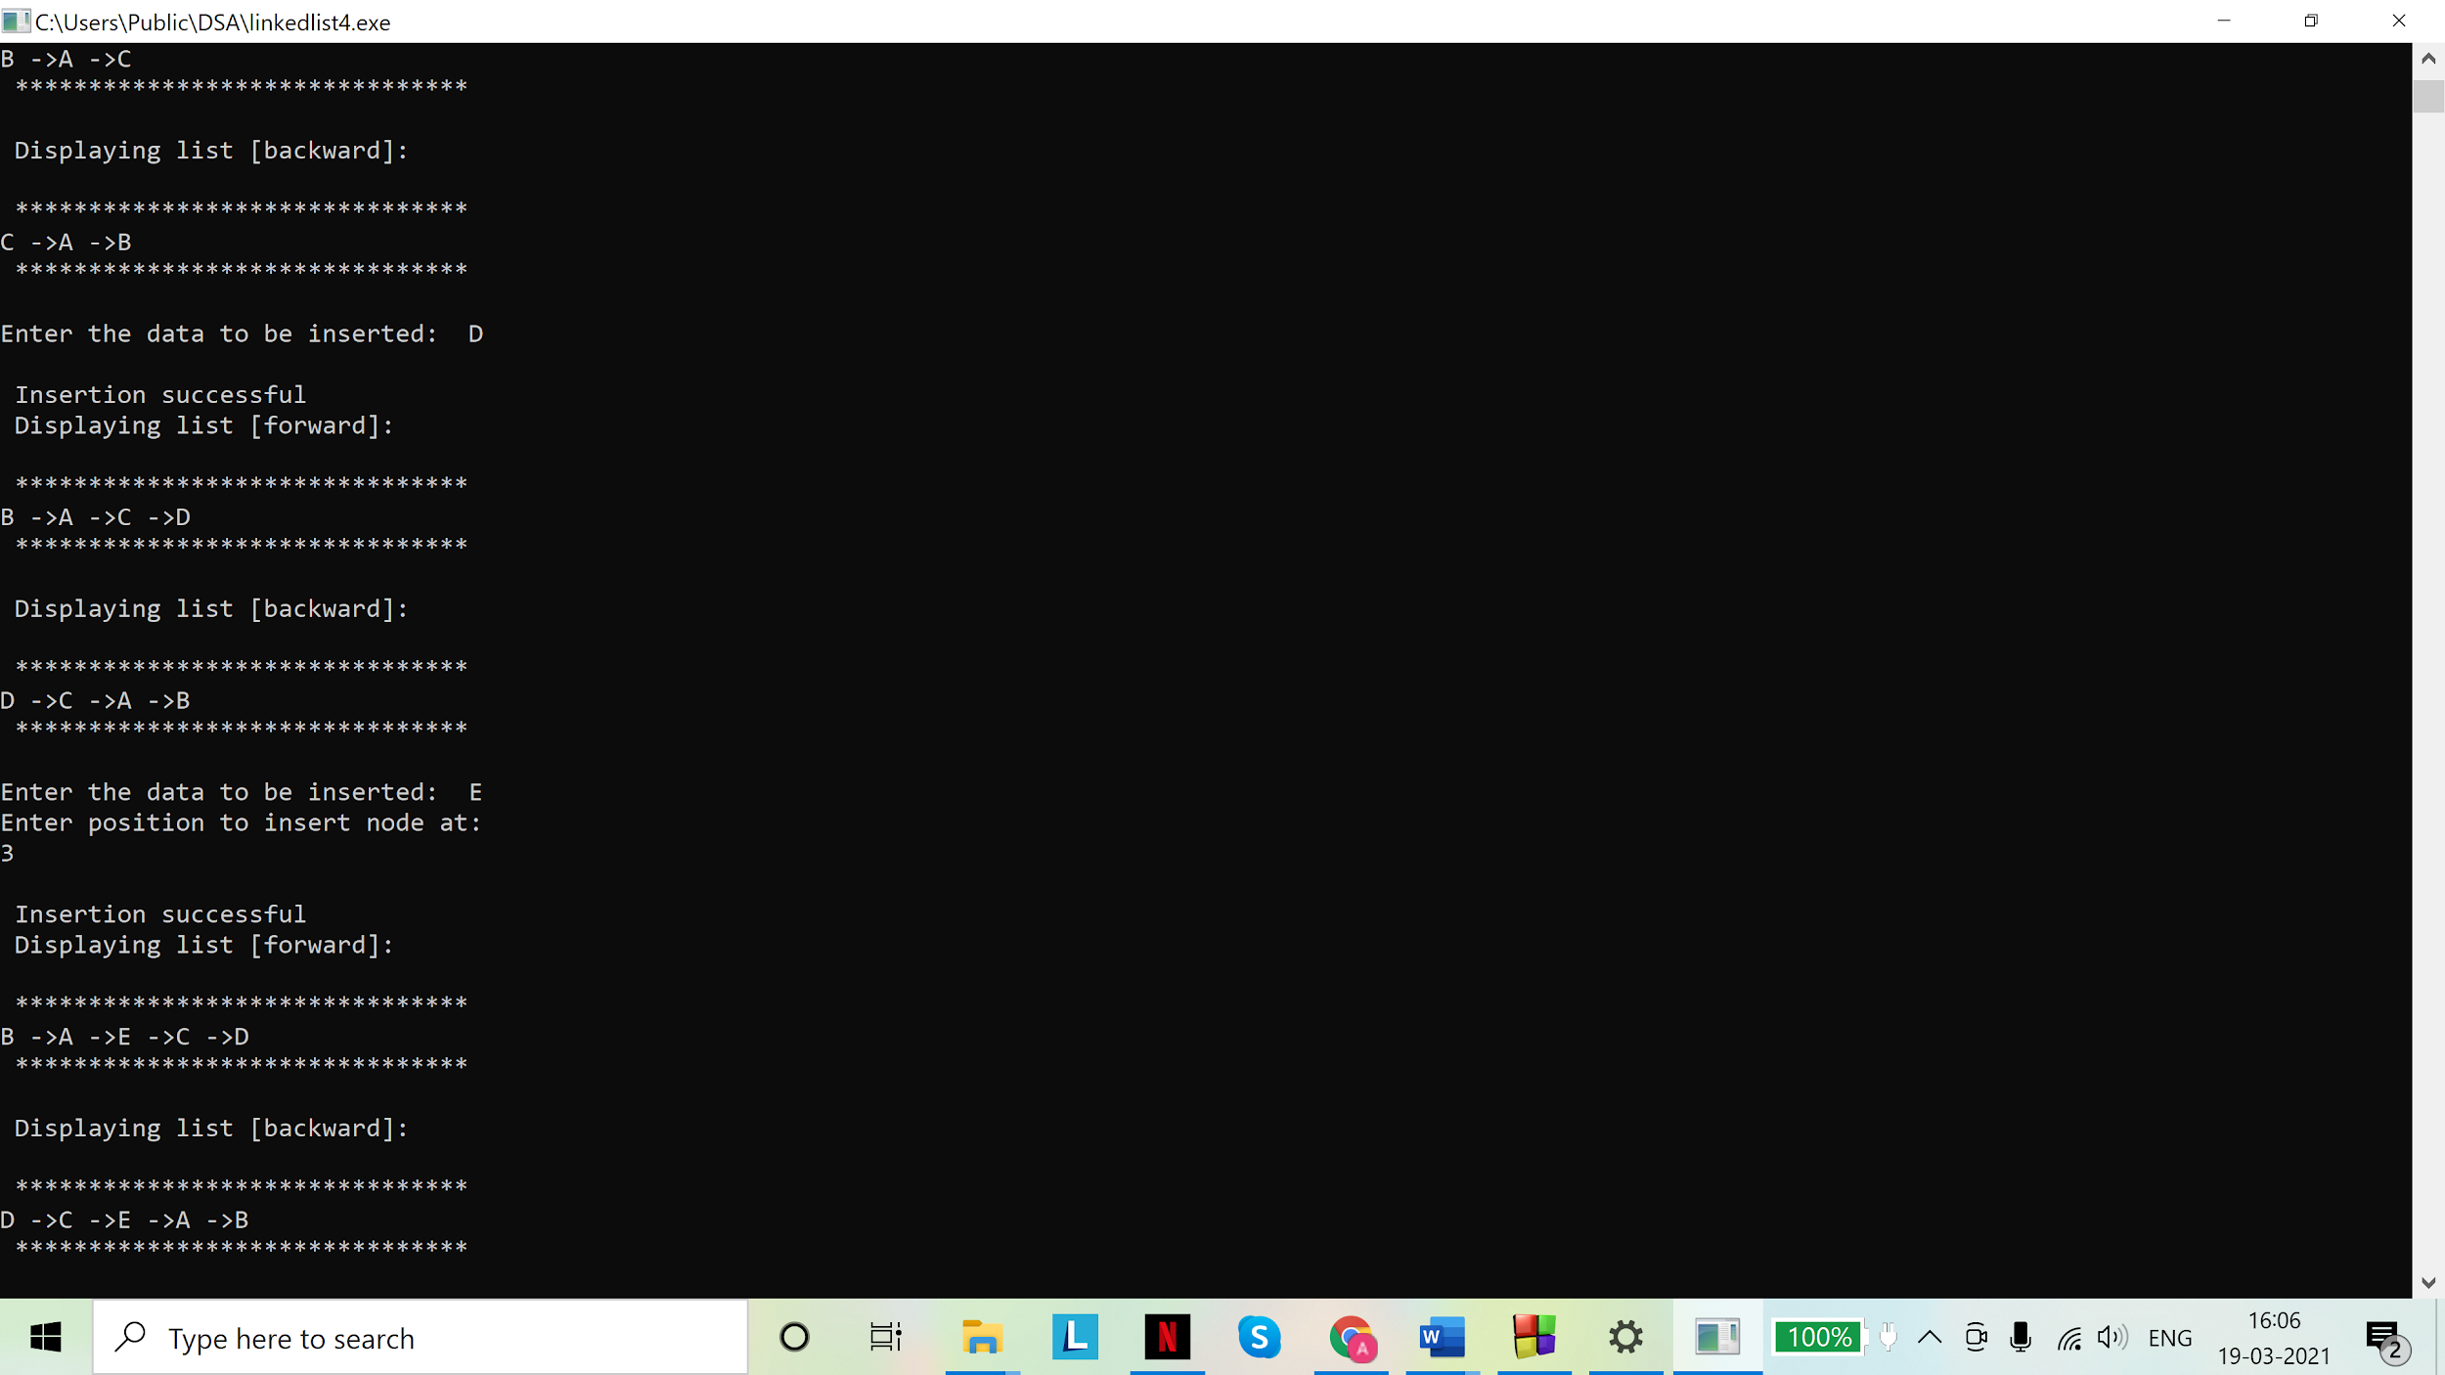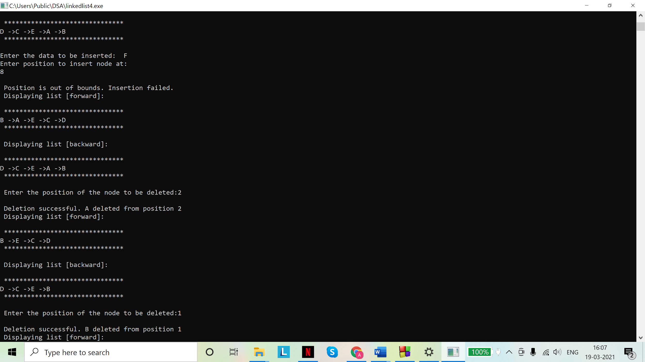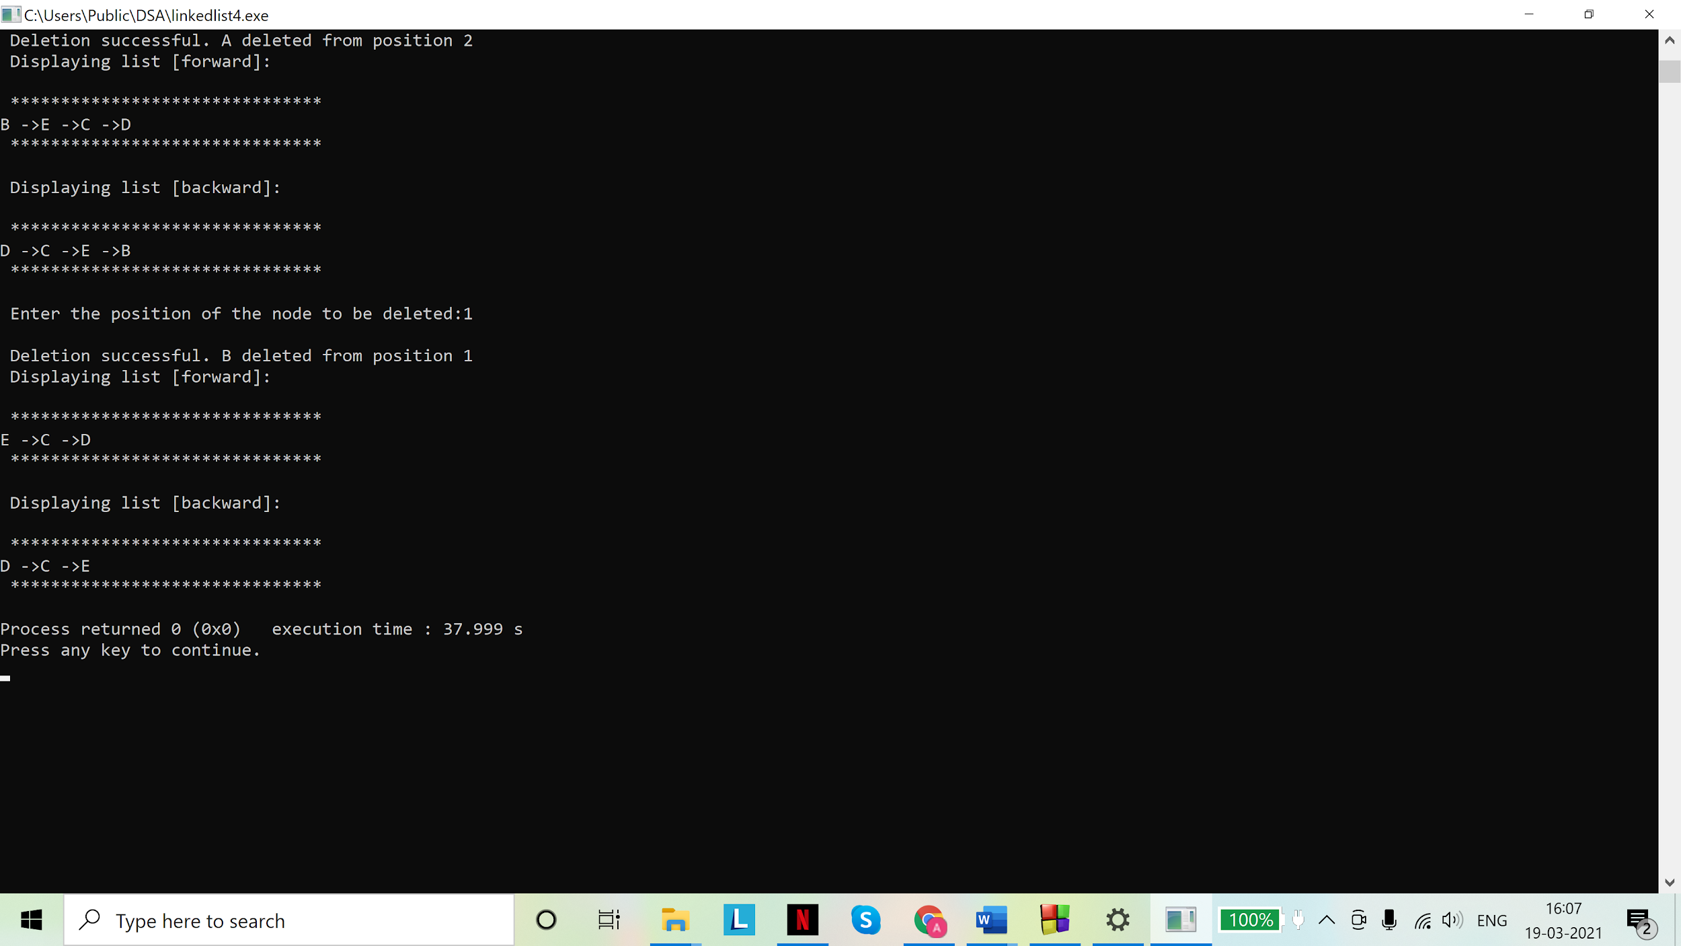

Assignment -02

1. Implement Stack using i) fixed memory and ii) dynamic memory representations. In both representations, code the two primitive stack functions. Add a display function to show the content of your stack after every operation.

Solutions

Code: Static implementation (using array)

#include <stdio.h>

# include <stdlib.h>

#define MAX 10

struct Stack{

int top, arr[];

};

typedef struct Stack stack;

//Pushing data into the stack

void push(stack *s){

if (s->top == (MAX-1)){

printf("\nOverflow"); //static implementation has an upper limit on number of elements it can store

}

else{

int d;

char temp;

printf("\nEnter the data to be pushed into the stack:");

scanf("%d", &d);

scanf("%c",&temp);

if(s->top == -1){

s->arr[++(s->top)] = d;

}

else{

s->top += 1;

s->arr[s->top] = d;

}

printf("\nPush successful\n");

}

return 0;

}

//Popping data from the top of the stack

int pop(stack *s){

int temp;

if(s->top == -1){

printf("\nUnderflow. Nothing to pop.\n");

return NULL;

}

else{

temp = s->arr[s->top];

s->arr[s->top] = NULL;

s->top -= 1;

printf("\nPopping successful.\n");

return temp;

}

}

//peeking at the data at the top of the stack

void peek(stack* s){

if(s->top==-1){

printf("\nEmpty stack\n");

return;

}

else{

printf("%d",s->arr[s->top]);

}

}

//Displaying the stack

int display(stack *s){

int i;

if(s->top == -1){

printf("\nStack is empty. Nothing to display.\n");

}

else{

printf("\n***********************************\n");

for(int i=s->top;i>0;i--){

printf("%d ->",s->arr[i]);

}

printf("%d \n",s->arr[0]);

printf("\n***********************************\n");

}

}

int main(){

stack s;

//initialization

s.top=-1;

s.arr[MAX];

printf("\nPushing 4 elements\n");

push(&s);

push(&s);

push(&s);

push(&s);

printf("\nPeeking\n");

peek(&s);

printf("\nPushing 2 elements\n");

push(&s);

push(&s);

printf("\nDisplaying the stack\n");

display(&s);

printf("\nPopping 2 elements\n");

printf("Popped element %d\n",pop(&s));

printf("Popped element %d\n",pop(&s));

printf("\nThe length of the stack is %d", (s.top+1));

display(&s);

return 0;

}

Output(s):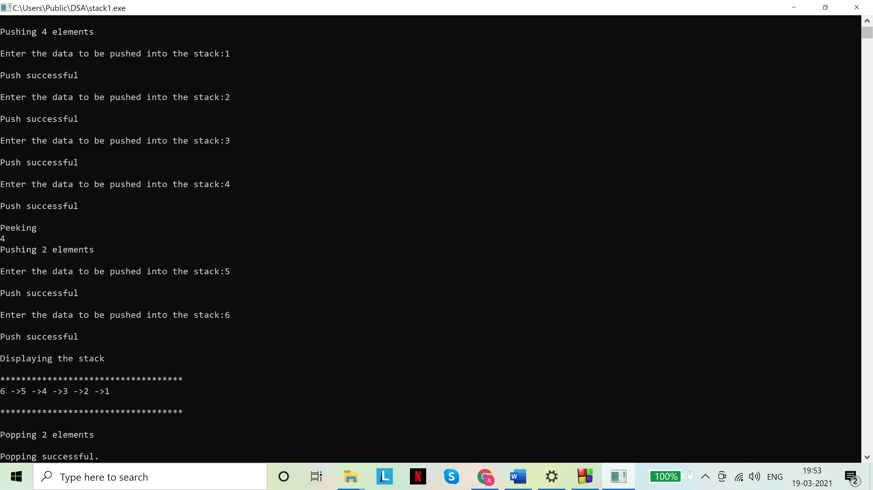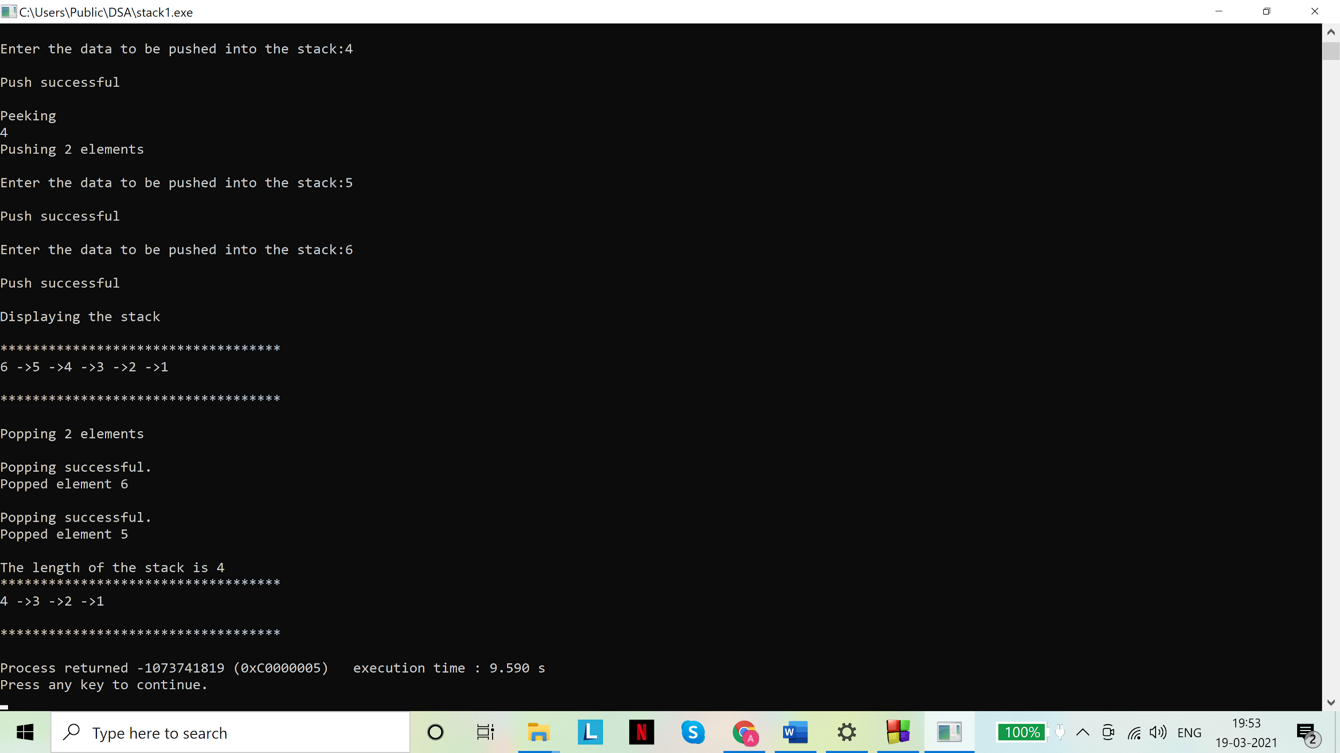

Code: Dynamic implementation (using linked list)

# include <stdio.h>

# include <stdlib.h>

//node

struct node{

int data;

struct node *next;

};

typedef struct node snode;

//stack

struct Stack{

int len;

snode *top;

};

typedef struct Stack stack;

// underflow check

int isEmpty(stack* s){

return (s->len==0);

}

//pushing data into the stack

void push(stack* s){

int d;

char temp;

printf("\nEnter the data to be pushed into the stack:\t");

scanf("%d", &d);

scanf("%c",&temp);

snode *a = malloc(sizeof(snode));

a->data=d;

a->next=NULL;

if(isEmpty(s)){

s->top = a;

a->next = NULL;

s->len = 1;

}

else{

a->next = s->top;

s->top = a;

s->len++;

}

printf("\nPush operation successful\n");

}

//Pop data out of the stack

int pop(stack* s){

if(isEmpty(s)){

printf("\nStack is empty. Nothing to pop.\n");

return NULL;

}

else{

int d;

snode *a = s->top;

d = a->data;

s->top = s->top->next;

s->len--;

printf("\nPop operation successful\n");

return d;

}

}

//To peek at the data at the top of the stack

void peek(stack* s){

if(isEmpty(s)){

printf("\nEmpty stack\n");

return;

}

else{

printf("%d",s->top->data);

}

}

//To display stack

void display(stack* s){

int i=1;

if(isEmpty(s)){

printf("\nStack is empty.\n");

}

else{

printf("\n***********************************\n");

snode *temp=s->top;

while(temp->next!=NULL){

printf("%d ->",temp->data);

temp = temp->next;

}

printf("%d \n",temp->data);

printf("\n***********************************\n");

}

}

int main(){

stack s;

s.top=NULL;

s.len=0;

printf("\nPushing 4 elements\n");

push(&s);

push(&s);

push(&s);

push(&s);

printf("\nPeeking\n");

peek(&s);

printf("\nPushing 2 elements\n");

push(&s);

push(&s);

printf("\nDisplaying the stack\n");

display(&s);

printf("\nPopping 2 elements\n");

printf("Popped element %d\n",pop(&s));

printf("Popped element %d\n",pop(&s));

printf("\nThe length of the stack is %d", s.len);

display(&s);

return 0;

}

Output(s):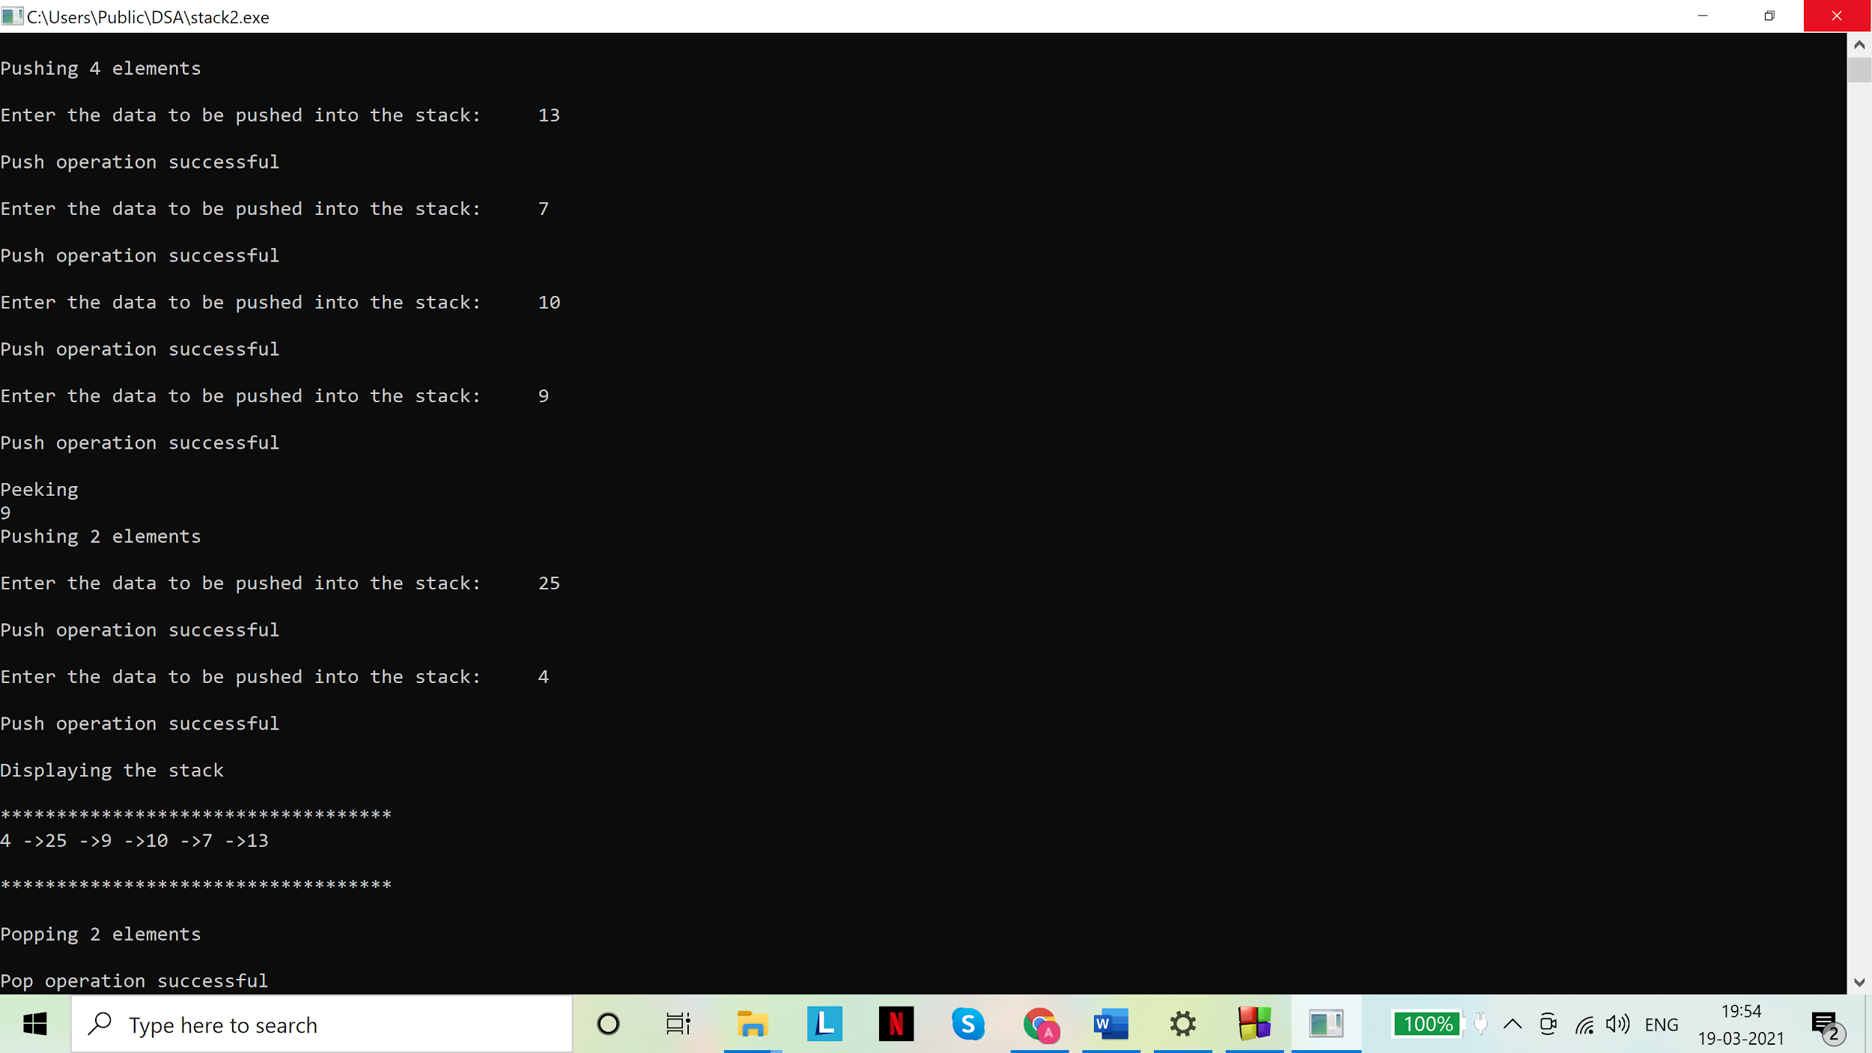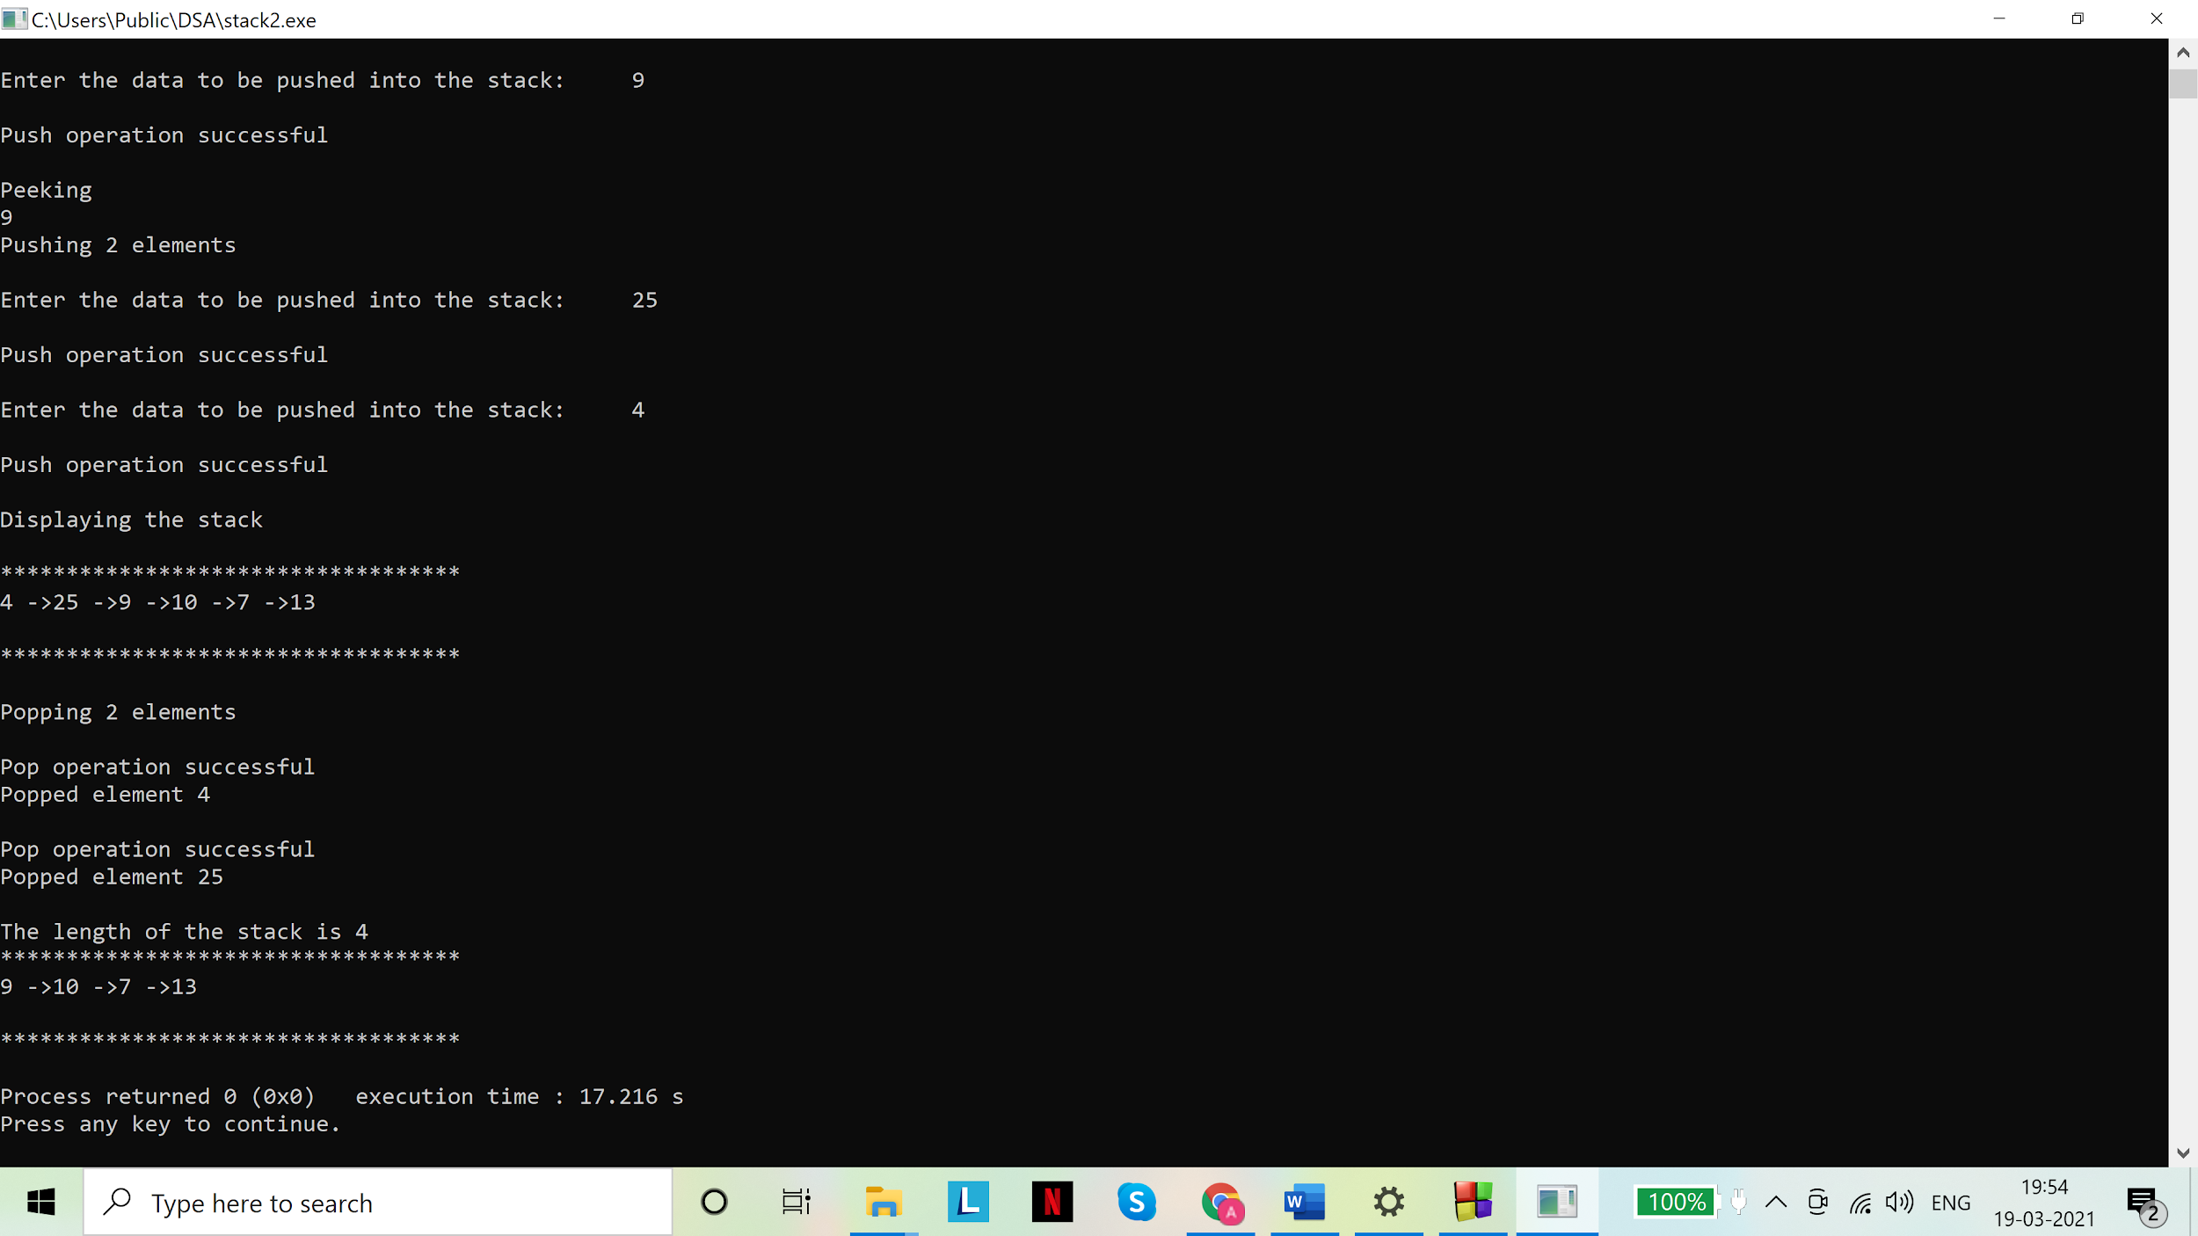

Assignment - 03

1. Evaluate postfix expressions using a Stack. You can use ',' as a delimiter between two tokens in an expression. You can use '$' as the end of input. Always show the intermediate steps including the content of the stack. Take some example postfix expressions. Here is one example:

6, 2, 3, +, -, 3, 8, 2, /, +, *, 2, ^, 3, +, $

(Use '^' for exponentiation)

1. Write a program for the Tower of Hanoi problem. Experiment with a varying number of discs. Show the intermediate moves in form of messages like the following:

Move disk ... from rod ... to rod ...

Solutions

1. Code:

# include <stdio.h>

# include <stdlib.h>

//node

struct node{

int data;

struct node *next;

};

typedef struct node snode;

//stack

struct Stack{

int len;

snode *top;

};

typedef struct Stack stack;

// underflow check

int isEmpty(stack* s){

return (s->len==0);

}

//pushing data into the stack

void push(stack* s, int d){

snode *a = malloc(sizeof(snode));

a->data=d;

a->next=NULL;

if(isEmpty(s)){

s->top = a;

a->next = NULL;

s->len = 1;

}

else{

a->next = s->top;

s->top = a;

s->len++;

}

}

//Pop data out of the stack

int pop(stack* s){

if(isEmpty(s)){

printf("\nStack is empty. Nothing to pop.\n");

return NULL;

}

else{

int d;

snode *a = s->top;

d = a->data;

s->top = s->top->next;

s->len--;

return d;

}

}

//To display stack

void display(stack* s){

int i=1;

if(isEmpty(s)){

printf("\nStack is empty.\n");

}

else{

printf("\nDisplaying stack:\n");

snode *temp=s->top;

while(temp->next!=NULL){

printf("%d ->",temp->data);

temp = temp->next;

}

printf("%d \n",temp->data);

}

}

void main(){

printf("Enter a postfix expression:\n");

char exp[50];

int c=0;

char ch='a';

while(ch!='\n')

{

scanf("%c",&ch);

exp[c]=ch;

c++;

}

stack opstack;

opstack.top=NULL;

opstack.len=0;

int val1=0, val2=0;

int i=0;

while(exp[i]!='$')

{

// if the character is an operand ,push it to the stack

if (isdigit(exp[i]))

push(&opstack, exp[i]-'0' );

else if (exp[i]==',')

{

i++;

continue;

}

// if the character is an operator, pop two elements from stack apply the operator

else

{

val1 = pop(&opstack);

val2 = pop(&opstack);

switch (exp[i])

{

case '+': push(&opstack, (val2+val1)); break;

case '-': push(&opstack, (val2-val1)); break;

case '*': push(&opstack, (val2*val1)); break;

case '/': push(&opstack, (val2/val1)); break;

case '^': push(&opstack, pow(val2,val1)); break;

}

}

display(&opstack);

i++;

}

printf("Result: %d \n",pop(&opstack));

}

Output(s):

For:“6,2,3,+,-,3,8,2,/,+,*,2,^,3,+,$”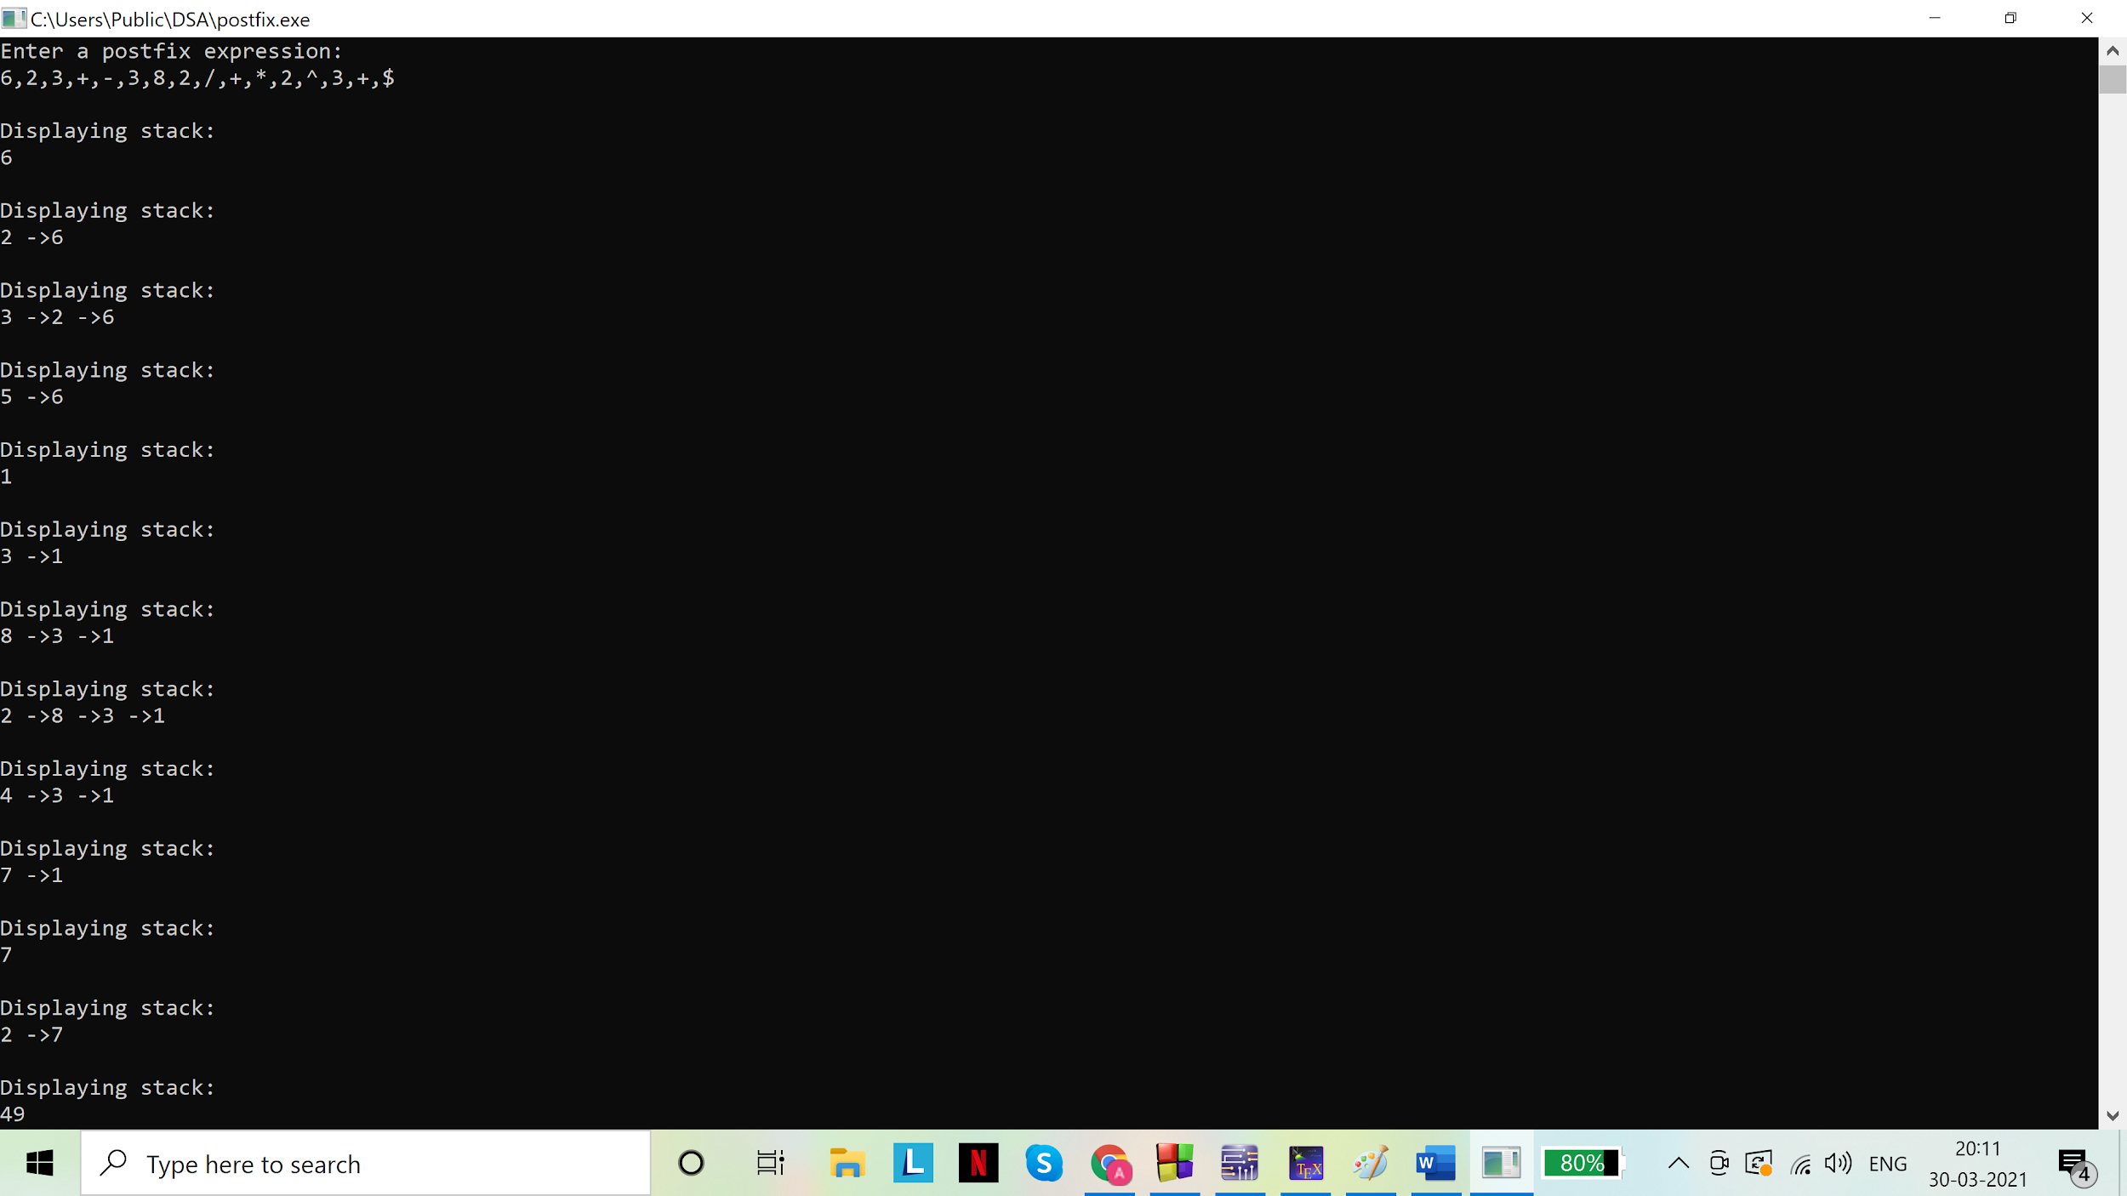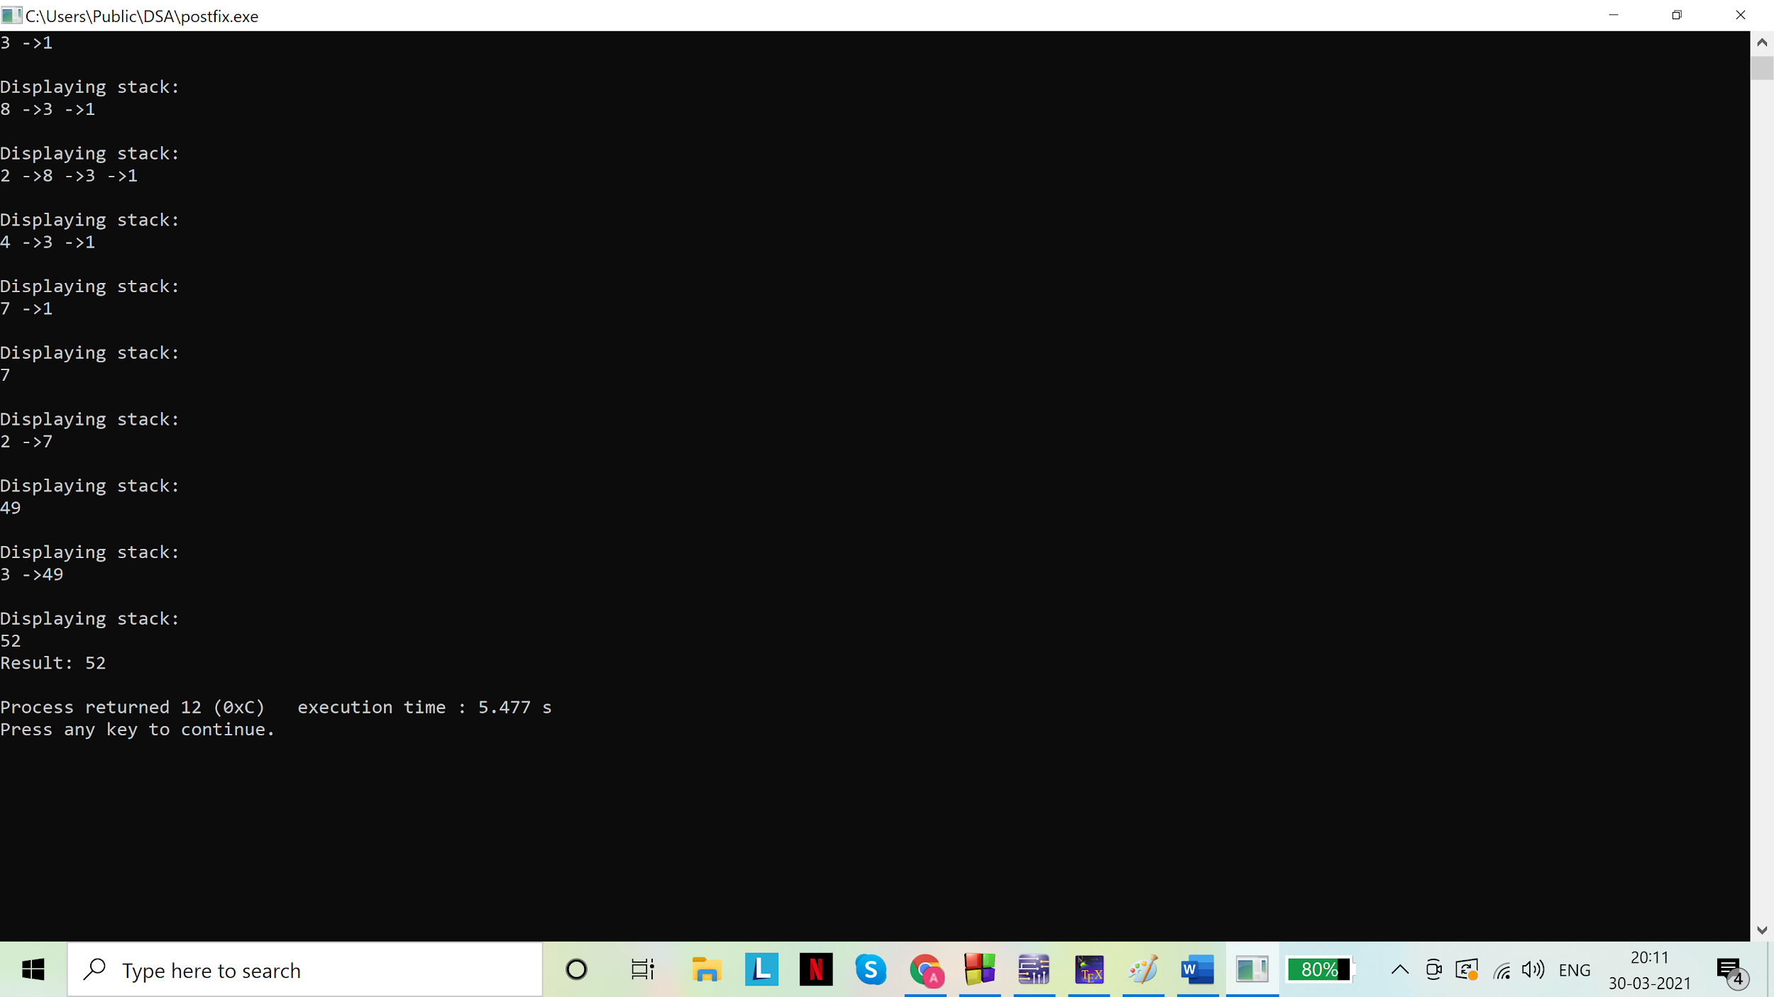For:”2,3,1,*,+,9,-,$”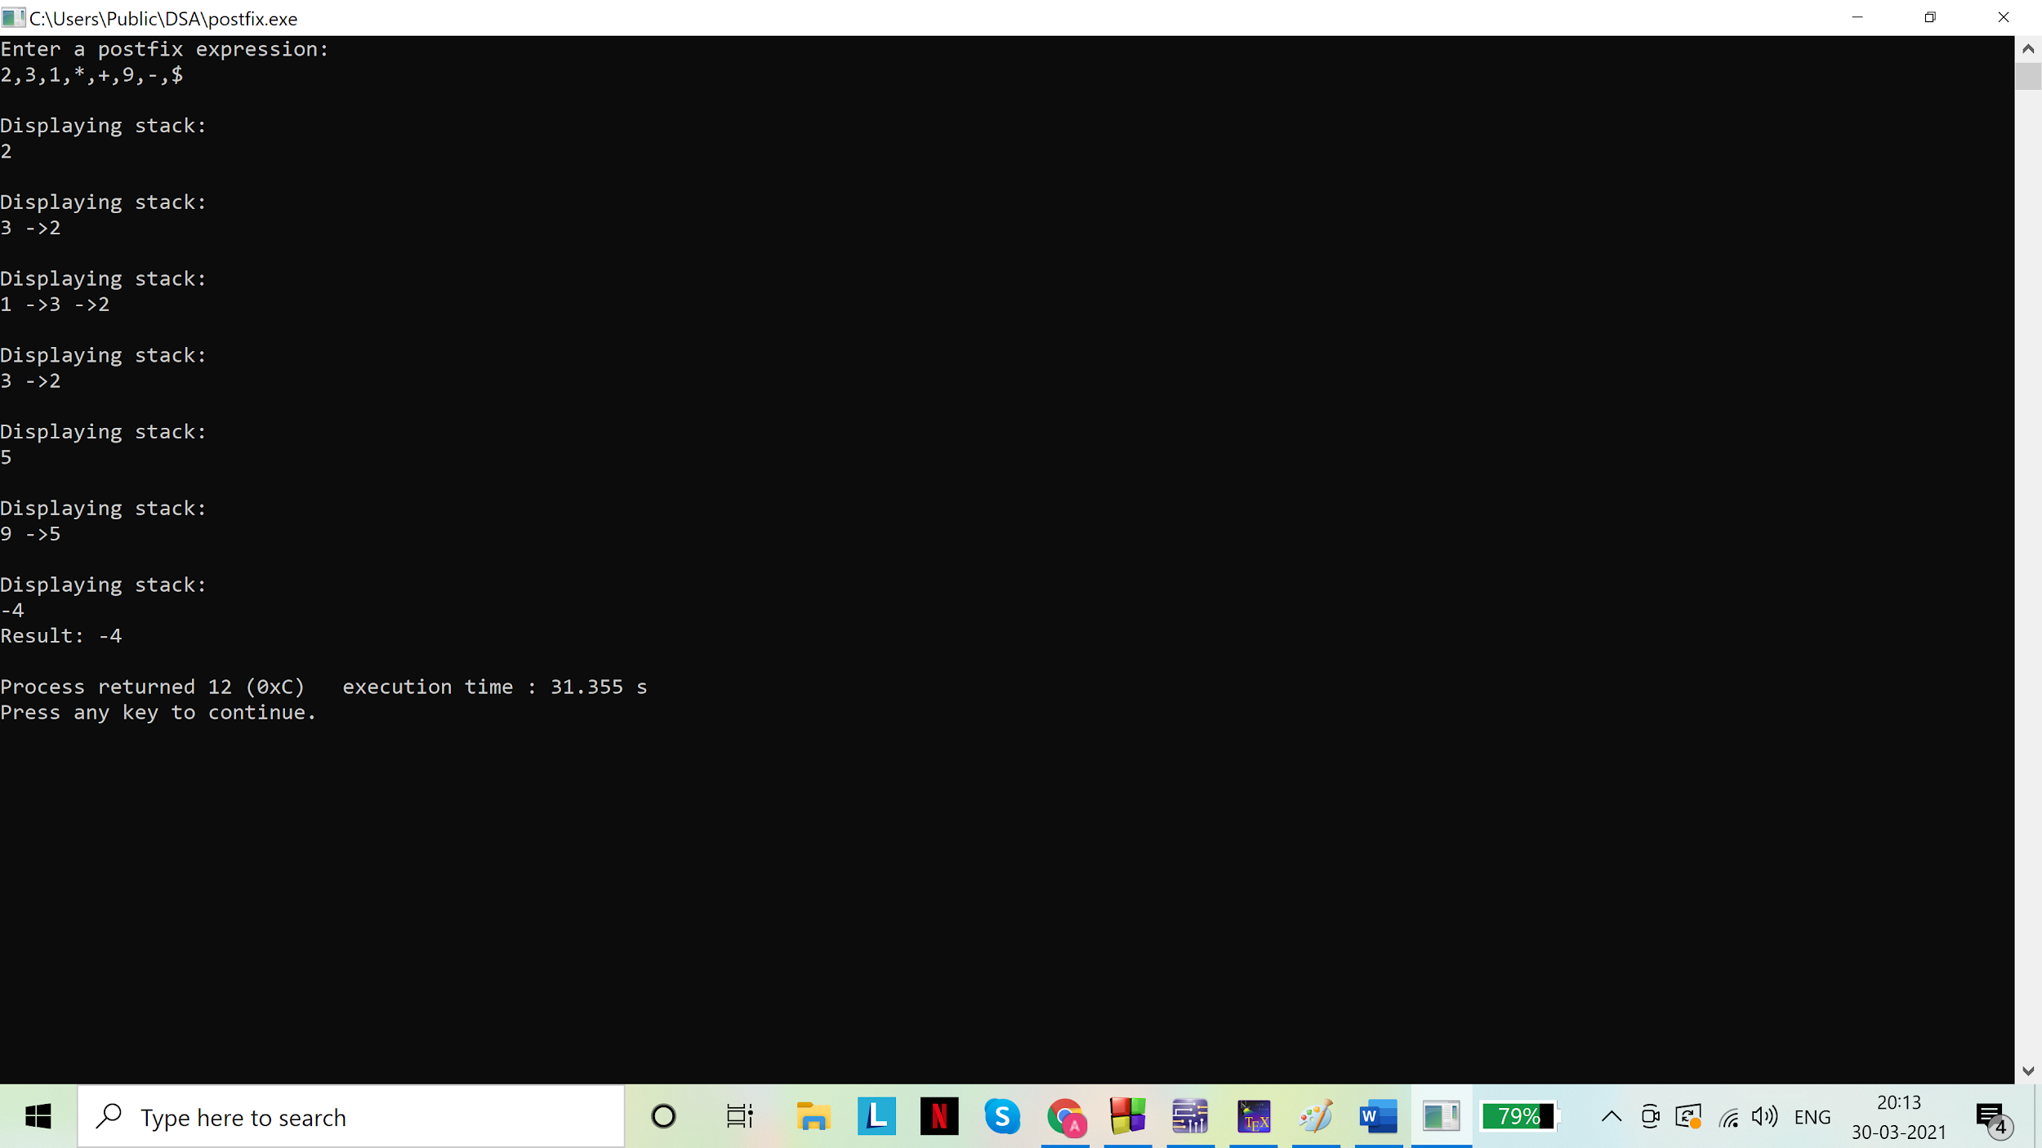

1. Code:

# include <stdio.h>

# include <stdlib.h>

//node

struct node{

int data;

struct node *next;

};

typedef struct node snode;

//stack

struct Stack{

int len;

snode *top;

};

typedef struct Stack stack;

stack A,B,C;

int n;

// underflow check

int isEmpty(stack* s){

return (s->len==0);

}

//pushing data into the stack

void push(stack* s, int d){

snode *a = malloc(sizeof(snode));

a->data=d;

a->next=NULL;

if(isEmpty(s)){

s->top = a;

a->next = NULL;

s->len = 1;

}

else{

a->next = s->top;

s->top = a;

s->len++;

}

}

//Pop data out of the stack

int pop(stack* s){

if(isEmpty(s)){

printf("\nStack is empty. Nothing to pop.\n");

return NULL;

}

else{

int d;

snode *a = s->top;

d = a->data;

s->top = s->top->next;

s->len--;

return d;

}

}

//To display stack

void display(stack* s){

int i=1;

if(isEmpty(s)){

printf("Stack is empty.\n");

}

else{

snode *temp=s->top;

while(temp->next!=NULL){

printf("%d ->",temp->data);

temp = temp->next;

}

printf("%d \n",temp->data);

}

}

void towers(int n, char frompeg, stack *f, char topeg, stack *t, char auxpeg, stack *a)

{

if(n==1)

{

printf("Move disk 1 from peg %c to peg %c \n",frompeg,topeg);

push(t,pop(f));

printf("Stack A:\n");

display(&A);

printf("Stack B:\n");

display(&B);

printf("Stack C:\n");

display(&C);

printf("***************************\n");

}

else

{

towers((n-1),frompeg,f,auxpeg,a,topeg,t);

printf("Move disk %d from peg %c to peg %c \n",n,frompeg,topeg);

push(t,pop(f));

printf("Stack A:\n");

display(&A);

printf("Stack B:\n");

display(&B);

printf("Stack C:\n");

display(&C);

printf("***************************\n");

towers((n-1),auxpeg,a,topeg,t,frompeg,f);

}

}

void main(){

//initializing the stacks

A.top=NULL;

B.top=NULL;

C.top=NULL;

A.len=0;

B.len=0;

C.len=0;

printf("Enter number of disks:\n");

scanf("%d",&n);

for (int i =n;i>=1;i--)

push(&A,i);

printf("\nInitial stacks:\n");

printf("Stack A:\n");

display(&A);

printf("Stack B:\n");

display(&B);

printf("Stack C:\n");

display(&C);

printf("***************************\n");

towers(n,'A',&A,'C',&C,'B',&B);

}

Output(s):

For n=2

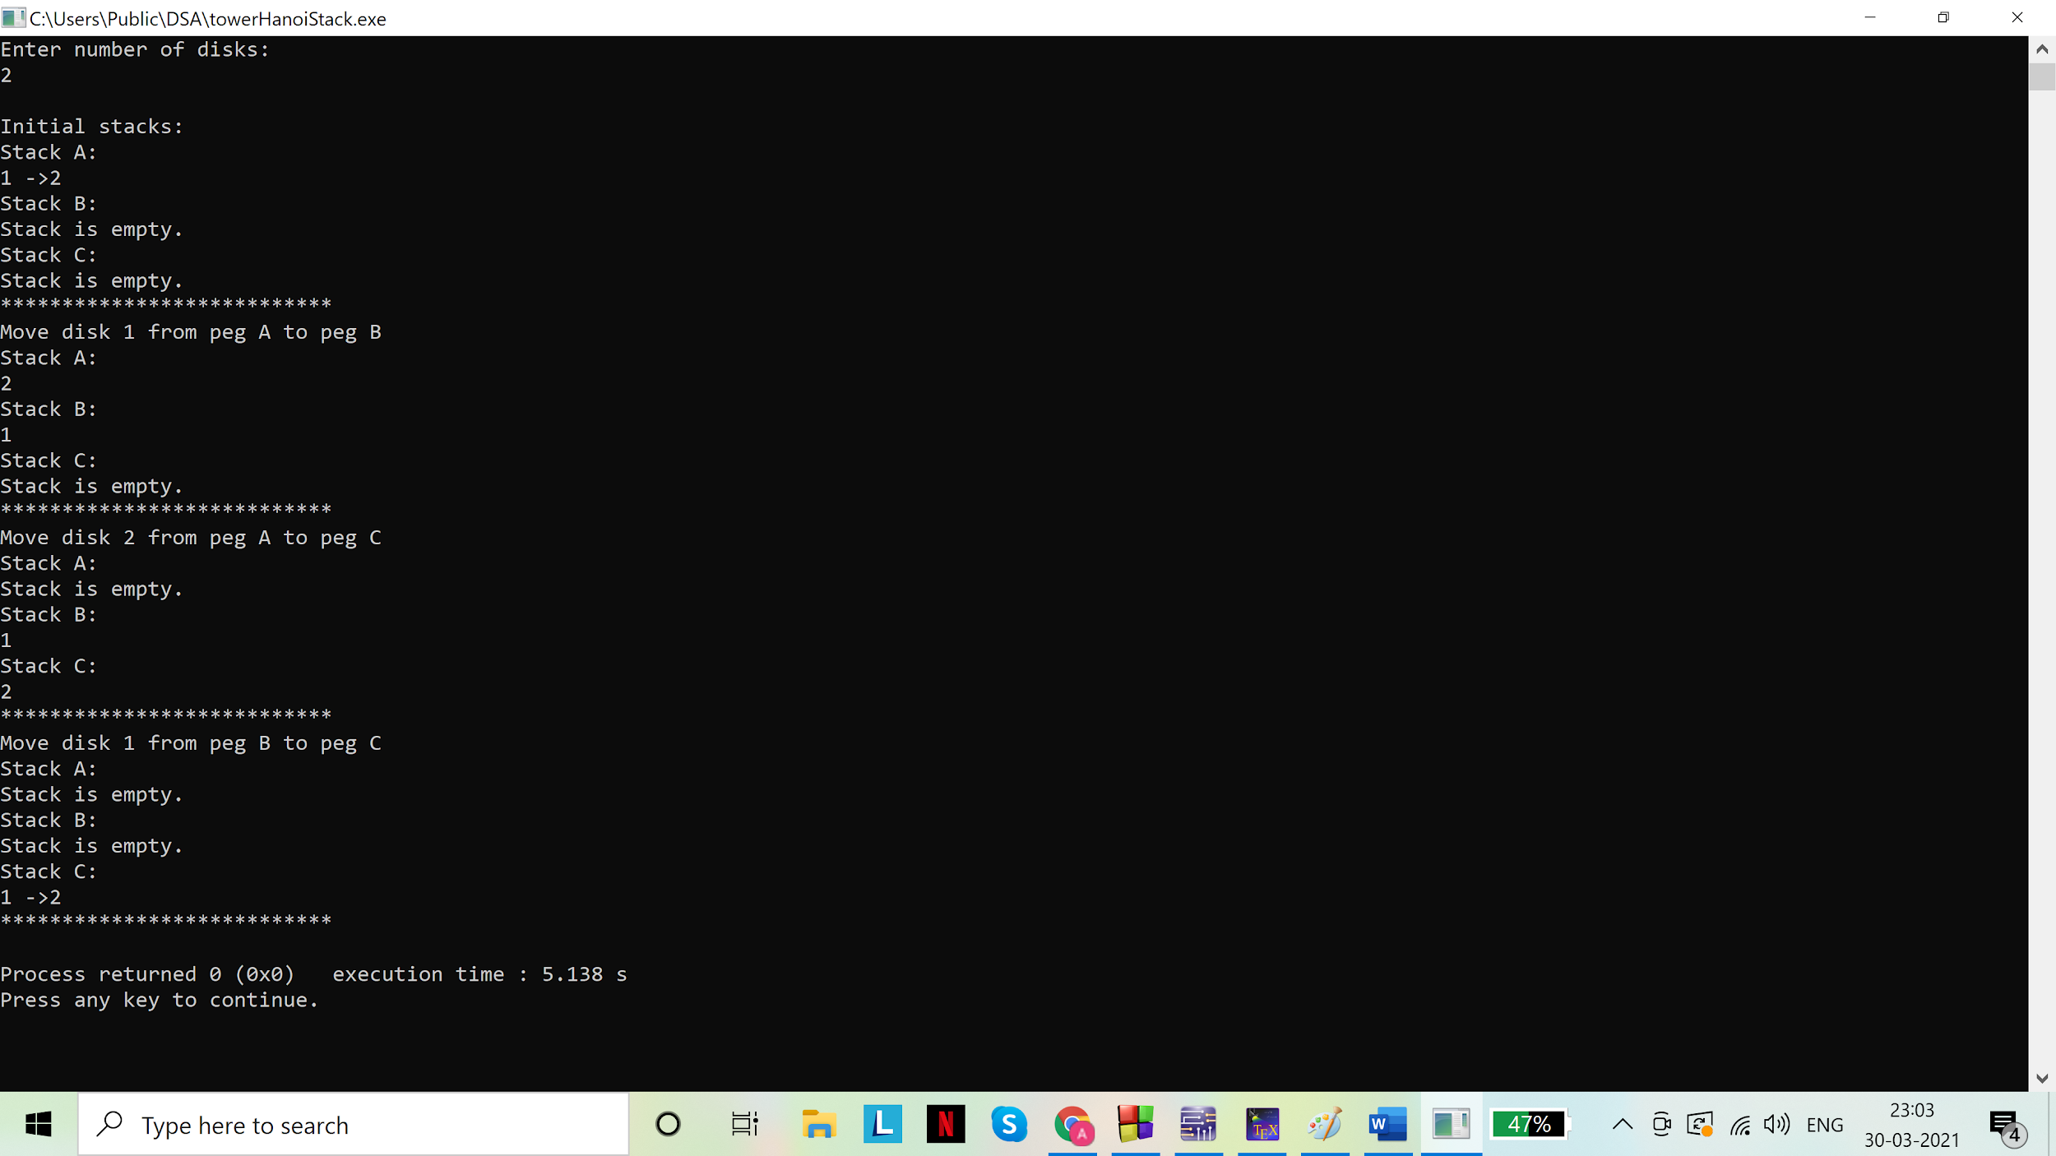

For n=3

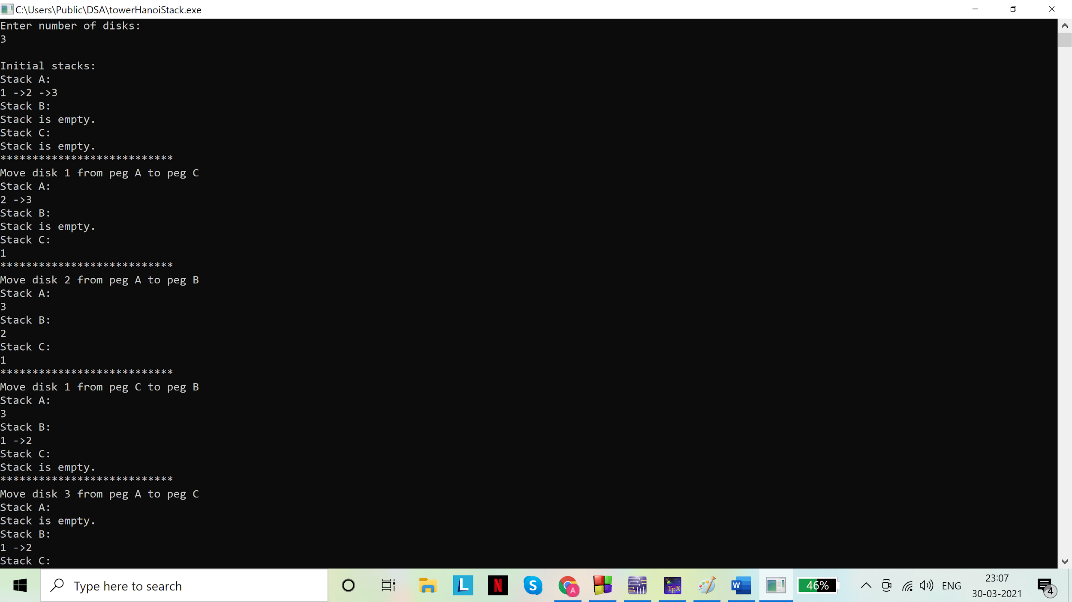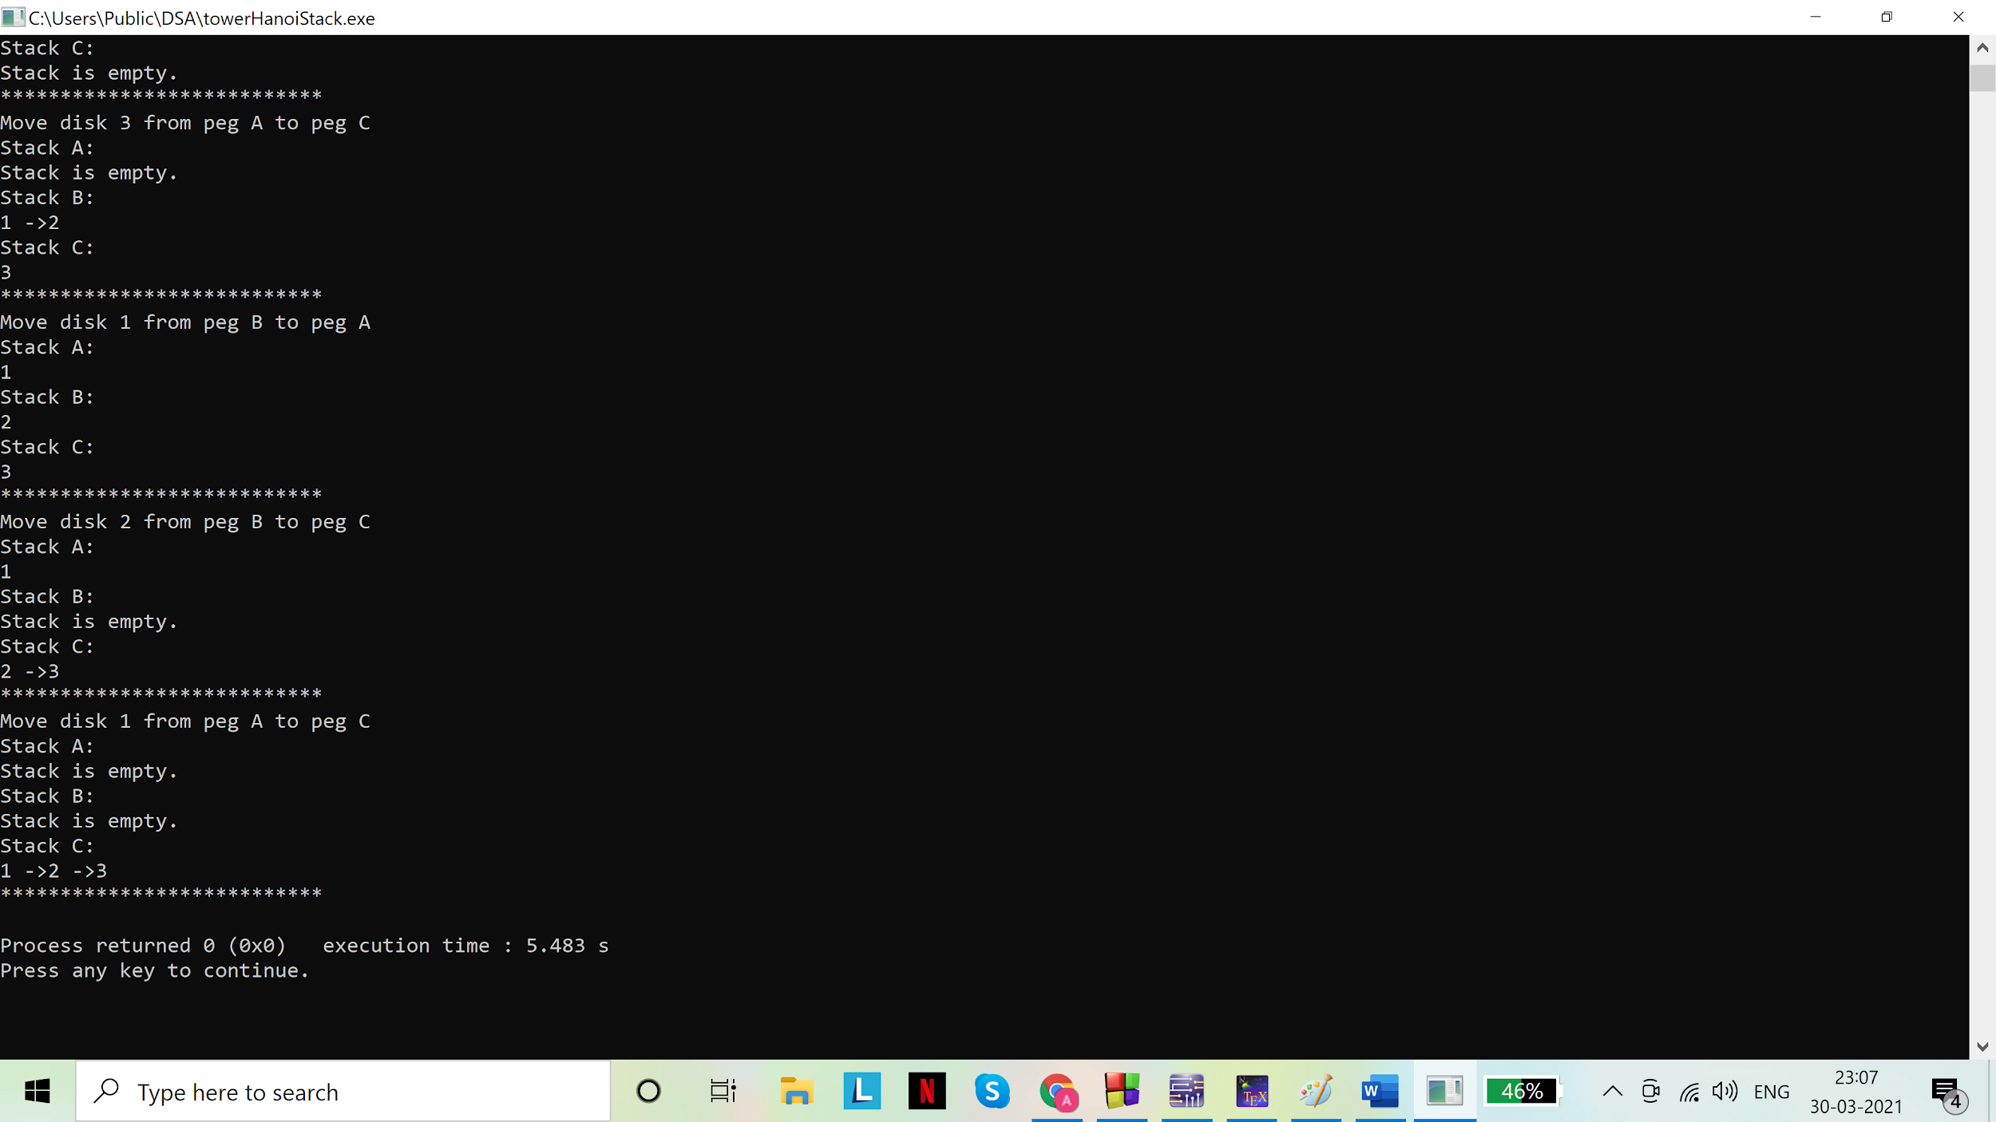

For n=4

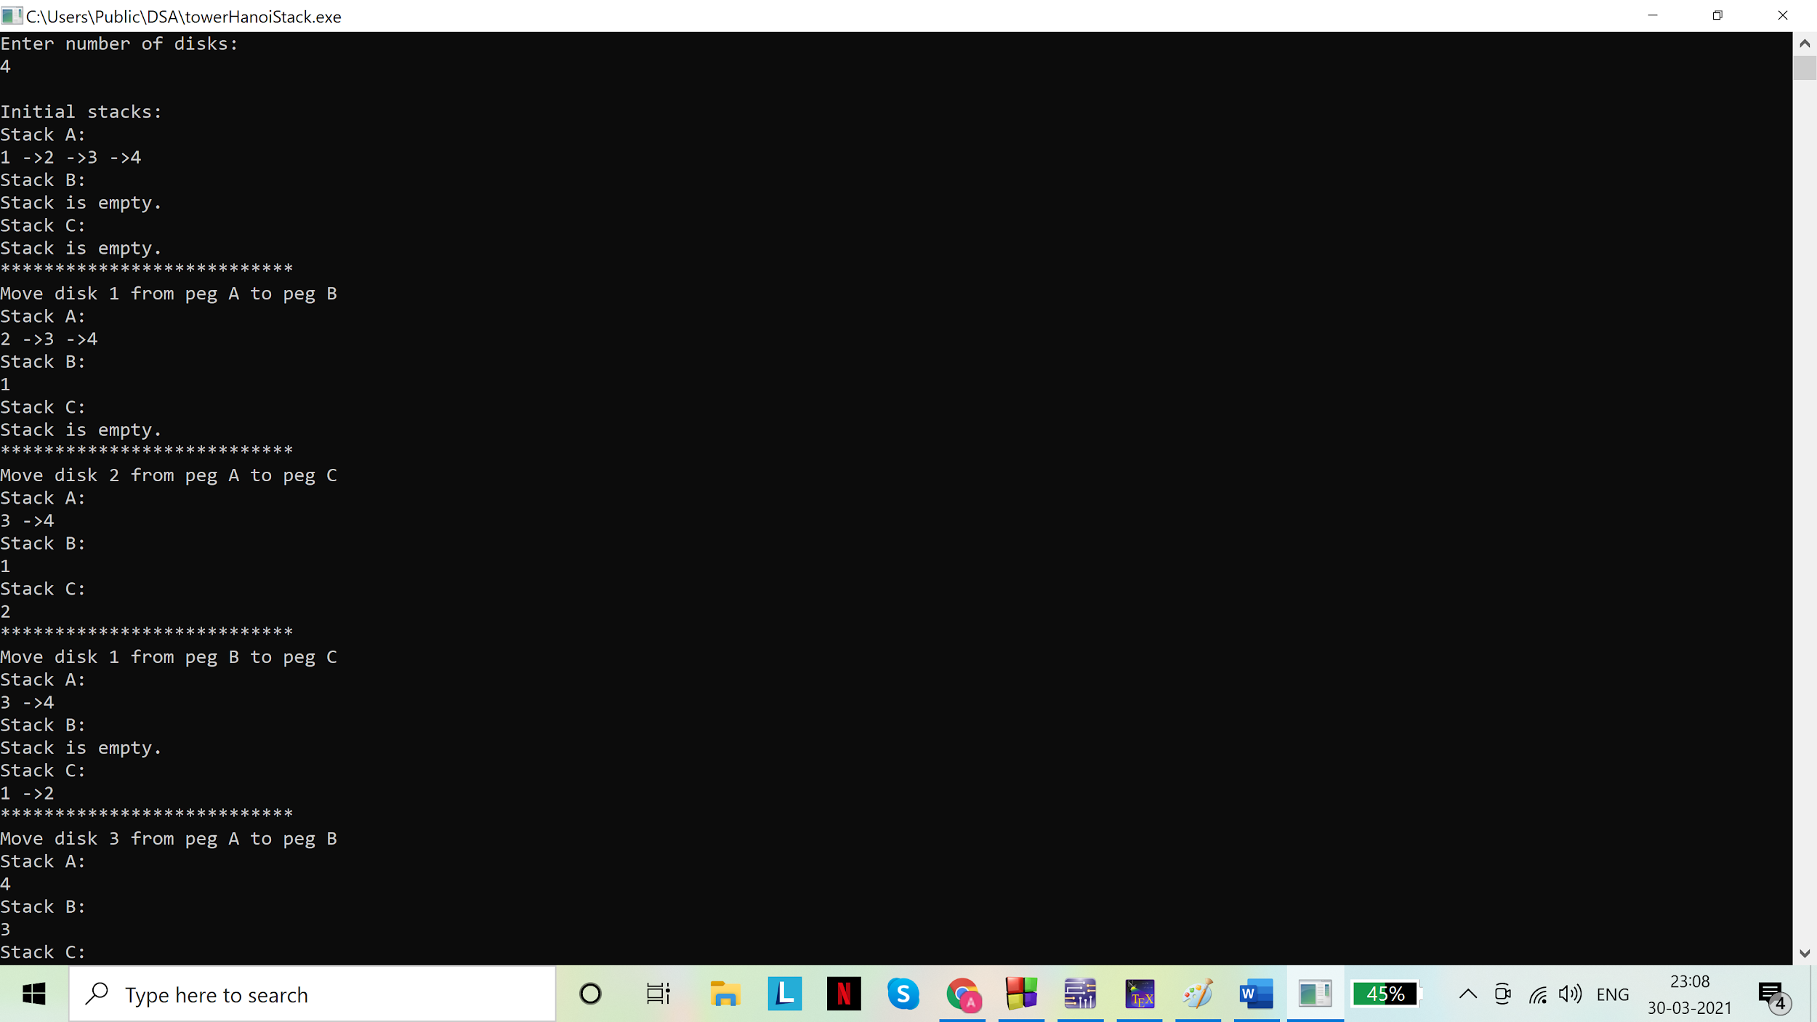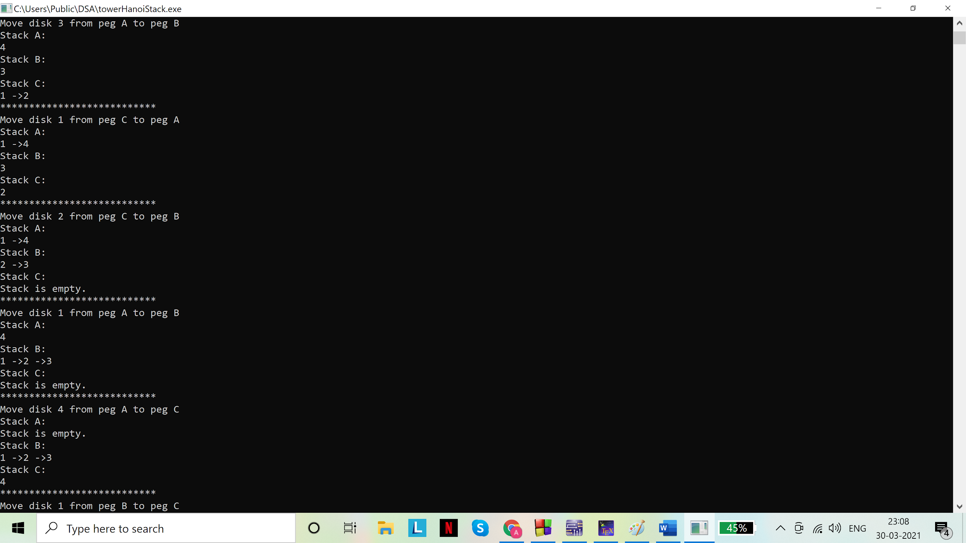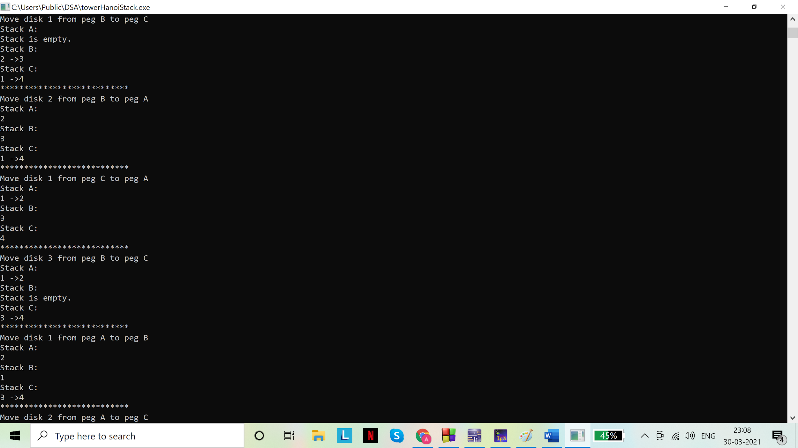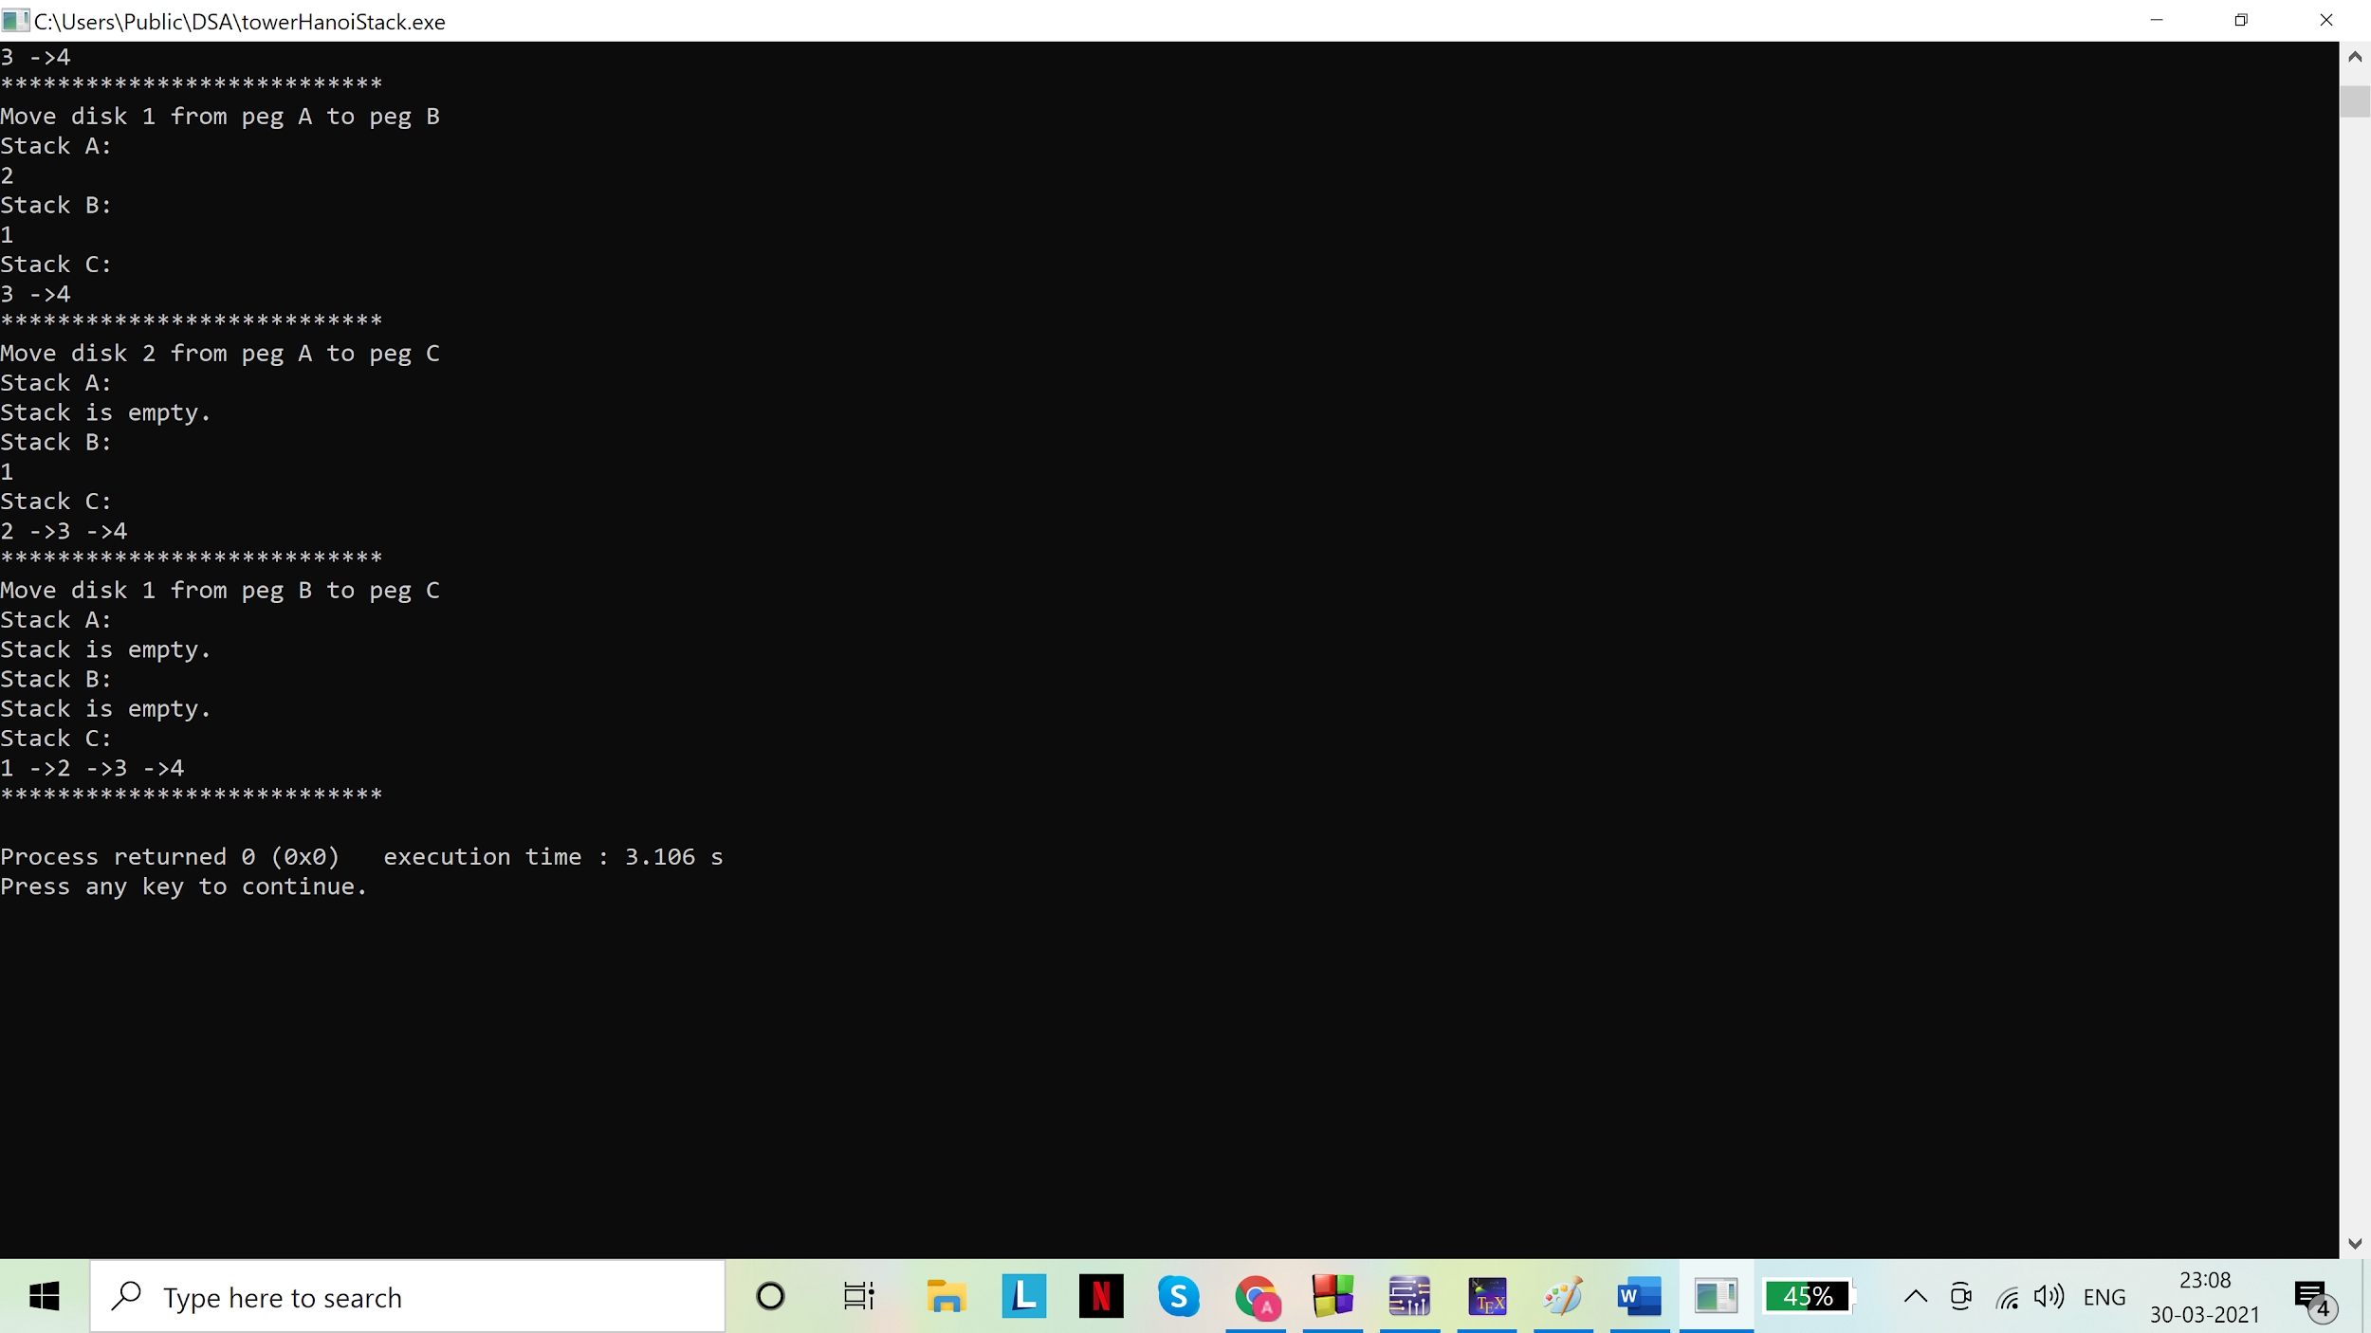

Assignment - 04

1. Implement a Queue using i) a fixed memory representation and ii) a dynamic memory representation. In both cases, you should implement the two primitive operations, namely, insert and delete with proper guards. You should experiment with a set of insert and delete operations. Show the contents of your queue after each operation.

Solution(s)

Code(s):

i. Linear queue implementation using array:

# include <stdio.h>

# include <stdlib.h>

#define MAX 5

//queue

struct Queue{

int items[MAX];

int f,r;

};

typedef struct Queue queue;

int isEmpty(queue *pq){

return (pq->r<pq->f);

}

//function for inserting data in queue

void insert(queue *pq, int d){

if (pq->r==MAX-1)//static implementation: overflow check

printf("Overflow\n");

else

pq->items[++(pq->r)]=d;

}

//function for removing data from queue

int rem(queue *pq){

if(isEmpty(pq))

{

printf("Queue underflow\n");

return NULL;

}

else

return pq->items[(pq->f)++];

}

//main for function calls

void main()

{

queue q;

q.f=0;

q.r=-1;

int ch=1,d=0;

char t='a';//temporary variable

while (ch!=0)

{

printf("0. Exit\n");

printf("1. Insert\n");

printf("2. Remove\n");

scanf("%d",&ch);

scanf("%c",&t);

switch(ch){

case 0: continue; break;

case 1: printf("Enter data:\n");

scanf("%d",&d);

scanf("%c",&t);

insert(&q,d);

break;

case 2: printf("removing...\n");

printf("removed: %d\n",rem(&q));

break;

default:printf("Invalid choice\n");break;

};

//displaying the queue

printf("Displaying the queue\n");

if(isEmpty(&q))

printf("Empty queue\n");

else

{

int i=0;

for( i=q.f;i<q.r;i++)

{

if(i==MAX)

i=0;

printf("%d ->",q.items[i]);

}

printf("%d\n",q.items[i]);

printf("**********************\n");

}

}

}

Output(s):

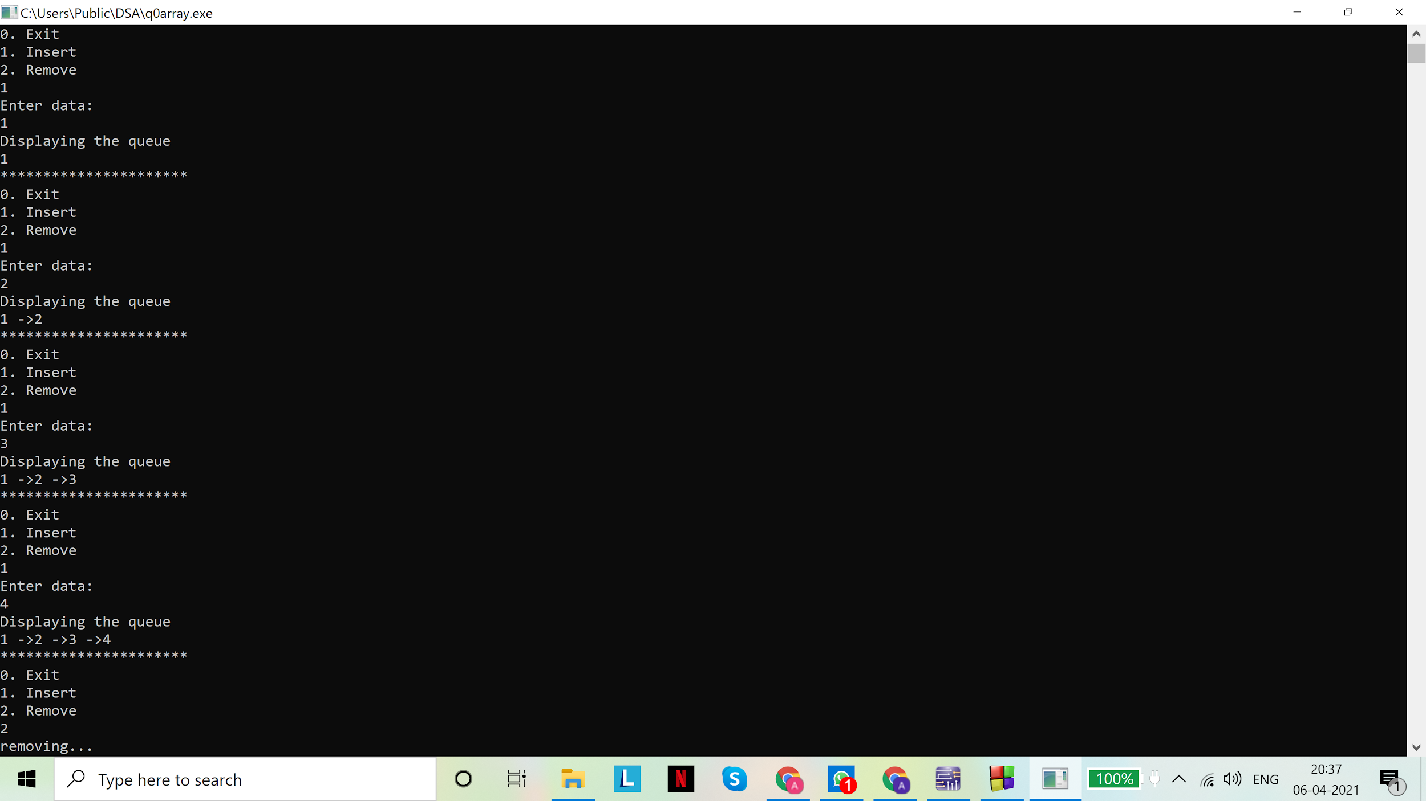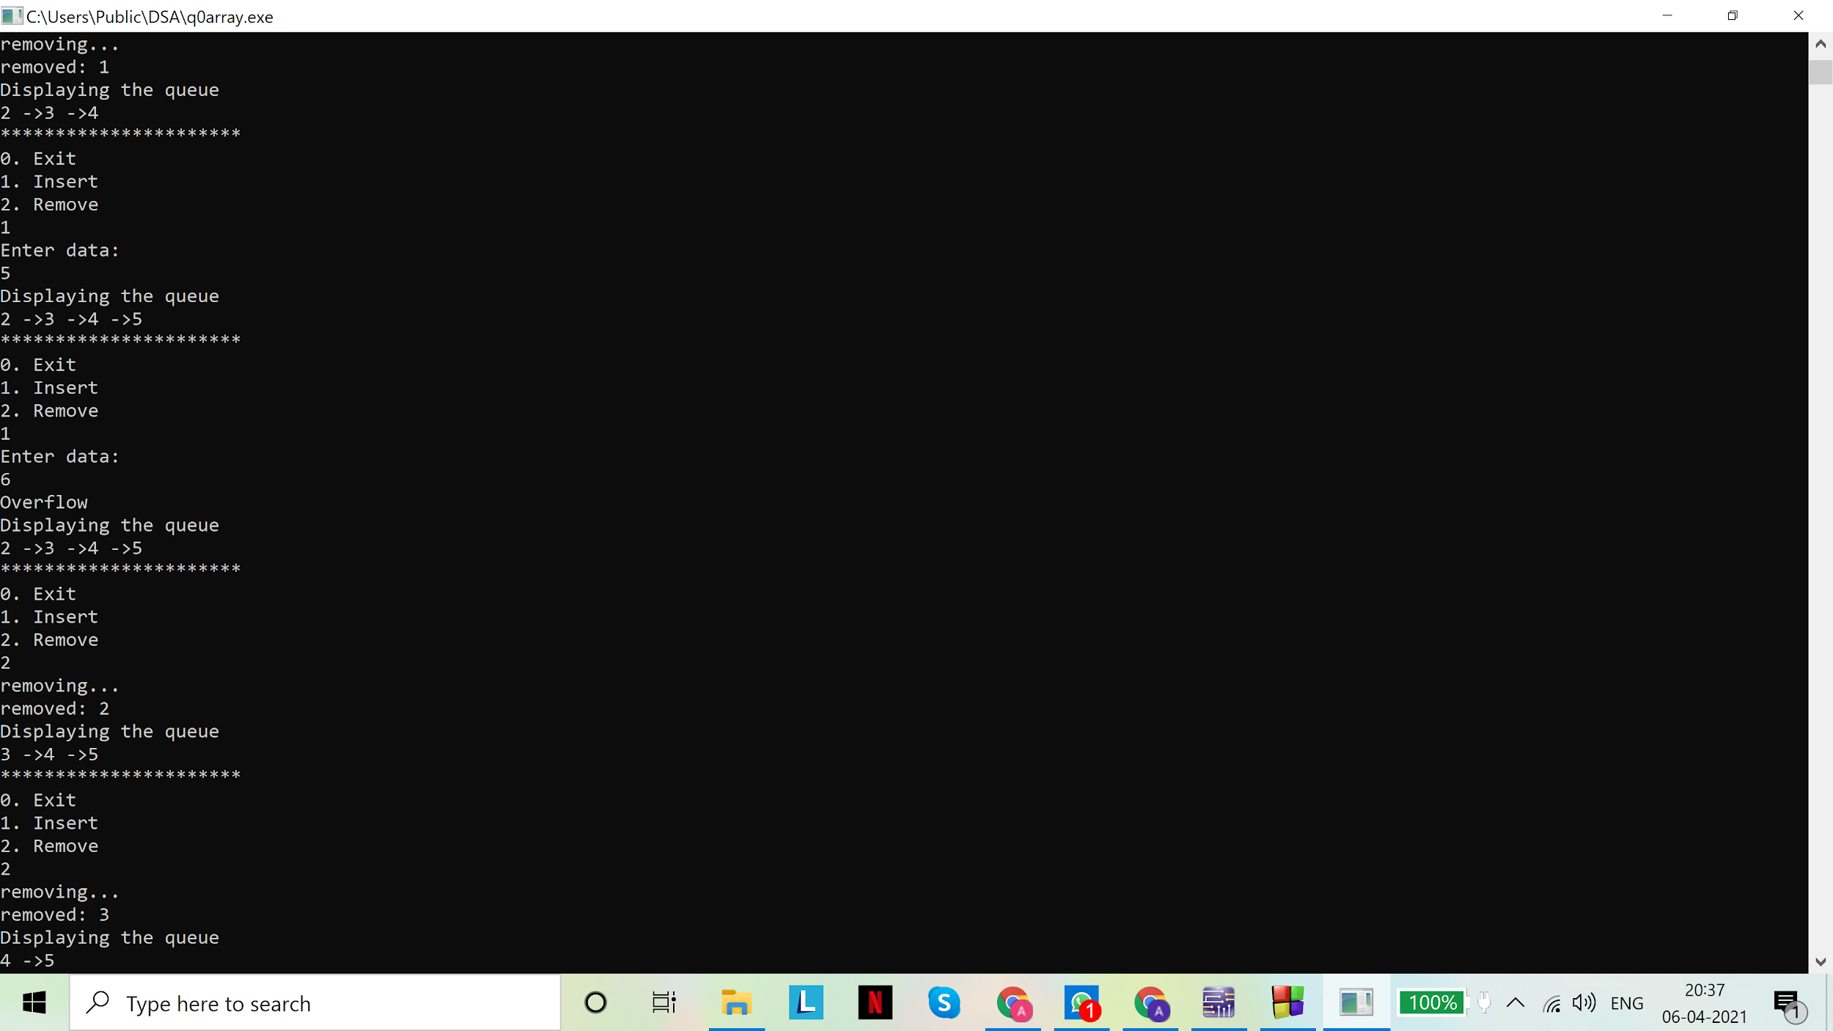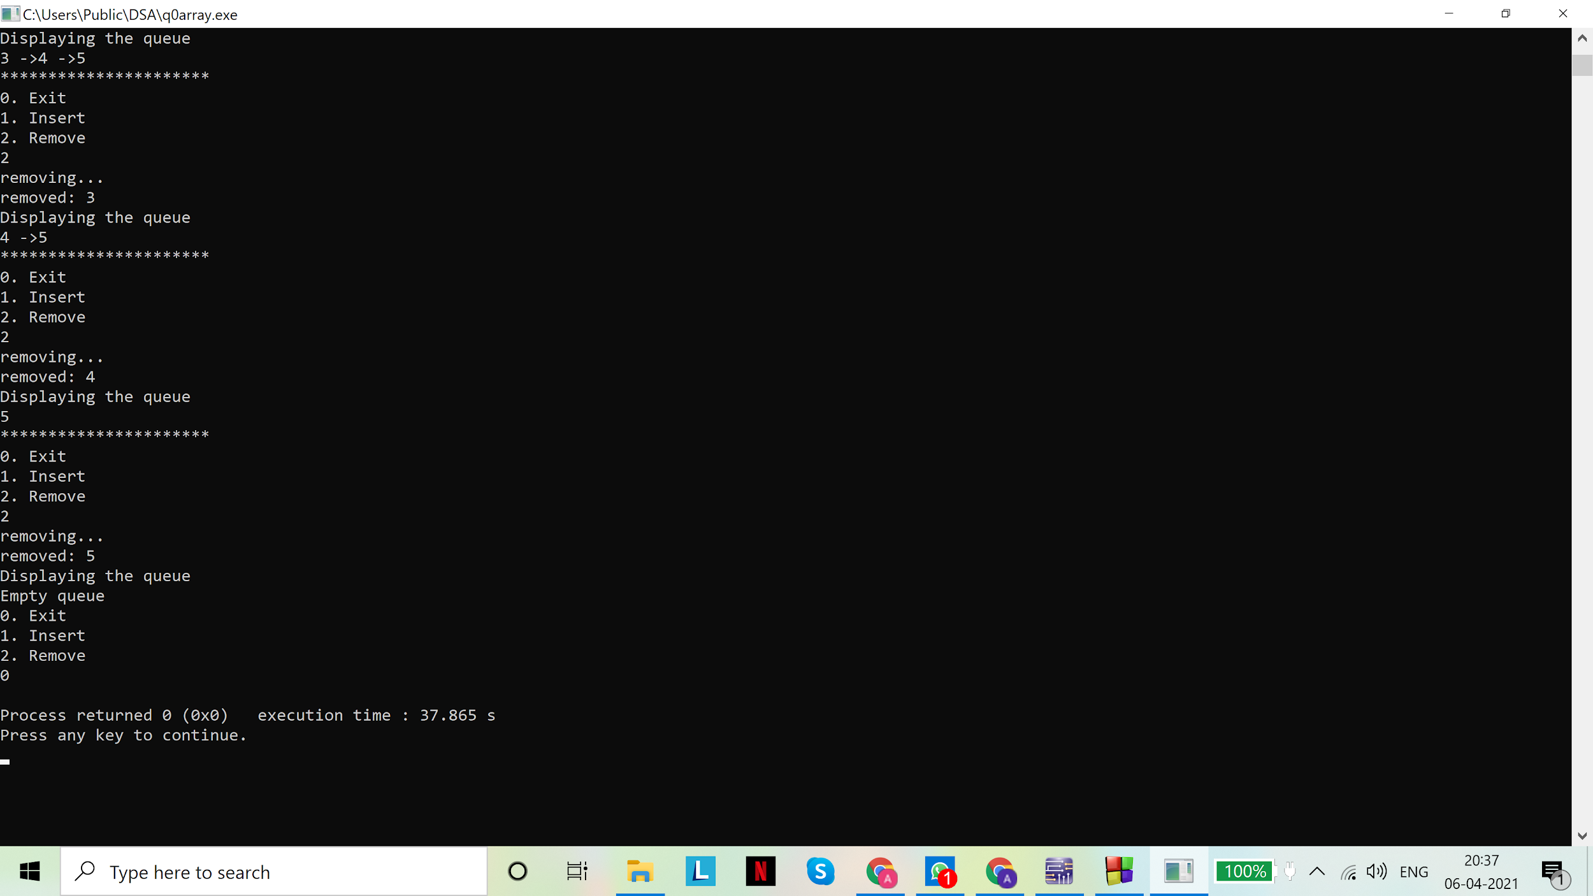

Code(s):

ii. Linear queue: dynamic implementation

# include <stdio.h>

# include <stdlib.h>

//node

struct node{

int data;

struct node *next;

};

typedef struct node snode;

//queue

struct Queue{

snode *f,*r;

};

typedef struct Queue queue;

int isEmpty(queue *pq){

return ((pq->f==NULL)&&(pq->r==NULL));

}

//function for inserting data in queue

void insert(queue *pq,int d){

snode *s=malloc(sizeof(snode*));//creating a temporary node to link to the queue

s->data=d;

s->next=NULL;

if(isEmpty(pq))

pq->r=pq->f=s;

else

{

pq->r->next=s;

pq->r=s;

}

}

//function for removing data from queue

int rem(queue *pq){

//underflow check

if (isEmpty(pq))

{

printf("Underflow\n");

return NULL;

}

else

{

int d=pq->f->data;

snode *s=pq->f;

pq->f=pq->f->next;

if(pq->f==NULL)/*if front pointer is null, front has passed the rear pointer and

queue must be empty, so we set rear to NULL*/

pq->r=NULL;

free(s);//freeing the memory

return d;

}

}

//main for function calls

void main()

{

queue q;//declare a variable of queue type

q.f=q.r=NULL;//initialize pointers

int ch=1,d=0;

char t='a';//temporary variable

while (ch!=0)

{

printf("0. Exit\n");

printf("1. Insert\n");

printf("2. Remove\n");

scanf("%d",&ch);

scanf("%c",&t);

switch(ch){

case 0: continue; break;

case 1: printf("Enter data:\n");

scanf("%d",&d);

scanf("%c",&t);

insert(&q,d);

break;

case 2: printf("removing...\n");

printf("removed: %d\n",rem(&q));

break;

default:printf("Invalid choice\n");break;

};

//displaying the queue

printf("Displaying the queue\n");

if(isEmpty(&q))

printf("Empty queue\n");

else

{

snode *s=q.f;

while (s->next!=NULL)

{

printf("%d->",s->data);

s=s->next;

}

printf("%d\n",s->data);

printf("**********************\n");

}

}

}

Output(s):

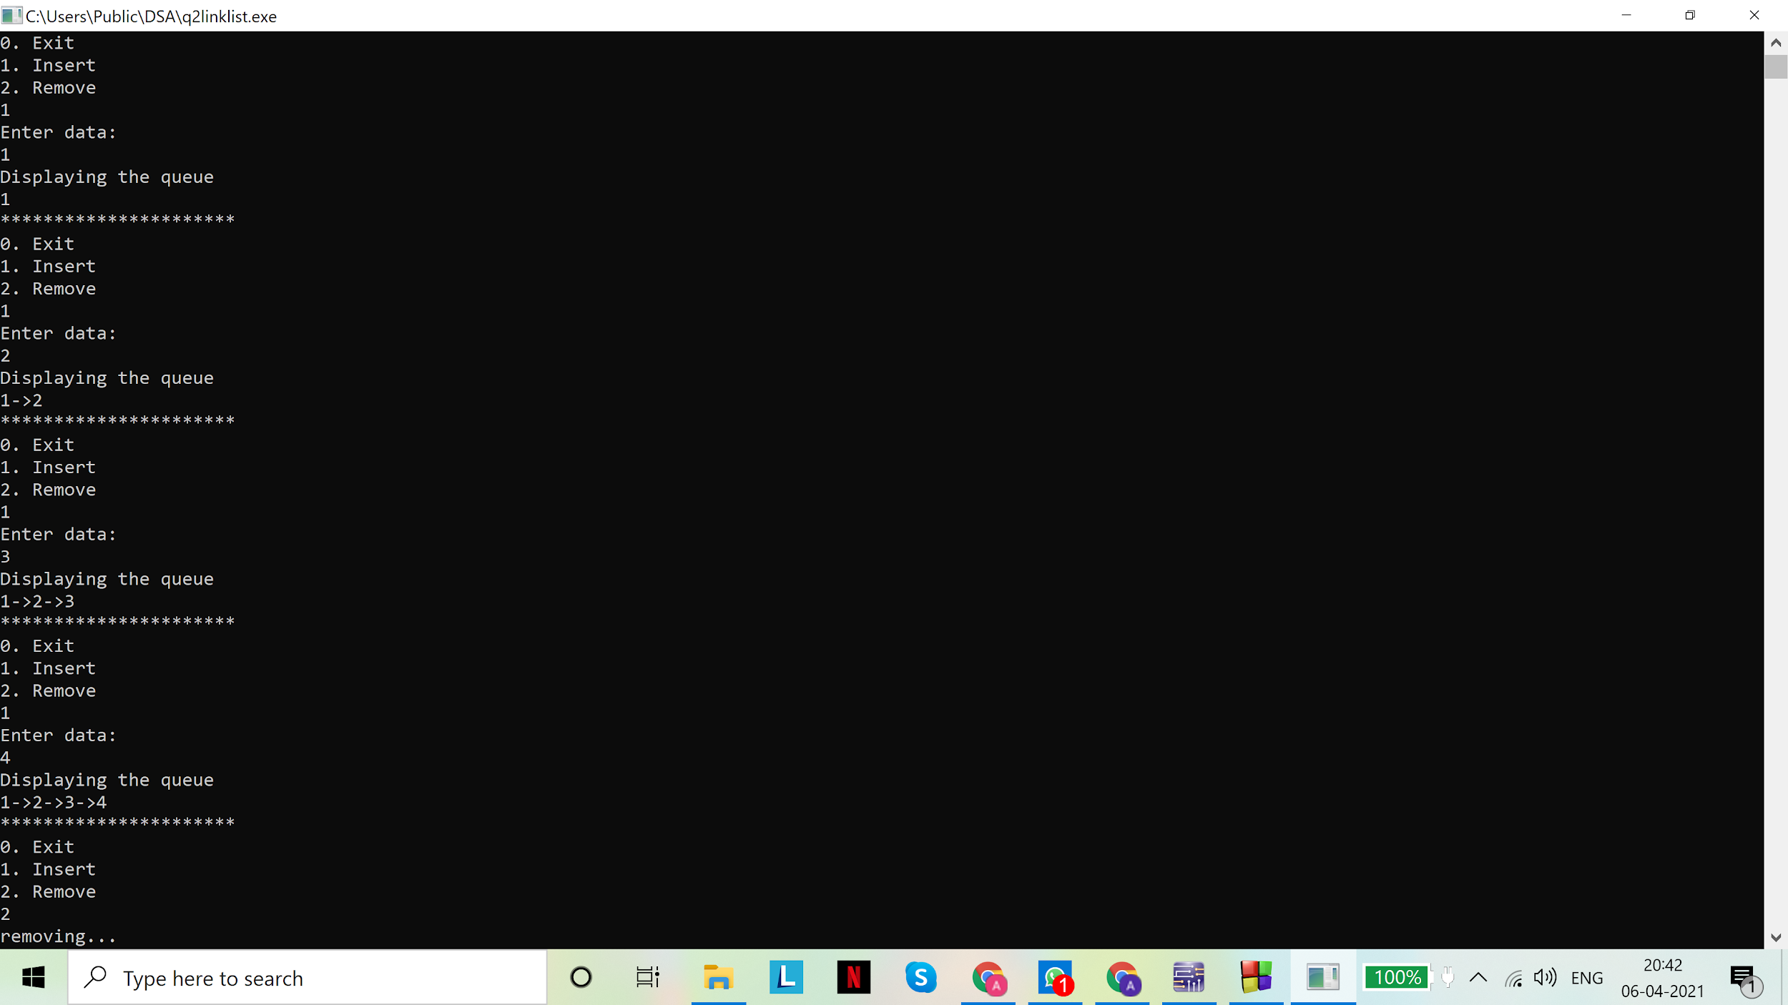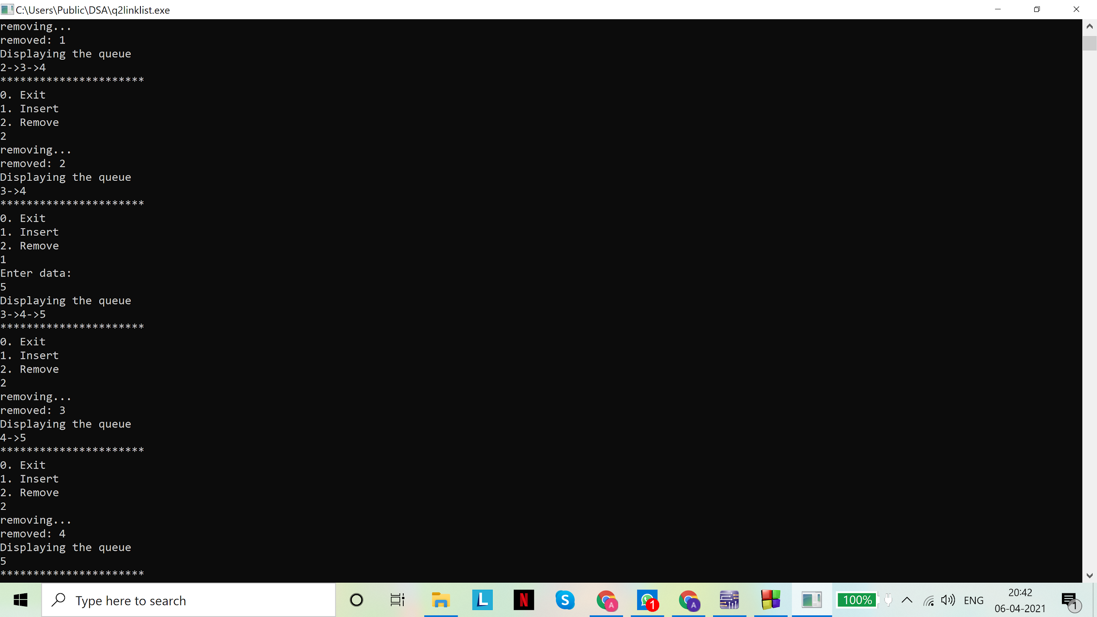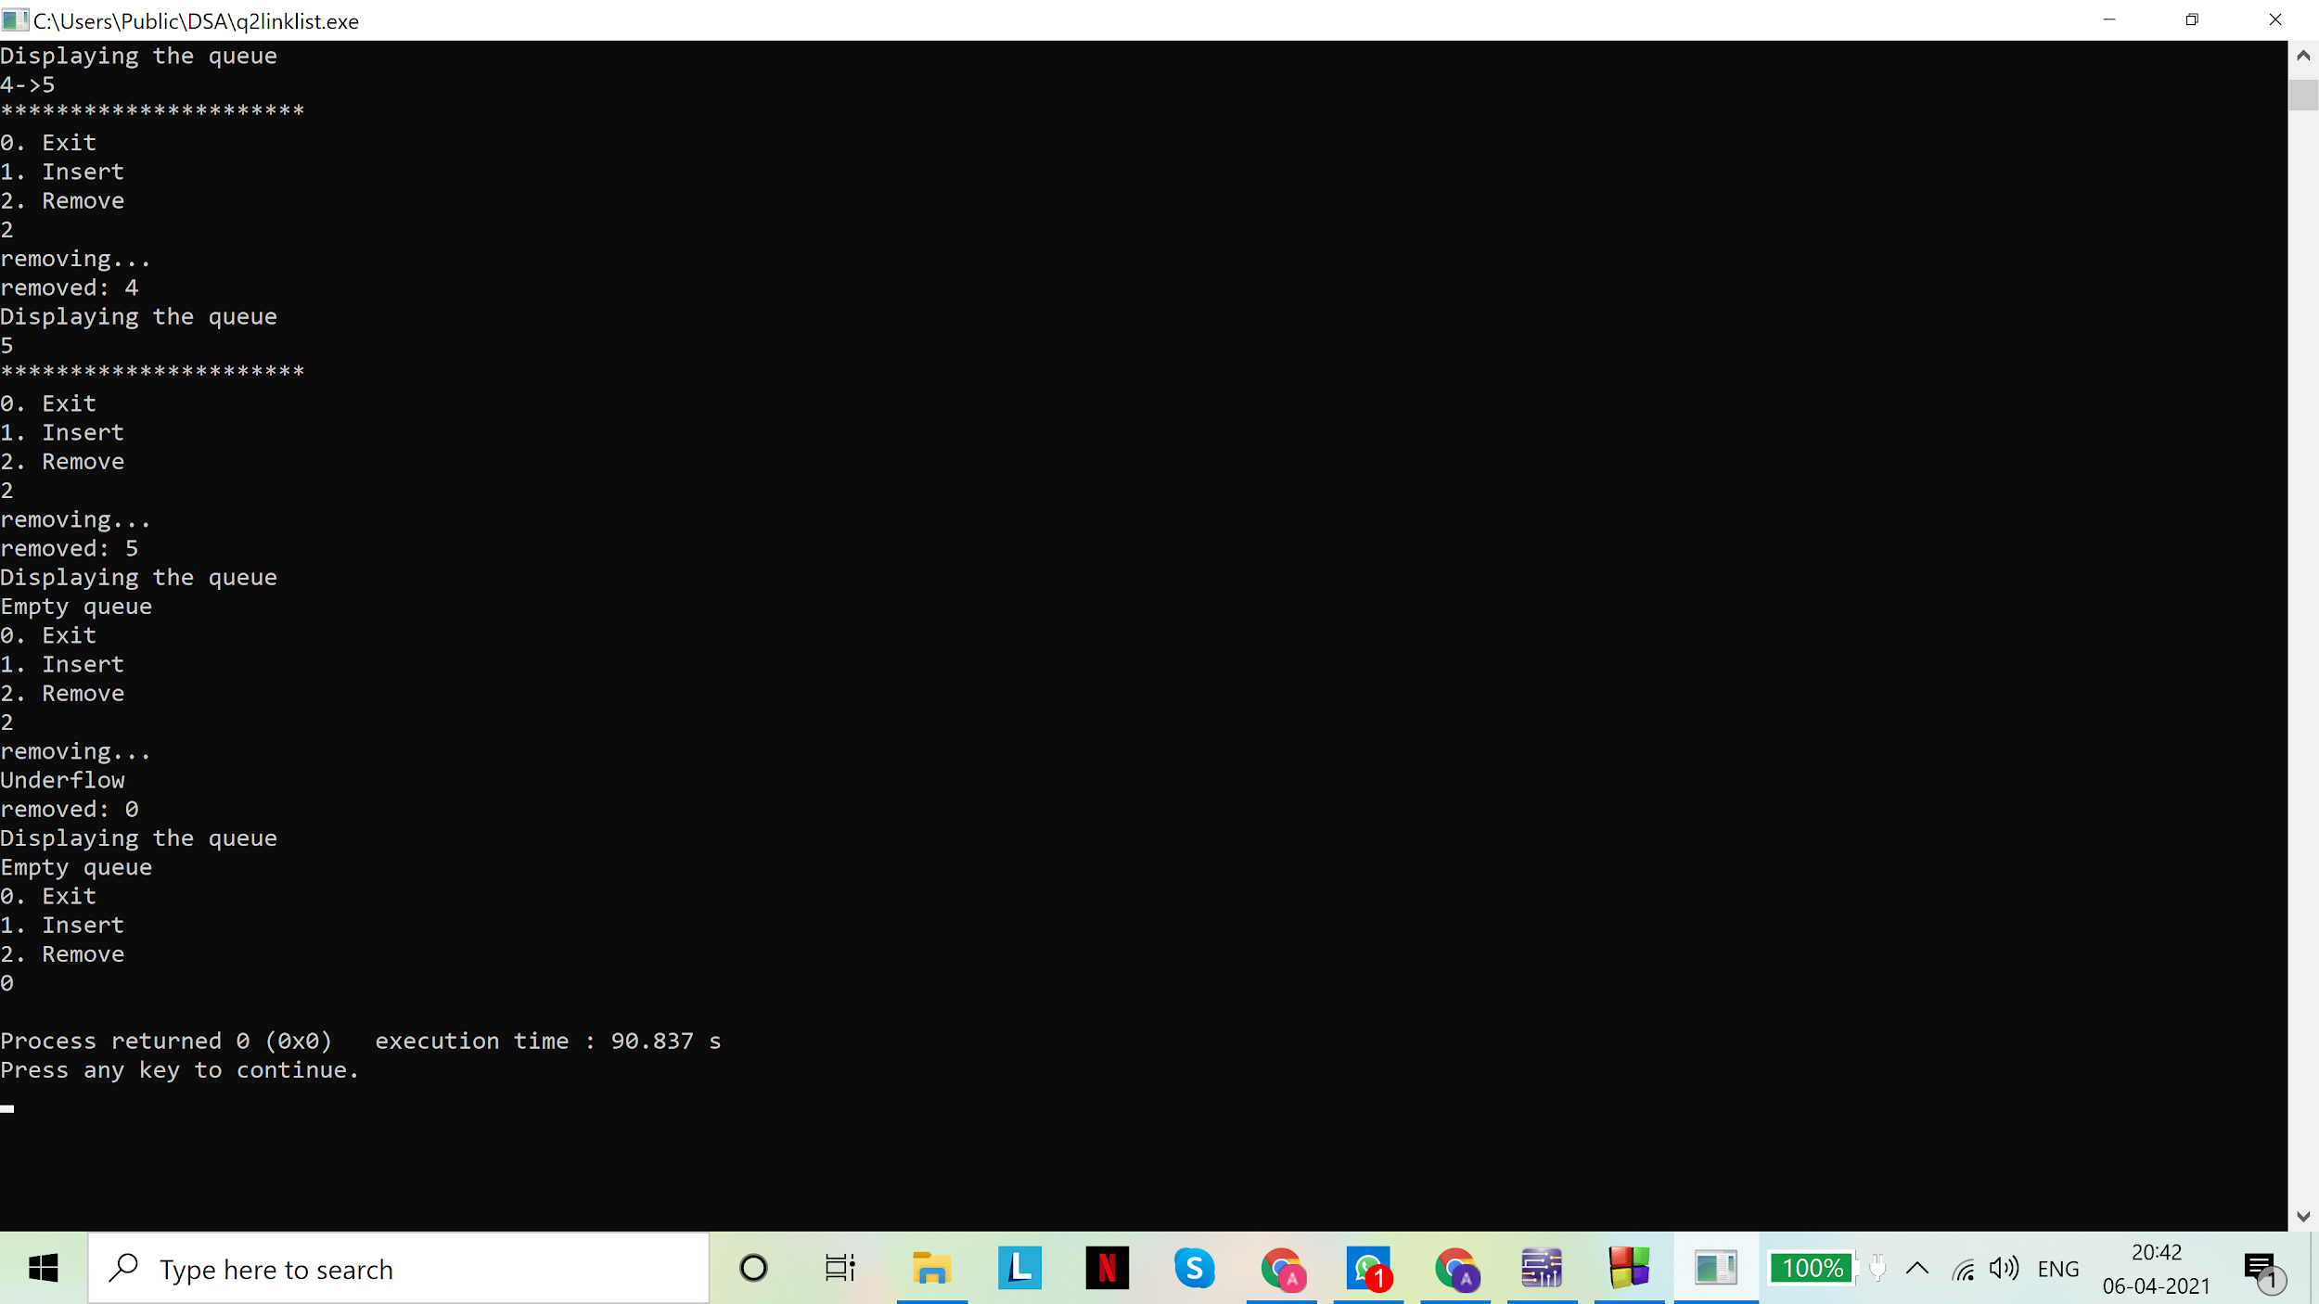

Assignment - 05

1. Implement a circular queue. Demonstrate that problems appearing in a linear queue can be circumvented in a circular queue.
2. Implement a min-priority queue. Your program should contain all the necessary functions like extract_min() and others.

**Solution(s)**

**Code(s): Static implementation of circular queue (array):**

# include <stdio.h>

# include <stdlib.h>

#define MAX 5

//queue

struct Queue{

int items[MAX];

int f,r;

};

typedef struct Queue queue;

//underflow check

int isEmpty(queue *pq){

return (pq->r==pq->f);

}

//to insert a value into the queue

void insert(queue *pq, int d){

//update the rear pointer and then proceed to check for overflow

if (pq->r==MAX-1)

pq->r=0;

else

(pq->r)++;

//static representation of queue: we must check for overflow

if (pq->r==pq->f)//since conditions for underflow and overflow are identical, we deal with it by sarcrifizing one element

{

printf("Queue overflow\n");

//change back the rear pointer if there is overflow

if (pq->r==0)

pq->r=MAX-1;

else

(pq->r)--;

}

else

pq->items[pq->r]=d;

}

//to remove a value from the queue

int rem(queue *pq){

if(isEmpty(pq))

{

printf("Queue underflow\n");

return NULL;

}

else

{

//updating the front pointer. In this implementation, front pointer points to location before the front of the queue

if (pq->f==MAX-1)

pq->f=0;

else

pq->f++;

return (pq->items[pq->f]);

}

}

void main()

{

queue q;

q.f=q.r=MAX-1;

int ch=1,d=0;

char t='a';//temporary variable

while (ch!=0)

{

printf("0. Exit\n");

printf("1. Insert\n");

printf("2. Remove\n");

scanf("%d",&ch);

scanf("%c",&t);

switch(ch){

case 0: continue; break;

case 1: printf("Enter data:\n");

scanf("%d",&d);

scanf("%c",&t);

insert(&q,d);

break;

case 2: printf("removing...\n");

printf("removed: %d\n",rem(&q));

break;

default:printf("Invalid choice\n");break;

};

//displaying the queue

printf("Displaying the queue\n");

printf("\nFront:%d\n",q.f);

printf("Rear:%d\n\n",q.r);

if(isEmpty(&q))

printf("\nEmpty queue\n");

else

{

int i=0;

if (q.f==MAX-1)

i=0;

else

i=q.f+1;

while(i!=q.r)

{

printf("%d ->",q.items[i]);

i++;

if(i==MAX)

i=0;

}

printf("%d\n",q.items[i]);

printf("**********************\n");

}

}

}

**Output(s):**

Comparison of linear and circular implementation of a queue using array (static) :

Linear (code submitted in assignment 4): We observe that overflow may be achieved even when there are empty spaces in the queue, making it inefficient.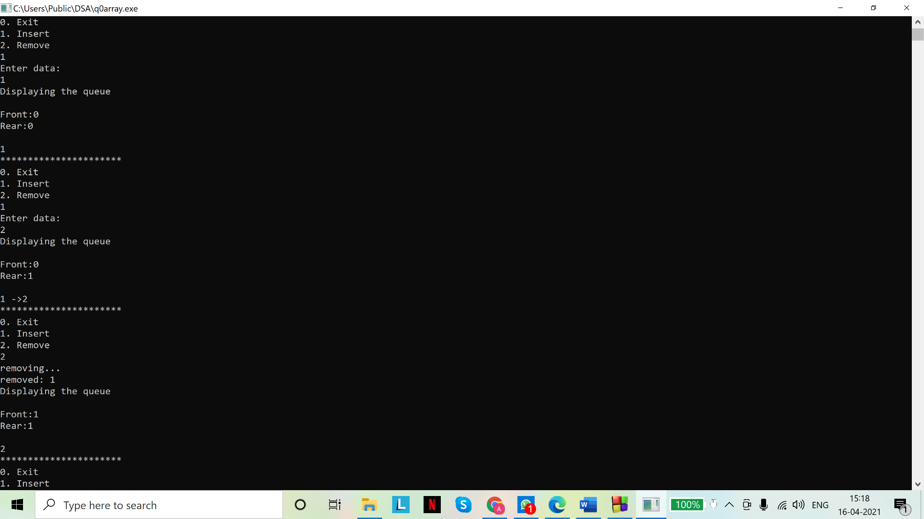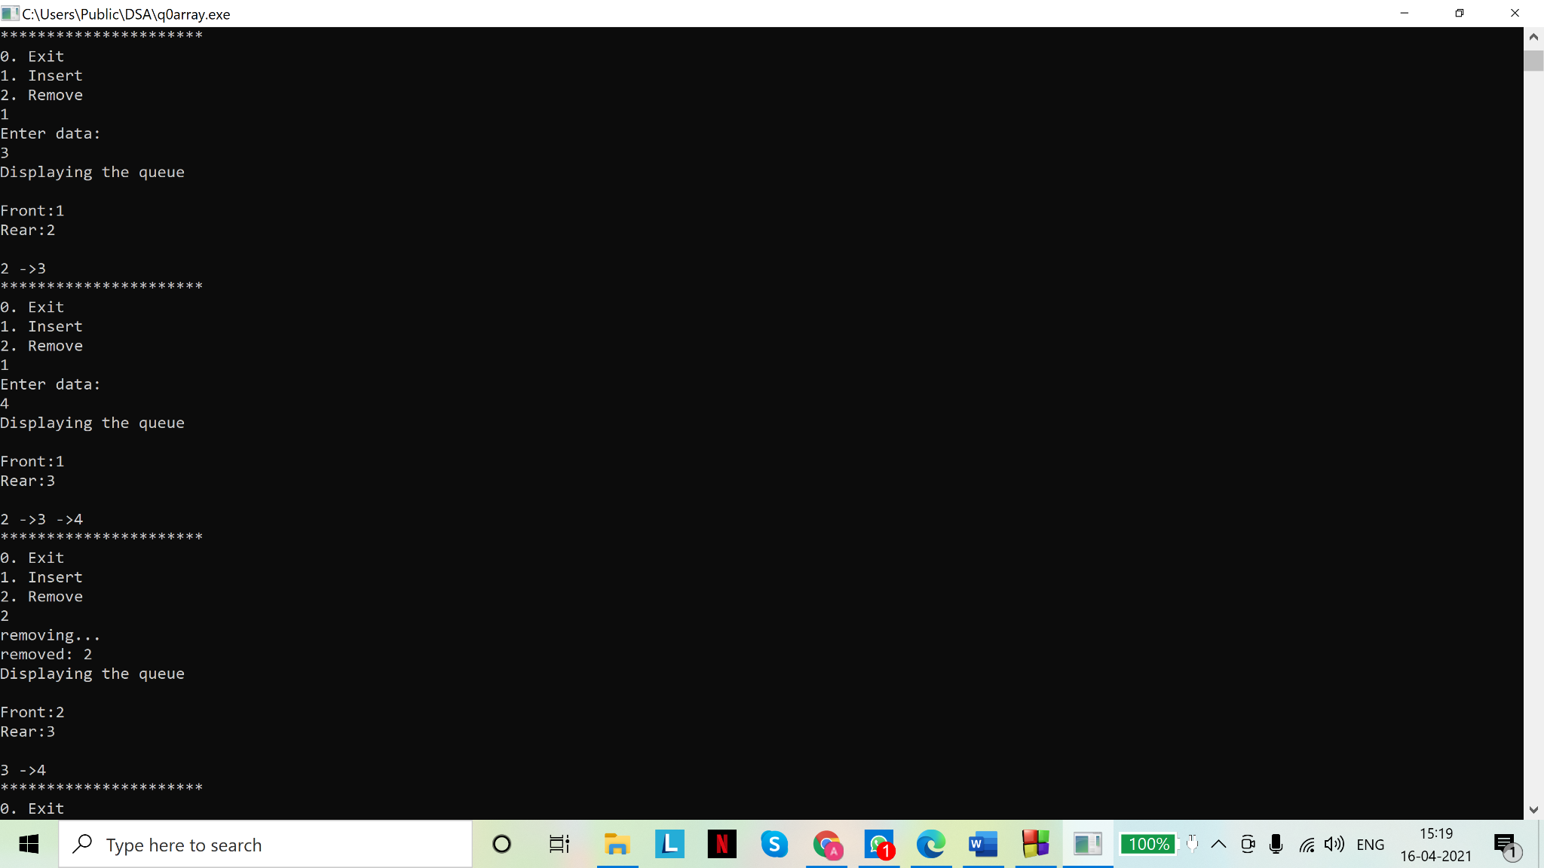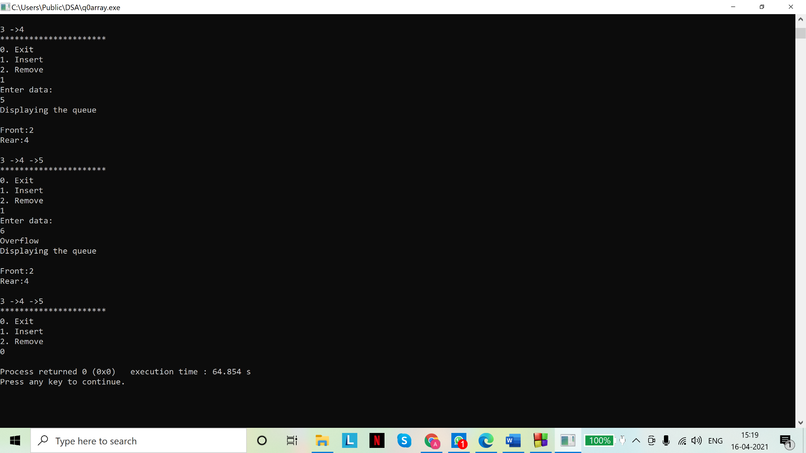

However for the same sequence of events in a circular queue, we have the advantage that all spaces are utilized at maximum capacity, except one space which we leave empty, else the conditions for overflow and underflow are same.

Circular:

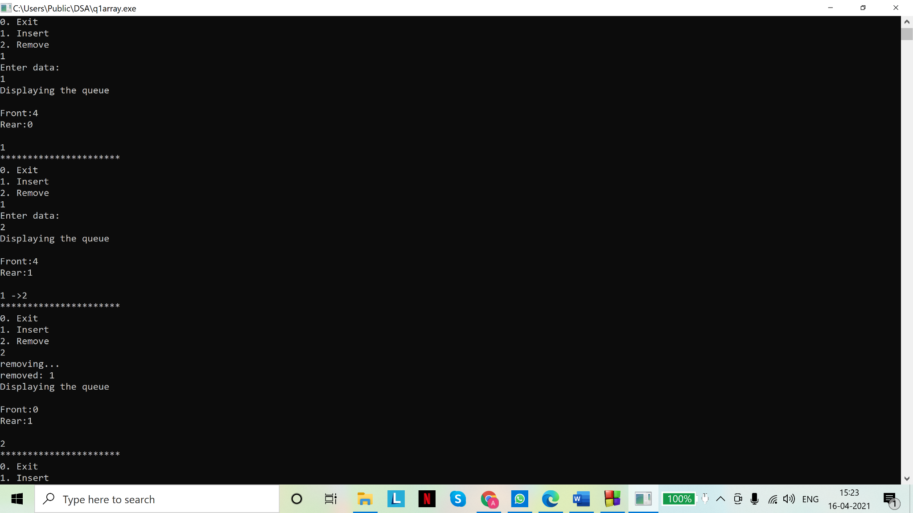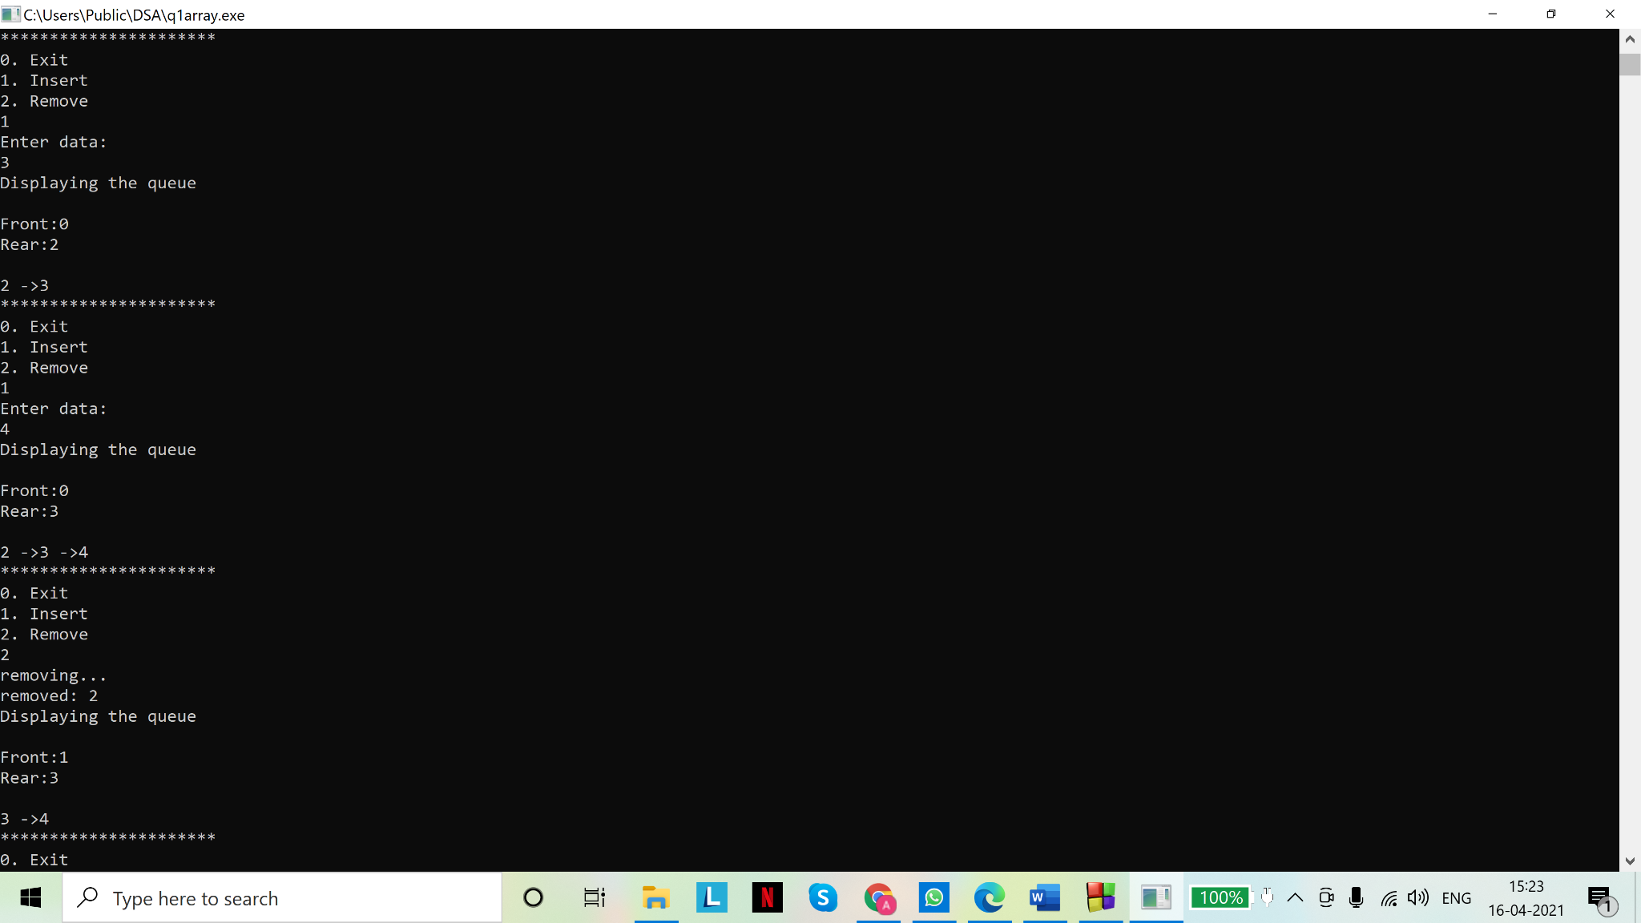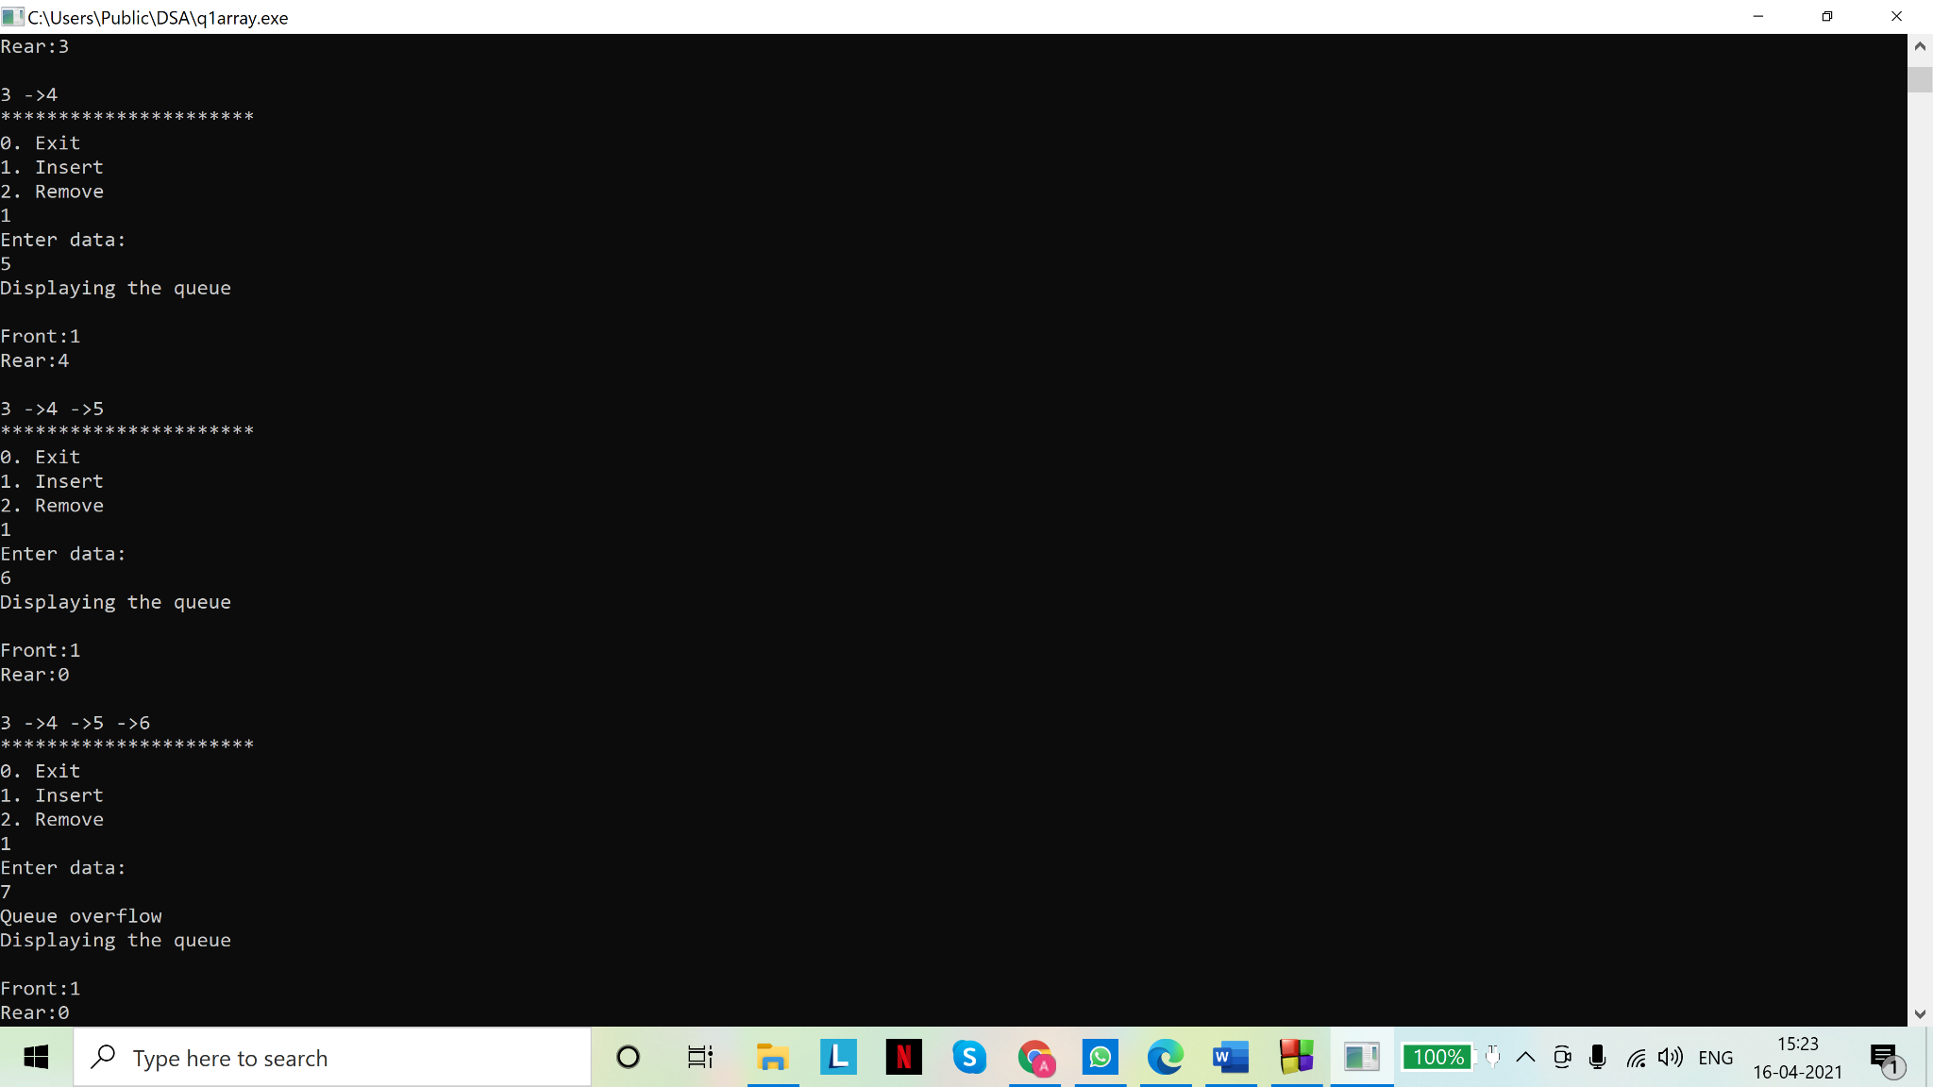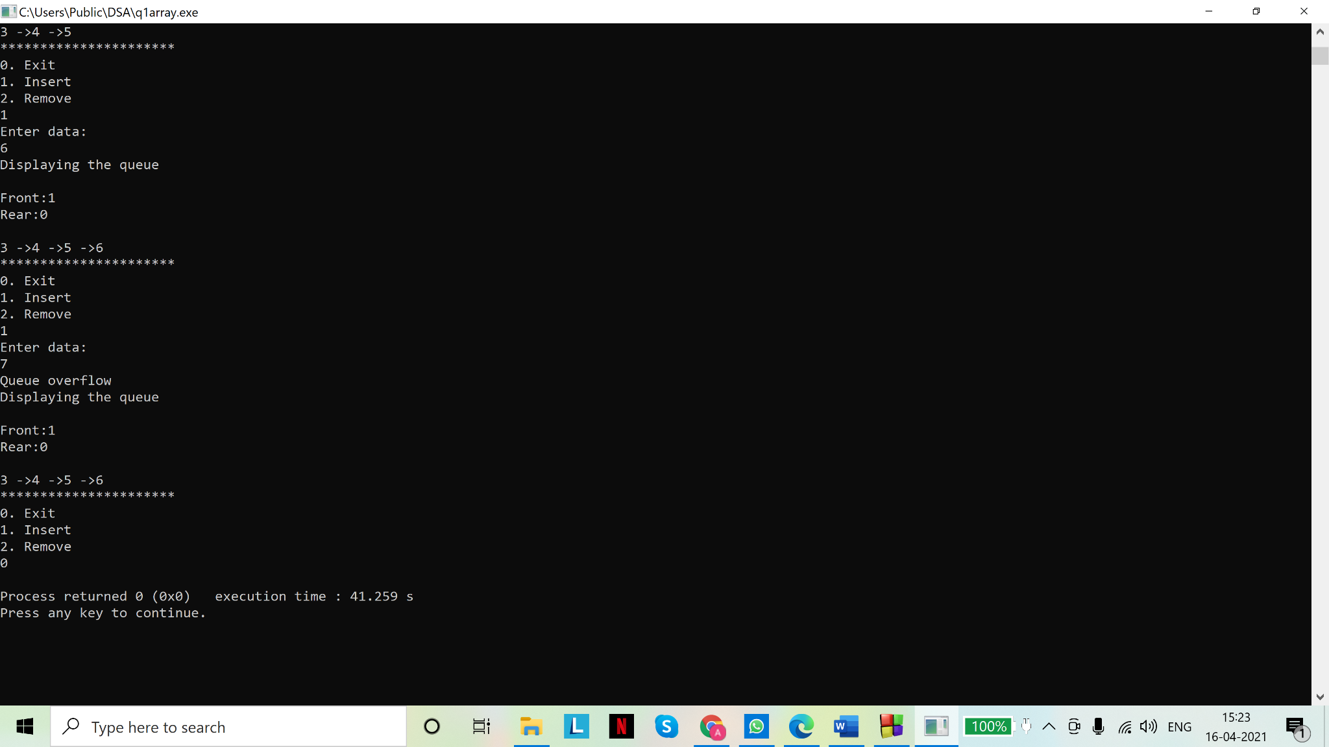

**Code(s): Dynamic implementation of circular queue (linked list)**

# include <stdio.h>

# include <stdlib.h>

//node

struct node{

int data;

struct node *next;

};

typedef struct node snode;

//queue

struct Queue{

snode *f,*r;

};

typedef struct Queue queue;

//underflow check

int isEmpty(queue *pq){

return ((pq->f==NULL)&&(pq->r==NULL));

}

//function for inserting data in queue

void insert(queue *pq,int d){

//dynamic implementation does not require us to check for overflow. This is an advantage over static implementation

snode *s=malloc(sizeof(snode*));//creating a temporary node to link to the queue

s->data=d;

s->next=NULL;

if(isEmpty(pq))

{

pq->r=pq->f=s;

pq->r->next=pq->f;//update rear pointer

}

else

{

pq->r->next=s;

pq->r=s;

pq->r->next=pq->f;//update rear pointer

}

}

//function for removing data from queue

int rem(queue *pq){

//underflow check

if (isEmpty(pq))

{

printf("Underflow\n");

return NULL;

}

else

{

int d=pq->f->data;

if(pq->f->next==pq->f)/*if front node pointer points to itself, queue must be empty after this function is executed.

Set both pointers to NULL to denote empty queue. This condition is different from the one seen in linear queue.*/

pq->r=pq->f=NULL;

else

{

snode *s=pq->f;

pq->f=pq->f->next;

pq->r->next=pq->f;//update rear pointer

free(s);//freeing the memory

}

return d;

}

}

//main for function calls

void main()

{

queue q;//declare a variable of queue type

q.f=q.r=NULL;//initialize pointers

int ch=1,d=0;

char t='a';//temporary variable

while (ch!=0)

{

printf("0. Exit\n");

printf("1. Insert\n");

printf("2. Remove\n");

scanf("%d",&ch);

scanf("%c",&t);

switch(ch){

case 0: continue; break;

case 1: printf("Enter data:\n");

scanf("%d",&d);

scanf("%c",&t);

insert(&q,d);

break;

case 2: printf("removing...\n");

printf("removed: %d\n",rem(&q));

break;

default:printf("Invalid choice\n");break;

};

//displaying the queue

printf("Displaying the queue\n");

if(isEmpty(&q))

printf("Empty queue\n");

else

{

snode *s=q.f;

while (s!=q.r)

{

printf("%d->",s->data);

s=s->next;

}

printf("%d\n",q.r->data);

}

printf("**********************\n");

}

}

**Output(s):**

In linked list implementation of queue, the circular and linear queue don’t have any observable difference, except that the rear node pointer points to the front node, instead of NULL.

Dynamic implementation of circular queue: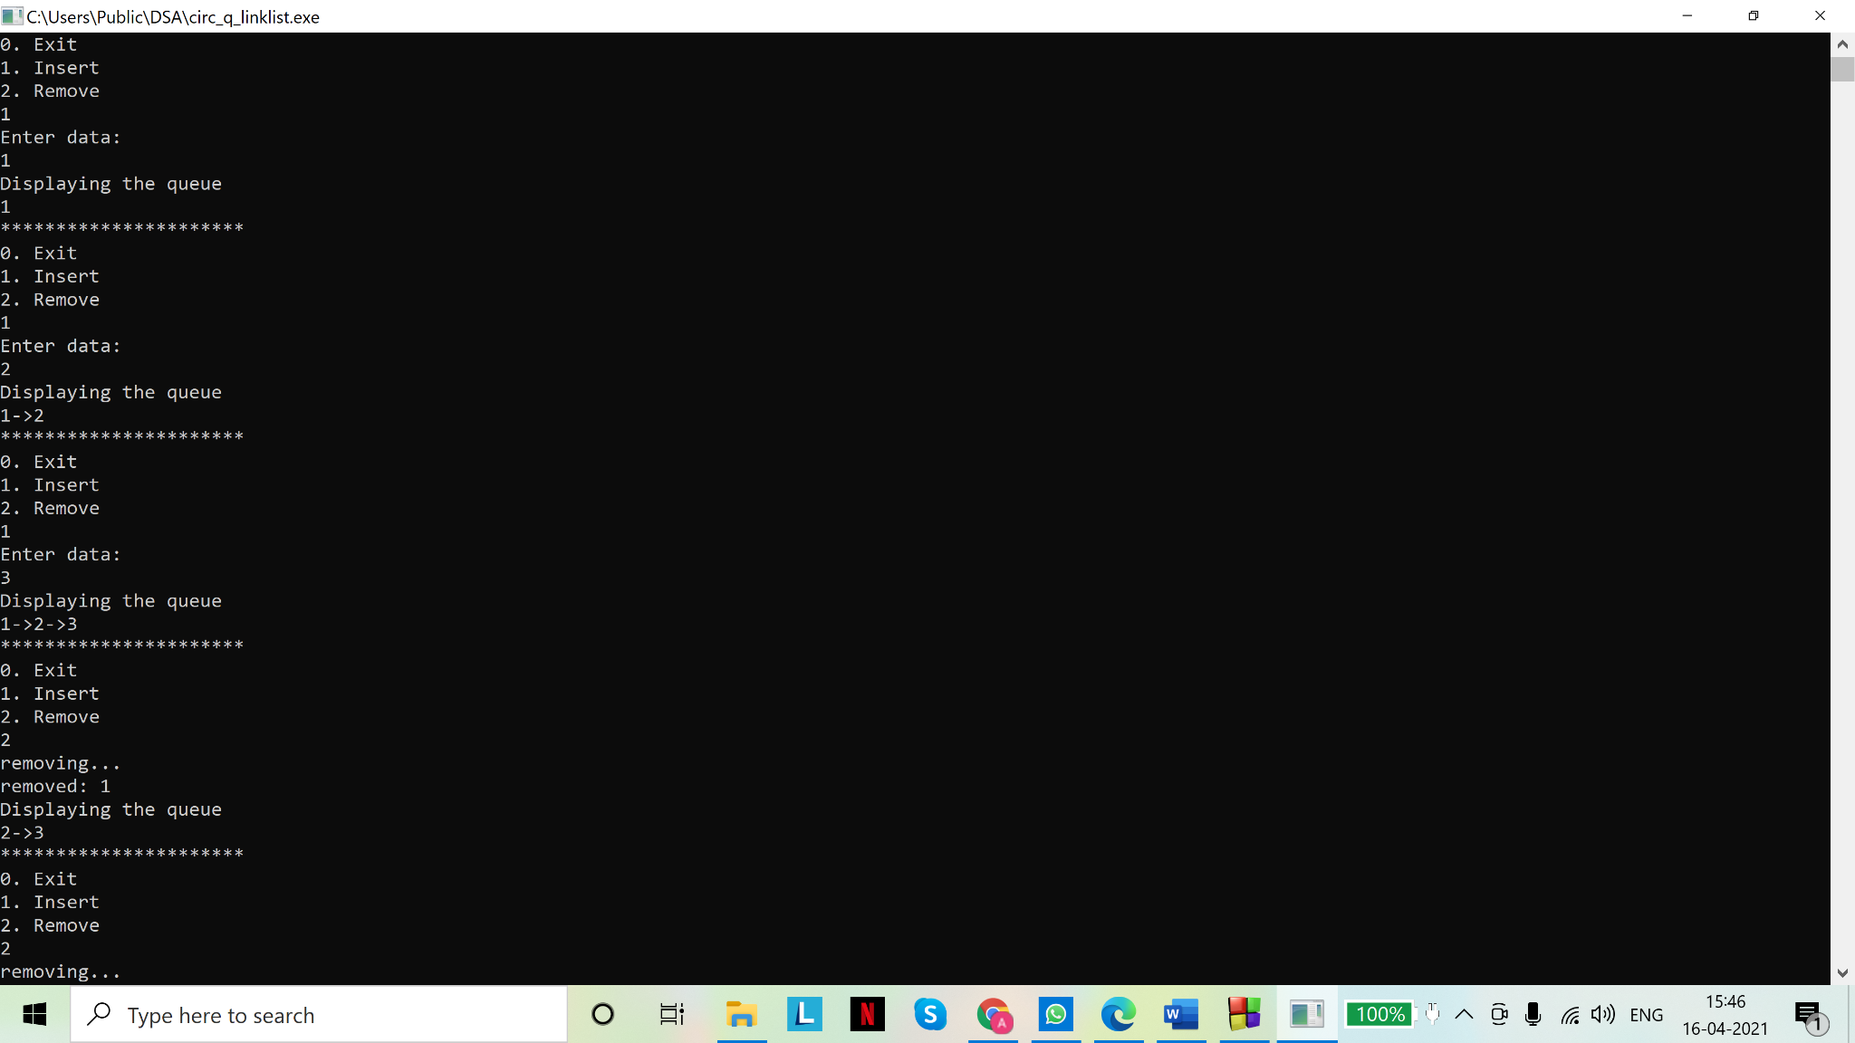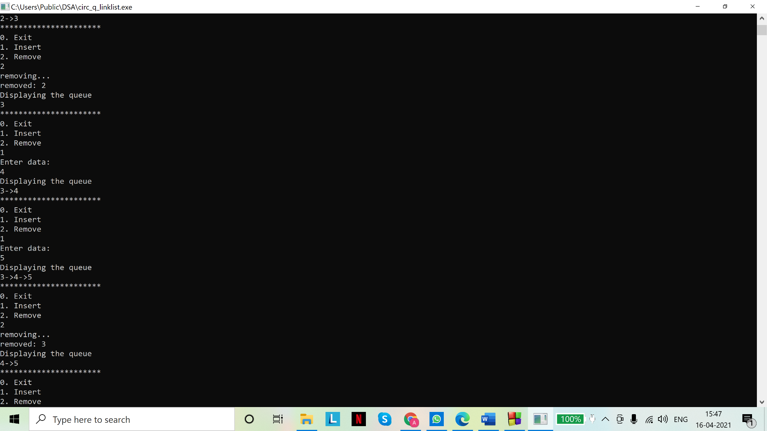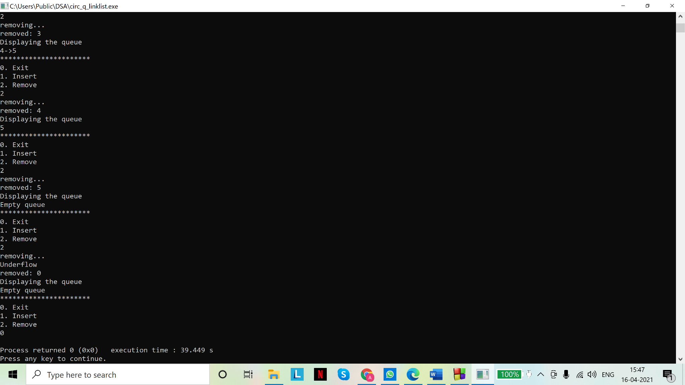

**Code(s): Minimum priority queue: Static (array)**

# include <stdio.h>

# include <stdlib.h>

#define MAX 5

//queue

struct Queue{

int items[MAX];

int f,r;

};

typedef struct Queue queue;

//underflow check

int isEmpty(queue *pq){

return (pq->r<pq->f);

}

//to obtain index of minimum element of queue

int peek(queue *pq){

if (isEmpty(pq))

{

printf("Underflow\n");

return NULL;

}

else

{

int minm=pq->items[pq->f];//initialise variable to determine minimum element of a queue

int idx=pq->f;//to hold the index of minimum element in queue

//to find location of minimum element by scanning the queue: complexity= O(n)

for(int i=pq->f;i<=pq->r;i++){

if(pq->items[i]<minm)

{

minm=pq->items[i];

idx=i;

}

}

return idx;

}

}

//function for inserting data in queue

void insert(queue *pq, int d){

if (pq->r==MAX-1)//static implementation: overflow check

printf("Overflow\n");

else

pq->items[++(pq->r)]=d;

}

//function for removing data from queue

int rem(queue *pq){

if(isEmpty(pq))

{

printf("Queue underflow\n");

return NULL;

}

else

{

int idx=peek(pq);//index of minimum element

int minm=pq->items[idx];

for(int i=idx;i>pq->f;i--)//shifting elements: complexity: O(n)

{

pq->items[i]=pq->items[i-1];

}

(pq->f)++;//update front pointer

return minm;

}

}

//main for function calls

void main()

{

queue q;

q.f=0;

q.r=-1;

int ch=1,d=0;

char t='a';//temporary variable

while (ch!=0)

{

printf("0. Exit\n");

printf("1. Insert\n");

printf("2. Remove\n");

scanf("%d",&ch);

scanf("%c",&t);

switch(ch){

case 0: continue; break;

case 1: printf("Enter data:\n");

scanf("%d",&d);

scanf("%c",&t);

insert(&q,d);

break;

case 2: printf("removing...\n");

printf("removed: %d\n",rem(&q));

break;

default:printf("Invalid choice\n");break;

};

//displaying the queue

printf("Displaying the queue\n");

if(isEmpty(&q))

printf("Empty queue\n");

else

{

int i=0;

for( i=q.f;i<q.r;i++)

{

if(i==MAX)

i=0;

printf("%d ->",q.items[i]);

}

printf("%d\n",q.items[i]);

}

printf("**********************\n");

}

}

**Output(s):**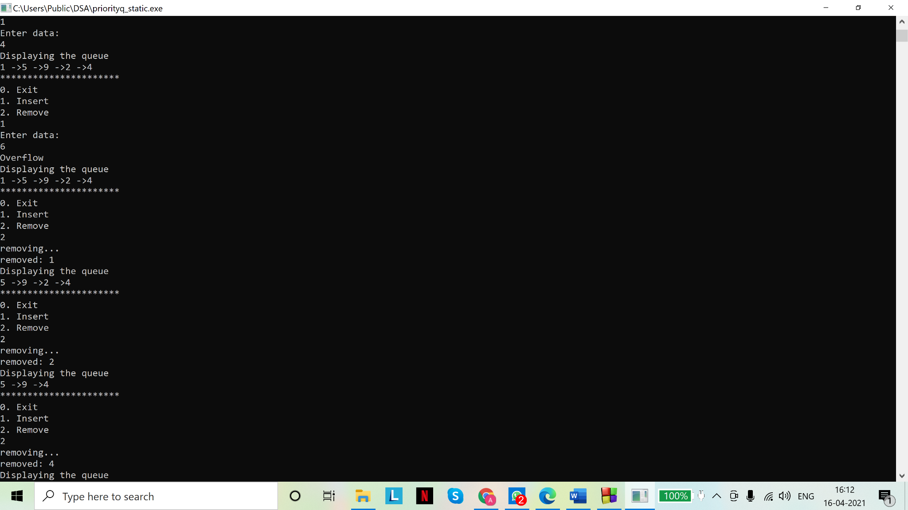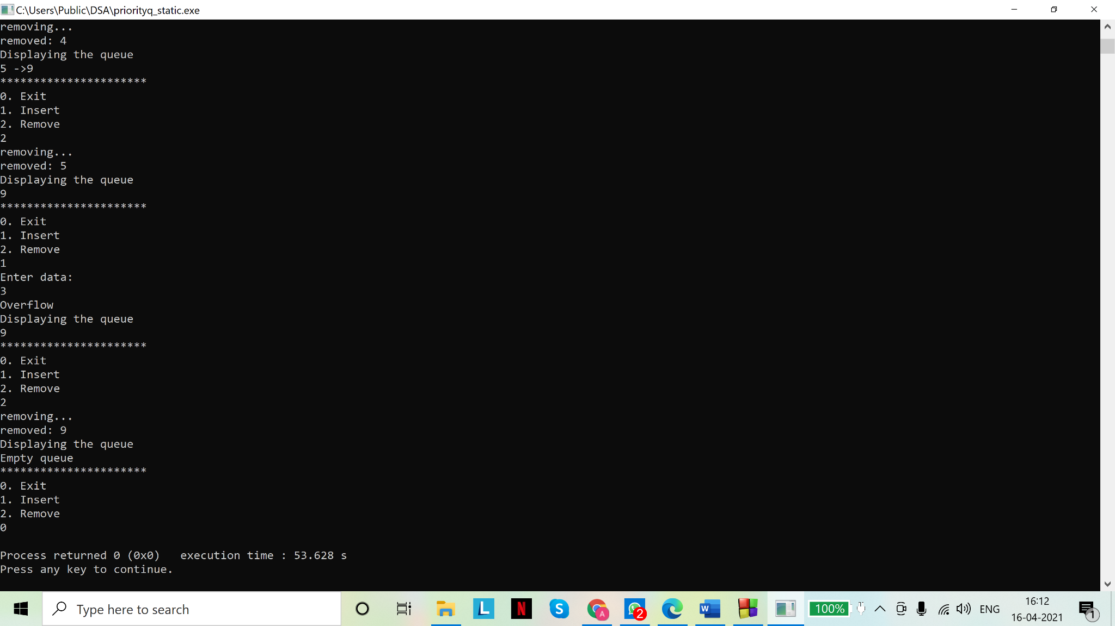

**Code(s): Minimum priority queue: Dynamic (linked list)**

# include <stdio.h>

# include <stdlib.h>

//node

struct node{

int data;

struct node *next;

};

typedef struct node snode;

//queue

struct Queue{

snode *f,*r;

};

typedef struct Queue queue;

int isEmpty(queue *pq){

return ((pq->f==NULL)&&(pq->r==NULL));

}

//function for inserting data in queue: same as linear queue

void insert(queue *pq,int d){

snode *s=malloc(sizeof(snode*));//creating a temporary node to link to the queue

s->data=d;

s->next=NULL;

if(isEmpty(pq))

pq->r=pq->f=s;

else

{

pq->r->next=s;

pq->r=pq->r->next;//update rear pointer

}

}

snode* peek(queue *pq)//returns pointer to minimum element of queue

{

if (isEmpty(pq))

{

printf("Underflow\n");

return NULL;

}

else

{

int minm=pq->f->data;//initialise variable to determine minimum element of a queue

snode *s=pq->f;//node pointer to traverse the queue

snode *p=s;//to hold the location of minimum element in queue

//to find location of minimum element by scanning the queue: complexity= O(n)

while(s!=NULL){

if(s->data<minm)//new minimum was found

{

//update

minm=s->data;

p=s;

}

s=s->next;//update

}

return p;

}

}

//function for removing data from queue: violates FIFO property of linear queue as it removes elements on basis of priority

int rem(queue *pq){

//underflow check

if (isEmpty(pq))

{

printf("Underflow\n");

return NULL;

}

else

{

snode *p=peek(pq);

int minm=p->data;

snode *s=pq->f;// for traversing the queue

//to delete minimum element found in last step: complexity= O(n)

//traversing the queue

if(s==p)//first element of queue is the minimum element

{

pq->f=pq->f->next;//update the front pointer

}

else if(p==pq->r)//last element of queue is minimum element

{

while(s->next!=p)

{

s=s->next;

}

pq->r=s;//update rear pointer

s->next=NULL;

}

else

{

while(s->next!=p)

{

s=s->next;

}

s->next=s->next->next;//updating the queue

}

if(pq->f==NULL)/*if front pointer is null, front has passed the rear pointer and

queue must be empty, so we set rear to NULL*/

pq->r=NULL;

free(p);//freeing the memory

return minm;

}

}

//main for function calls

void main()

{

queue q;//declare a variable of queue type

q.f=q.r=NULL;//initialize pointers

int ch=1,d=0;

char t='a';//temporary variable

while (ch!=0)

{

printf("0. Exit\n");

printf("1. Insert\n");

printf("2. Remove\n");

scanf("%d",&ch);

scanf("%c",&t);

switch(ch){

case 0: continue; break;

case 1: printf("Enter data:\n");

scanf("%d",&d);

scanf("%c",&t);

insert(&q,d);

break;

case 2: printf("removing...\n");

printf("removed: %d\n",rem(&q));

break;

default:printf("Invalid choice\n");break;

};

//displaying the queue

printf("Displaying the queue\n");

if(isEmpty(&q))

printf("Empty queue\n");

else

{

snode *s=q.f;

while (s!=q.r)

{

printf("%d->",s->data);

s=s->next;

}

printf("%d\n",q.r->data);

}

printf("**********************\n");

}

}

**Output(s):**

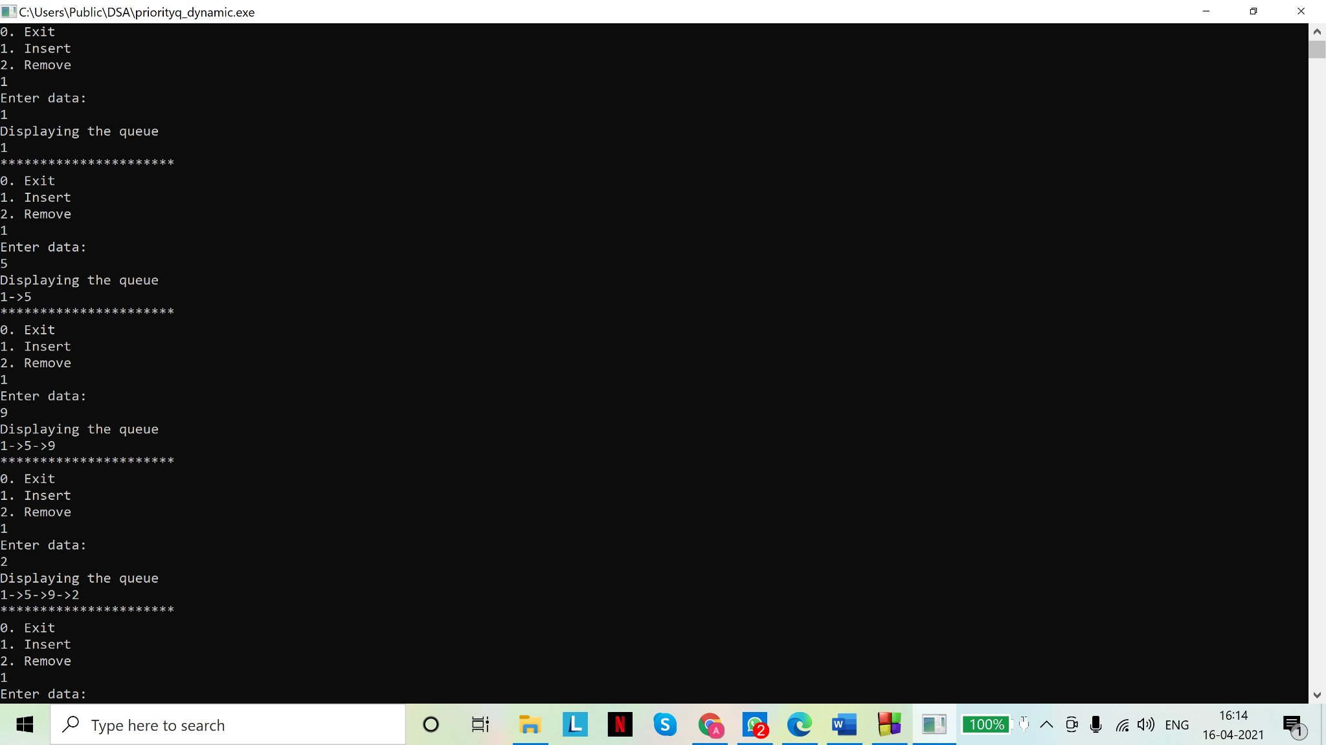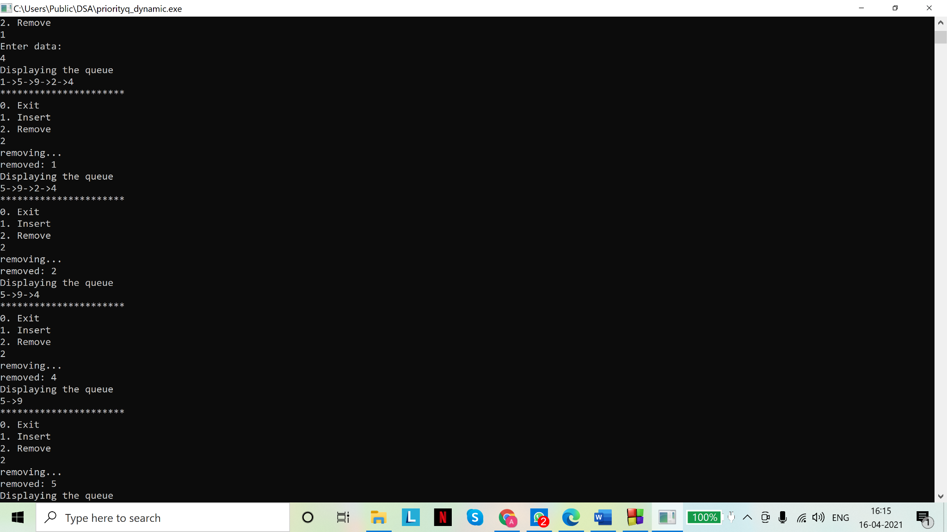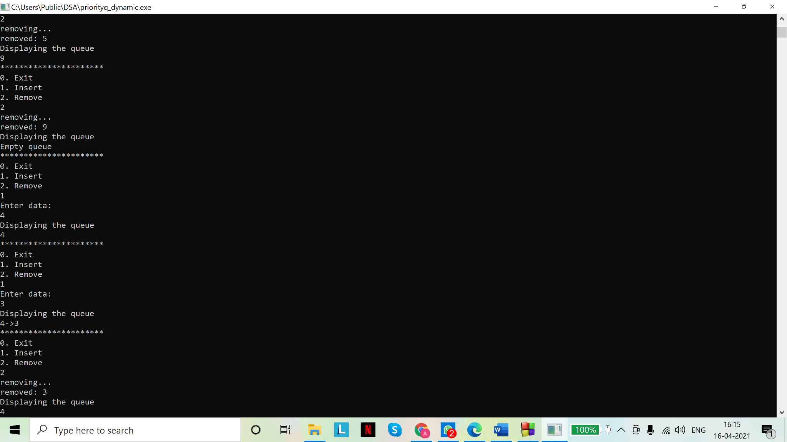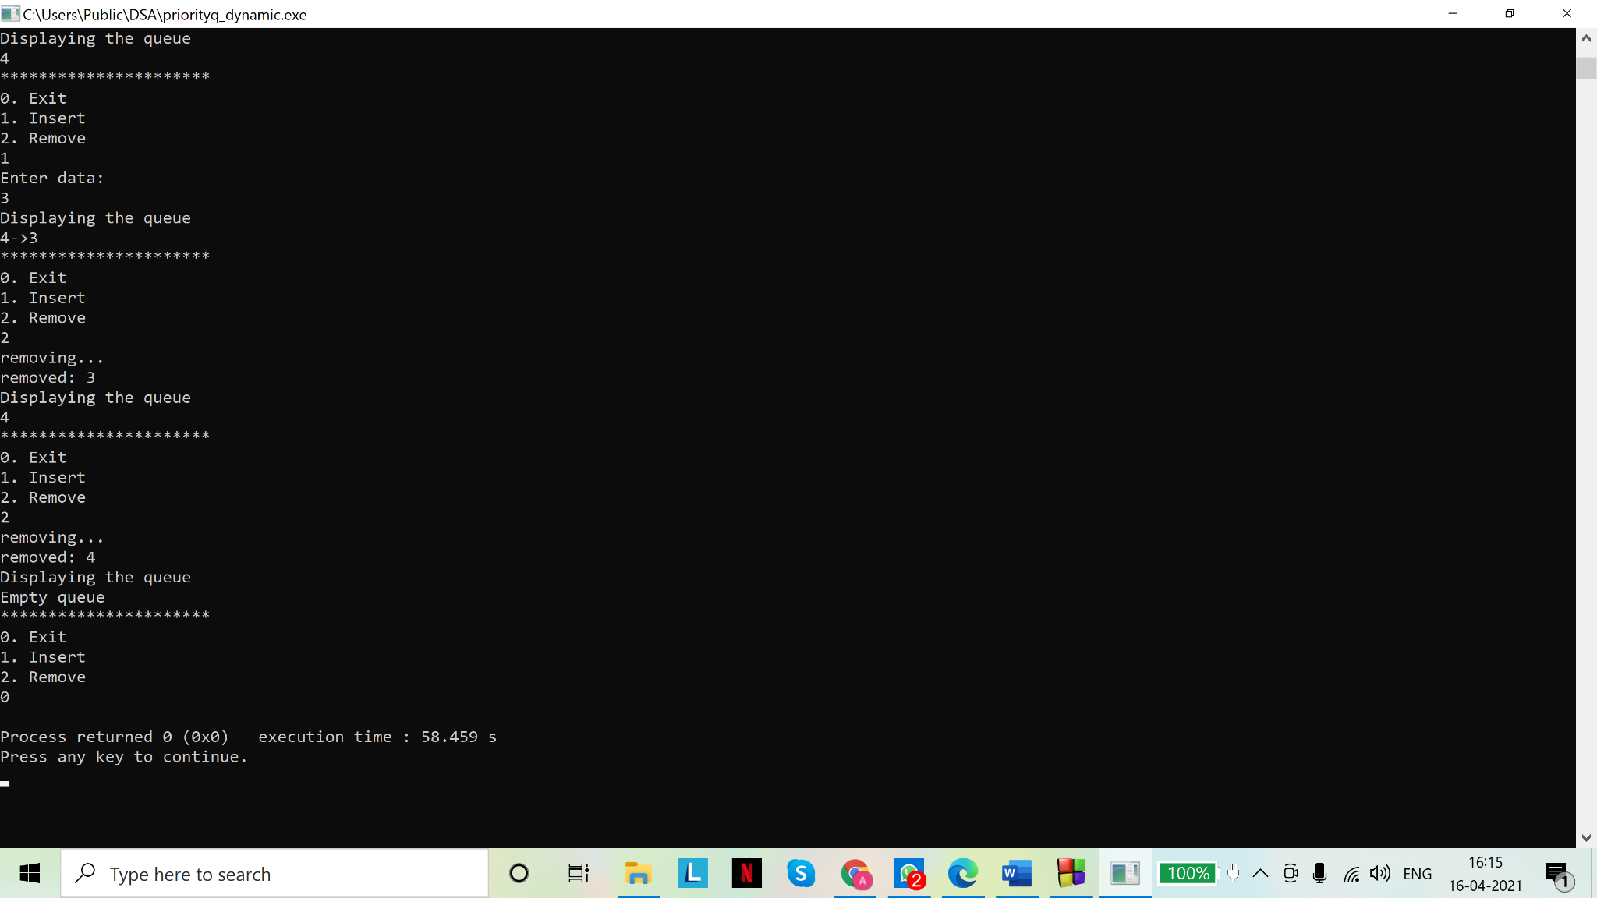

Assignment - 06

1. Compare the performance of following five sorting algorithms on different sets of data:

Bubble Sort, Quick Sort, Selection Sort Insertion Sort, Merge Sort

By different sets of data we mean i) completely unsorted dataset, ii) nearly sorted data etc.

1. Compare the performance of linear search and binary search algorithms
2. Solution(s)

Code(s):

# include <stdio.h>

# include <stdlib.h>

#include <time.h>

//bubble sort

void bubble_sort(int *arr,int n)

{

/*

Bubble sort: larger elements "bubble" to the top for each pass through the array

Time complexity (worst case): O(n^2) [worst case: array sorted in reverse order]

Best case: O(n) [array is already sorted]

*/

int t=0;//swapping variable

for(int i=0;i<n-1;i++)//outer loop for number of passes

{

for(int j=0;j<n-i-1;j++)//inner loop for comparisons in each pass

{

if(arr[j]>arr[j+1])//swap so that the larger element can 'bubble' to the top

{

t=arr[j];

arr[j]=arr[j+1];

arr[j+1]=t;

}

}

//at the end of each pass, the (n-i-1)th and higher locations hold the correct elements for final sorted array

}

}

//end of bubble sort

//selection sort

void selection_sort(int *arr,int n)

{

/*

Selection sort: for each pass, finds the next minimum element and places it in correct position. One swap per pass.

Time complexity (all cases): O(n^2)

*/

int t=0;//swapping variable

int min=arr[0],p=0;

for(int i=0;i<n-1;i++)//outer loop for number of passes

{

min=arr[i];//present minimum

p=i;//position of minimum

for(int j=i+1;j<n;j++)//inner loop to find the minimum element in the unsorted (i+1 to n-1) portion of the array

{

if(arr[j]<min)//comparison, but no swapping until the inner loop completes its iterations

{

//reassign minimum element to new minimum and note it's position for swapping

min=arr[j];

p=j;

}

}

//swap once per iteration

t=arr[i];

arr[i]=arr[p];

arr[p]=t;

//at the end of (i)th iteration, the sub-array from index 0 to index i is sorted

}

}

//end of selection sort

//insertion sort

void insert_sort(int *arr,int n)

{

/*

Insertion sort: a portion of the array is sorted at each iteration and compared against the next item in the array which

is inserted at the correct position in the sub-array at the end of each iteration

Time complexity (worst/average cases): O(n^2)

Best case: O(n) [array is already sorted]

*/

int t=0;//swap variable

int p=0;

for(int i=0;i<n-1;i++)//outer loop for number of passes; i represents length of sorted sublist

{

t=arr[i+1];// element to be compared against every element of the sublist

p=i+1;//to keep track of the position where (i+1)th element will be inserted in the sorted sub-array to maintain sorted

//property while increasing length of sub-array by 1 per pass

for(int j=0;j<=i;j++)//checking against sublist elements

{

if(t<arr[j])//insertion location found

{

p=j;

break;

}

}

//shifting the higher elements to the right by one position to accommodate the (i+1)th element

for(int k=i+1;k>p;k--)

{

arr[k]=arr[k-1];

}

arr[p]=t;

//at the end of (i)th iteration we have a sorted sub-array in the front of the array

//however, unlike selection sort and bubble sort, the positions of elements in the sorted sub-array are not

//necessarily their final positions in the sorted array

}

}

//end of insertion sort

//quick sort

void quick_sort(int *arr,int l, int h)//divide and conquer

{

/*

Quick sort: picks an element as pivot and partitions the given array around the picked pivot

Recursively sorts the remaining portions to the left and right of the pivot element until the entire array is sorted

Time complexity (best/average cases): O(nlog(n))

Worst case: O(n) [all elements are equal]

*/

if (l<h)//there remains some portion of the array to sort [lower bound of portion to be sorted<upper bound]

{

int pi=part(arr,l,h);//index of the pivot element

//after part() is called, the pivot element is at its correct location in the final sorted array

//the portion of the array above and below pivot (at index pi) remain to be sorted

quick_sort(arr,l,(pi-1));//recursive call on lower part

quick_sort(arr,(pi+1),h);//recursive call on upper part

}

//base case: array has been sorted. No statements to execute in this case

}

//function to place the pivot index in the correct position and return it's index

int part(int *arr, int l, int h)

{

int pivot, down, up, t=0;

pivot=arr[l];//pivot set to element at beginning position of sub-array

down=l;//left marker

up=h;//right marker

while(down<up)//while left marker and right markers do not cross

//crossing of markers indicates that the higher elements have already been shifted to the right and lower ones to the left

//of final pivot index. A final swap remains between pivot and element at index 'up'

{

while(down<h && arr[down]<=pivot)

//sub-array from (l+1) to h is scanned sequentially to locate an element > pivot

//this element being > pivot must be to the right of pivot

down++;

while (arr[up]>pivot)

//sub-array from h to (l+1) is scanned sequentially (reverse direction) to locate an element < pivot

//this element being < pivot must be to the left of pivot

up--;

//swapping the next higher and lower elements found by searching the sub-array sequentially

if (down<up)//swap only if the markers have not crossed

{

t=arr[down];

arr[down]=arr[up];

arr[up]=t;

}

}

//while loop is terminated when markers have crossed. a final swap places pivot at proper location in array

arr[l]=arr[up];

arr[up]=pivot;

//pivot index to be returned to calling function

return up;

}

//end of quick sort

//merge sort

void merge_sort(int *arr,int l, int r)//divide and conquer

{

/*

Merge sort: splits the array in 2 parts recursively until sub-arrays of length 1 are obtained. Then "builds back"

the final sorted array piece by piece, by comparing the elements of the arrays

splits the input array into two halves, calls itself for the two halves, and then merges the two sorted halves.

The merge() function is used for merging two halves.

Time complexity (all cases): O(nlog(n))

*/

if (r>l)//there remains some portion of the array to sort [lower bound of portion to be sorted<upper bound]

{

int m=(l+r)/2;//split at the middle

merge_sort(arr,l,m);//recursive call to sort the left half

merge_sort(arr,m+1,r);//recursive call to sort the right half

merge(arr, l, r);//to combine two sorted halves

}

//base case: array has been sorted. No statements to execute in this case

}

void merge(int *arr, int l, int r)//to merge the 2 sorted halves of the array

{

int m=(l+r)/2;//the mid point need not be passed explicitly and can be determined from the lower and upper bounds

//we assume the sub-arrays from (l to m) and (m+1 to r) are sorted

//they must be combined to produce a sorted sub-array from (l to r)

int nl= m-l+1;//length of left temporary array

int nr= r-m;//length of right temporary array

int i,j;//indices for scanning the temporary arrays

//arrays to copy the elements of arr

int L[nl], R[nr];

//copying

for(i=0;i<nl;i++)

{

L[i]=arr[i+l];

}

for(j=0;j<nr;j++)

{

R[j]=arr[j+m+1];

}

//merging

i=0;//initial index of left array

j=0;//initial index of right array

int k=l;//initial index of arr

while(i<nl && j<nr)//if either temporary array is exhausted, while loop must be terminated as array index will

//be out of bounds for the exhausted temporary array

{

if(L[i]<R[j])

{

arr[k]=L[i];

//as we insert an element from R into arr, it's scanning index (j) must be incremented for the next comparison

i++;

}

else

{

arr[k]=R[j];

j++;

}

k++;

}

//copying the remaining elements of L and R, if any. Either R or L will have been exhausted at this point

while(i<nl)

{

arr[k]=L[i];

k++;

i++;

}

while(j<nr)

{

arr[k]=R[j];

k++;

j++;

}

}

//end of merge sort

//display

void display(int *arr,int n)

{

for(int i=0;i<n-1;i++)

printf("%d, ",arr[i]);

printf("%d\n",arr[n-1]);

printf("*******************************\n");

}

//main to call the functions

void main()

{

clock_t tb,ts,ti,tq,tm;//to compare the time taken to search for an element by either algorithm

int *arr, *bub, *sel, *ins, *quik, *merg;

int n;

int ch;

printf("Enter your choice\n");

printf("*******************************\n");

printf("1. Array of your choice\n");

printf("2. Random array (average case)\n");

printf("3. Sorted array\n");

printf("4. Nearly sorted array\n");

printf("5. Reverse sorted array\n");

printf("*******************************\n");

scanf("%d",&ch);

switch(ch)

{

case 1:

printf("Enter number of elements:");

scanf("%d",&n);

// Dynamically allocate memory using calloc()

arr = bub = sel = ins = quik = merg = (int*)calloc(n,sizeof(int));

for(int i=0;i<n;i++)

{

printf("Enter element %d for array \n",(i+1));

scanf("%d",&arr[i]);

bub[i]=sel[i]=ins[i]=quik[i]=merg[i]=arr[i];

}

printf("Displaying unsorted array\n");

display(arr,n);

//bubble sort

bubble_sort(bub,n);

printf("Displaying bubble sorted array\n");

display(bub,n);

//selection sort

selection_sort(sel,n);

printf("Displaying selection sorted array\n");

display(sel,n);

//insertion sort

insert_sort(ins,n);

printf("Displaying insertion sorted array\n");

display(ins,n);

//quick sort

quick_sort(quik,0,n-1);

printf("Displaying quick sorted array\n");

display(quik,n);

//merge sort

merge_sort(merg,0,n-1);

printf("Displaying merge sorted array\n");

display(merg,n);

break;

case 2://unsorted

printf("Enter number of elements:");

scanf("%d",&n);

// Dynamically allocate memory using calloc()

arr = bub = sel = ins = quik = merg = (int*)calloc(n,sizeof(int));

//create an unsorted array

for(int i=0;i<n;i++)

{

bub[i]=sel[i]=ins[i]=quik[i]=merg[i]=rand();

}

printf("For unsorted input array\n");

break;

case 3://sorted

printf("Enter number of elements:");

scanf("%d",&n);

// Dynamically allocate memory using calloc()

arr = bub = sel = ins = quik = merg = (int*)calloc(n,sizeof(int));

//create a sorted array

for(int i=0;i<n;i++)

{

bub[i]=sel[i]=ins[i]=quik[i]=merg[i]=i;

}

printf("For sorted input array\n");

break;

case 4://nearly sorted

printf("Enter number of elements:");

scanf("%d",&n);

// Dynamically allocate memory using calloc()

arr = bub = sel = ins = quik = merg = (int*)calloc(n,sizeof(int));

for(int i=0;i<n;i++)

{

bub[i]=sel[i]=ins[i]=quik[i]=merg[i]=i;

}

//making the array nearly sorted

for(int k=0;k<n/10;k++)

{

bub[10*k]=sel[10*k]=ins[10*k]=quik[10*k]=merg[10*k]=k;

}

printf("For nearly sorted input array\n");

break;

case 5://reverse sorted

printf("Enter number of elements:");

scanf("%d",&n);

// Dynamically allocate memory using calloc()

arr = bub = sel = ins = quik = merg = (int*)calloc(n,sizeof(int));

//create reverse sorted array

for(int i=0;i<n;i++)

{

bub[i]=sel[i]=ins[i]=quik[i]=merg[i]=n-i;

}

printf("For reverse sorted input array\n");

break;

default: printf("Invalid input\n");

break;

}

if(ch==2||ch==3||ch==4||ch==5)//cases for inputs not from the user

{

//bubble sort

tb=clock();

bubble_sort(bub,n);

tb=clock()-tb;

//selection sort

ts=clock();

selection_sort(sel,n);

ts=clock()-ts;

//insertion sort

ti=clock();

insert_sort(ins,n);

ti=clock()-ti;

//quick sort

tq=clock();

quick_sort(quik,0,n-1);

tq=clock()-tq;

//merge sort

tm=clock();

merge_sort(merg,0,n-1);

tm=clock()-tm;

printf("\nTime taken to sort array:\n\n");

printf("Bubble sort: %.2f milliseconds\n",1000*(float)tb/(float)CLOCKS_PER_SEC);

printf("Selection sort: %.2f milliseconds\n",1000*(float)ts/(float)CLOCKS_PER_SEC);

printf("Insertion sort:%.2f milliseconds\n",1000*(float)ti/(float)CLOCKS_PER_SEC);

printf("Quick sort:%.2f milliseconds\n",1000*(float)tq/(float)CLOCKS_PER_SEC);

printf("Merge sort:%.2f milliseconds\n",1000*(float)tm/(float)CLOCKS_PER_SEC);

}

}

Output(s):

For user input:

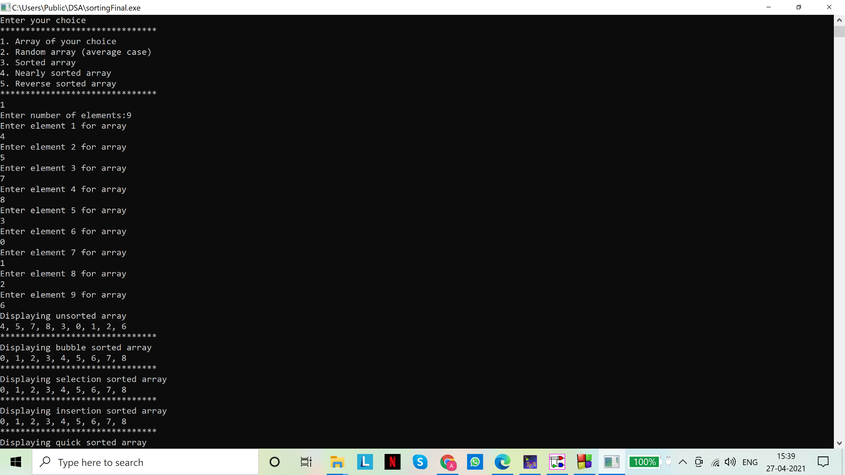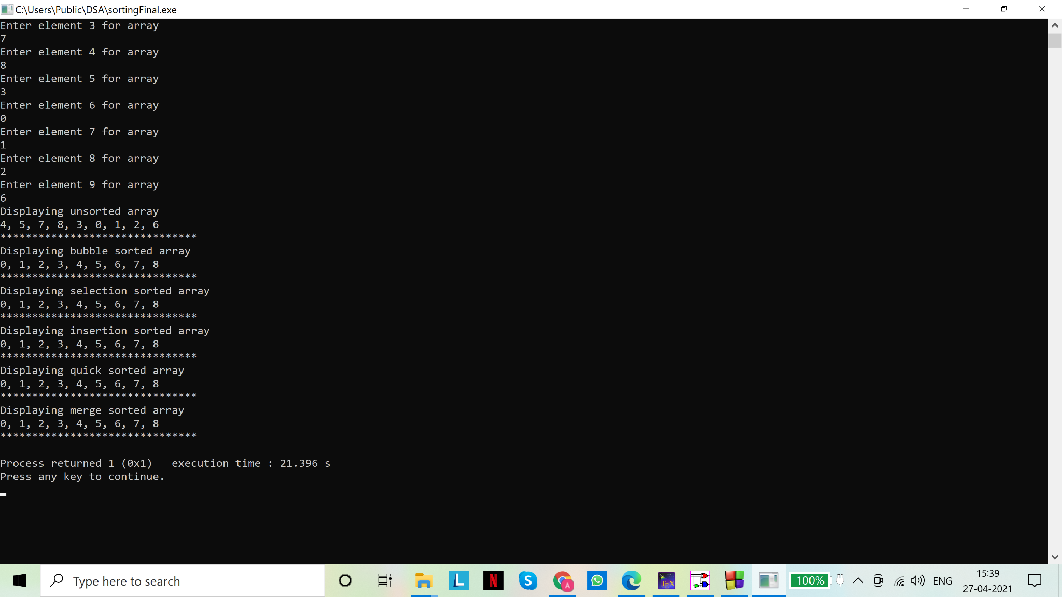

For random array:

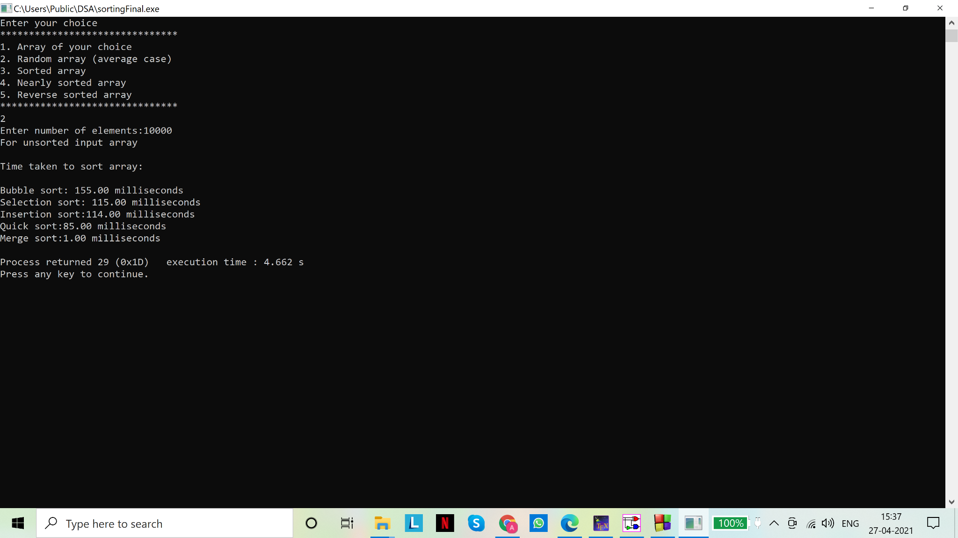

For sorted array:

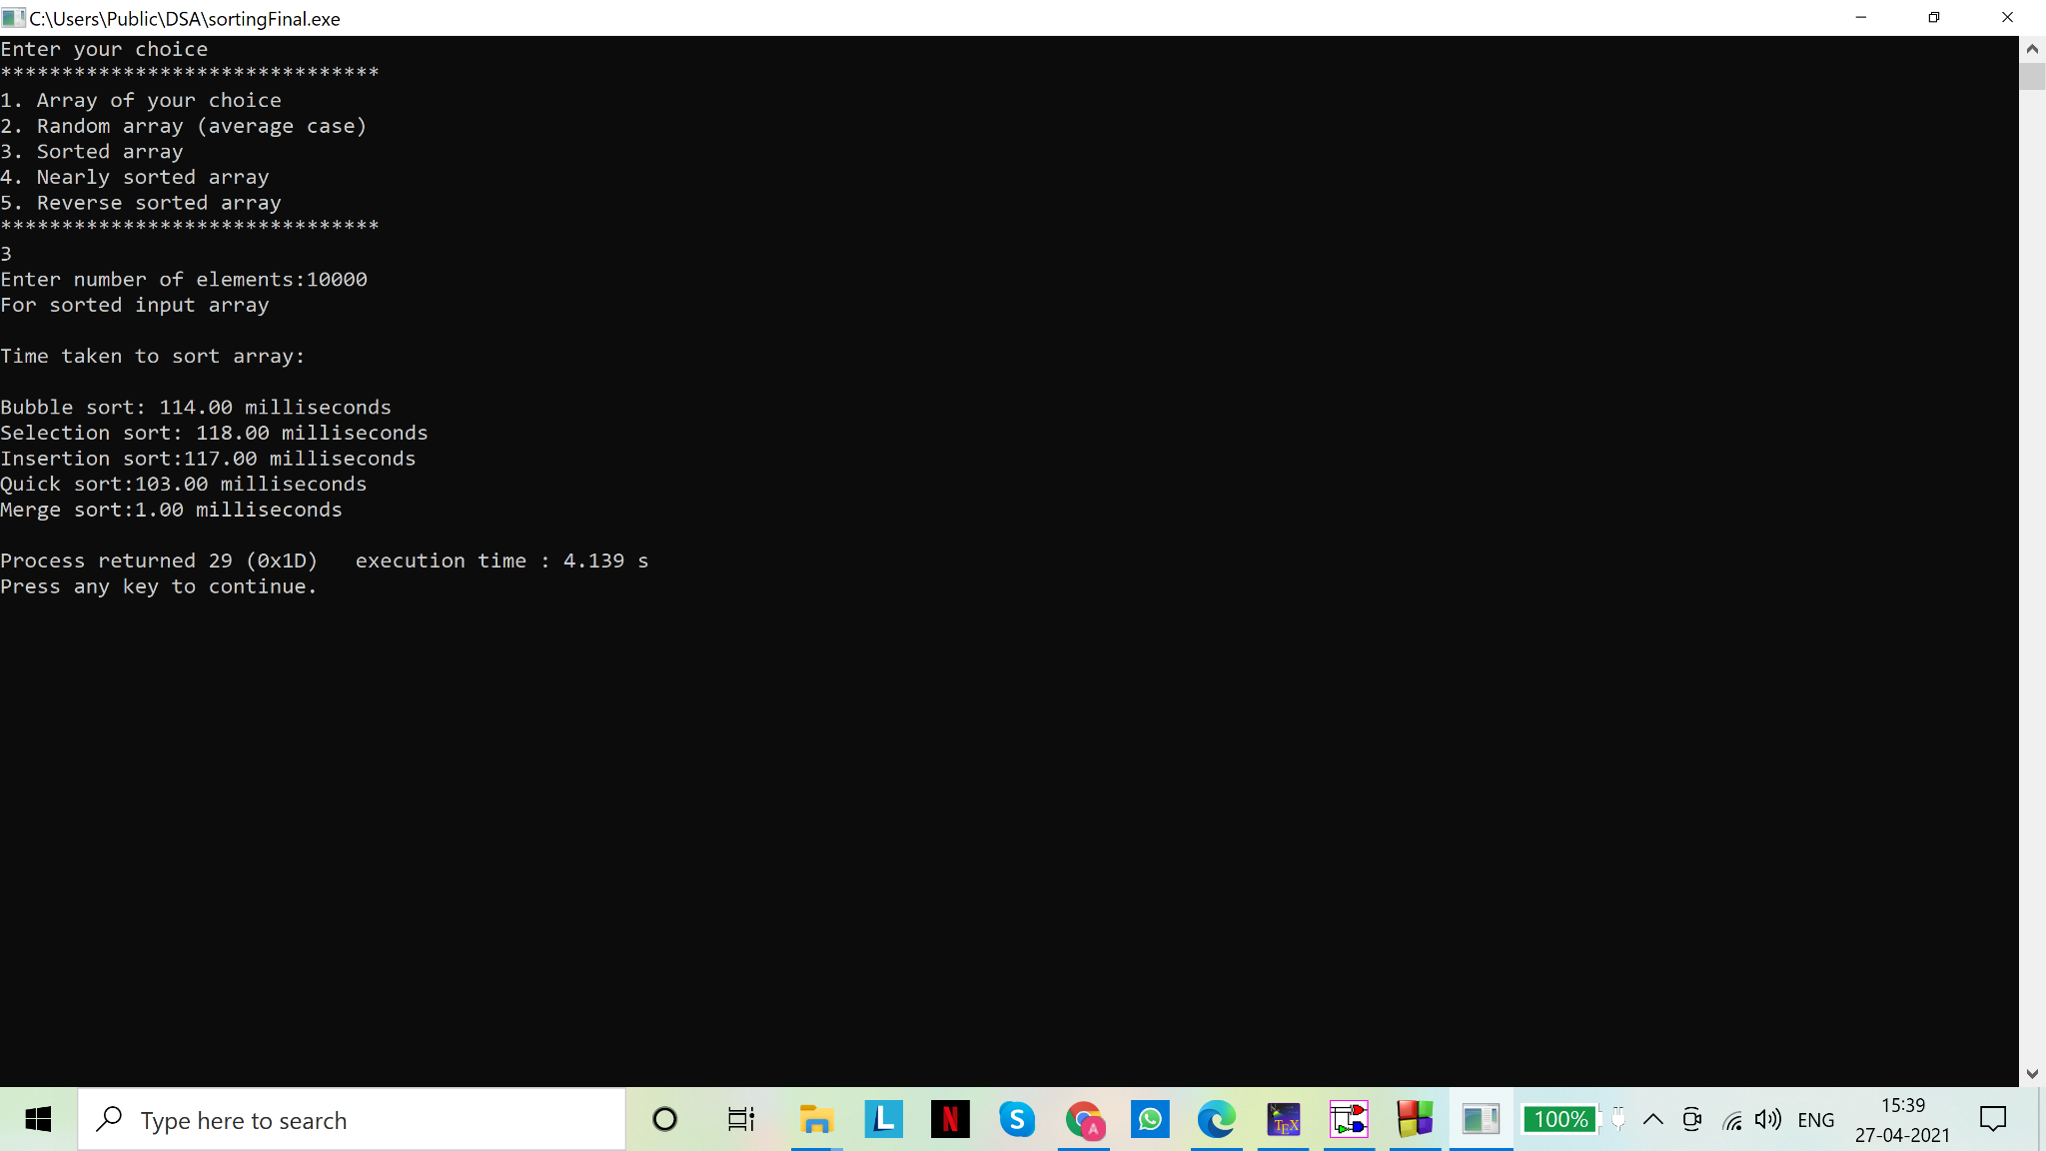

For nearly sorted array:

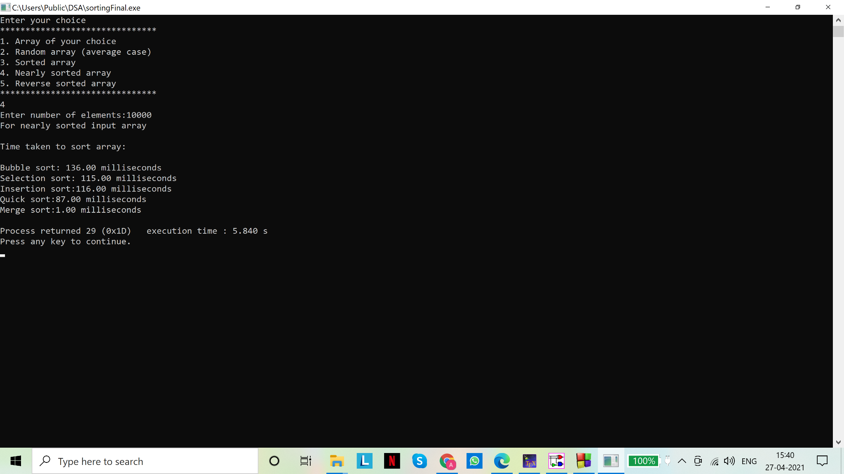

For reverse sorted array:

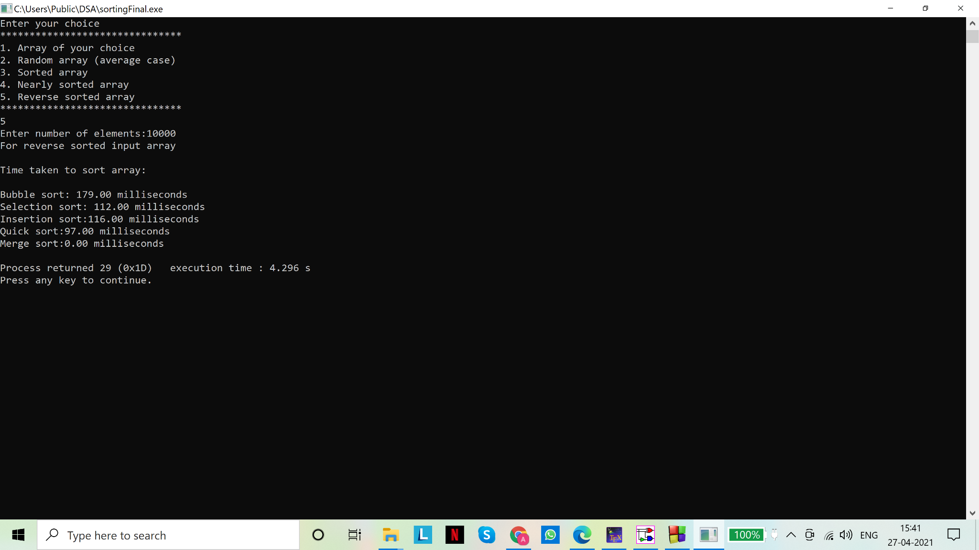

Graphical comparison of run time of algorithms (using Python code):

1. Unsorted array:

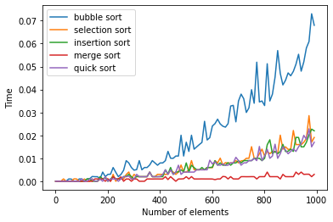

1. Sorted array:

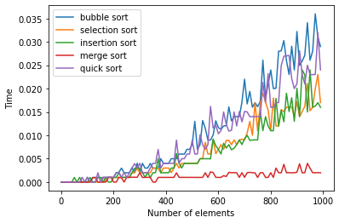

1. Nearly sorted array:

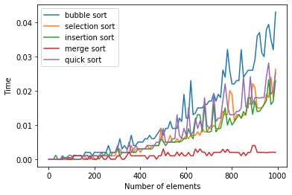

1. Reverse sorted array:

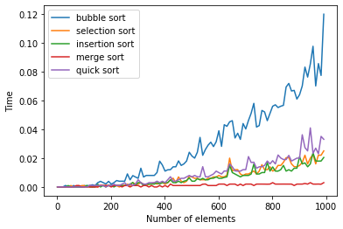

1. Solution(s)

Code(s):

# include <stdio.h>

# include <stdlib.h>

# include <time.h>

//binary search

int bin_search(int *arr, int l, int h, int n)

/*function for recursive binary search which returns index of item 'n' if found.

Else returns -1

We assume the array is sorted in ascending order*/

{

/*

Binary Search: array is split in two parts recursively until desired item is found or length of array is exhausted

Time complexity (worst/average case): O(log(n)) [worst case: item not found in array or at either extremity]

Best case: O(1) [match on middle element]

*/

if (l<=h)//if the front pointer has not exceeded the rear pointer

{

int mid=(l+h)/2;//middle index at which the array (or it's sub-array) will be split

if(arr[mid]==n)//item 'n' has been found

return mid;

if(arr[mid]>n)

//item to be found must be in lower half of array, if present: recursive call on lower half

return bin_search(arr,l,mid-1,n);

if(arr[mid]<n)

//item to be found must be in upper half of array, if present: recursive call on upper half

return bin_search(arr,mid+1,h,n);

}

return -1;//base case of recursion (if item 'n' is not found)

}

//end of binary search

//linear search

int lin_search(int *arr, int num, int n)

/*function for linear search which returns index of item 'num' if found.

Else returns -1

For comparison with binary sort, in this program we take a sorted array. However, it works for unsorted arrays as well*/

{

/*

Linear Search: array is scanned sequentially until item is found or length of array is exhausted

Time complexity (worst/average case): O(n) [worst case: element not found in array]

Best case: O(1) [match on first element]

*/

int i=0;//index for scanning the array

while(i<n)//sequentially scanning the array to locate the desired element

{

if(arr[i]==num)//item has been located

return i;//return the index to the calling function

i++;//if item has not been located, move on to the next item

}

return -1;//item not found

}

//end of linear search

//display function to print the array

void display(int *arr,int n)

{

for(int i=0;i<n-1;i++)

printf("%d, ",arr[i]);

printf("%d\n",arr[n-1]);

printf("*******************************\n");

}

//main function for function calls

void main()

{

int *arr;

int n;

printf("Enter number of elements:");

scanf("%d",&n);

// Dynamically allocate memory using calloc()

arr = (int*)calloc(n,sizeof(int));

if(arr == NULL)//failure to allocate memory. array cannot be used

{

printf("memory cannot be allocated\n");

}

else//memory allocated successfully

{

//creating sorted array

printf("Creating sorted array from 1 to %d \n\n",n);

for(int i=0;i<n;i++)

{

arr[i]=i+1;

}

int num;//element to be found. input from user

printf("Enter item to search for\n");

scanf("%d",&num);

clock_t t_bin, t_lin;//to compare the time taken to search for an element by either algorithm

t_bin=clock();

int pos1=bin_search(arr,0,n-1,num);

t_bin=clock()-t_bin;

t_lin=clock();

int pos2=lin_search(arr,num,n);

t_lin=clock()-t_lin;

printf("\nBinary search results:\n");

if(pos1==-1)

printf("Item not found\n");

else

printf("Item found at index %d of array\n", pos1);

printf("\nLinear search results:\n");

if(pos2==-1)

printf("Item not found\n");

else

printf("Item found at index %d of array\n", pos2);

printf("\n Time taken for binary search: %.2f microseconds \n",1000000*(float)t_bin/(float)CLOCKS_PER_SEC);

printf("\n Time taken for linear search: %.2f microseconds \n",1000000*(float)t_lin/(float)CLOCKS_PER_SEC);

}

}

Output(s):

Best case (item to be found is at the beginning of array)

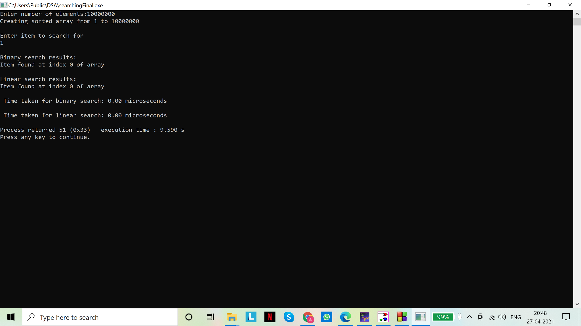

Average case (item to be found is at the middle index):

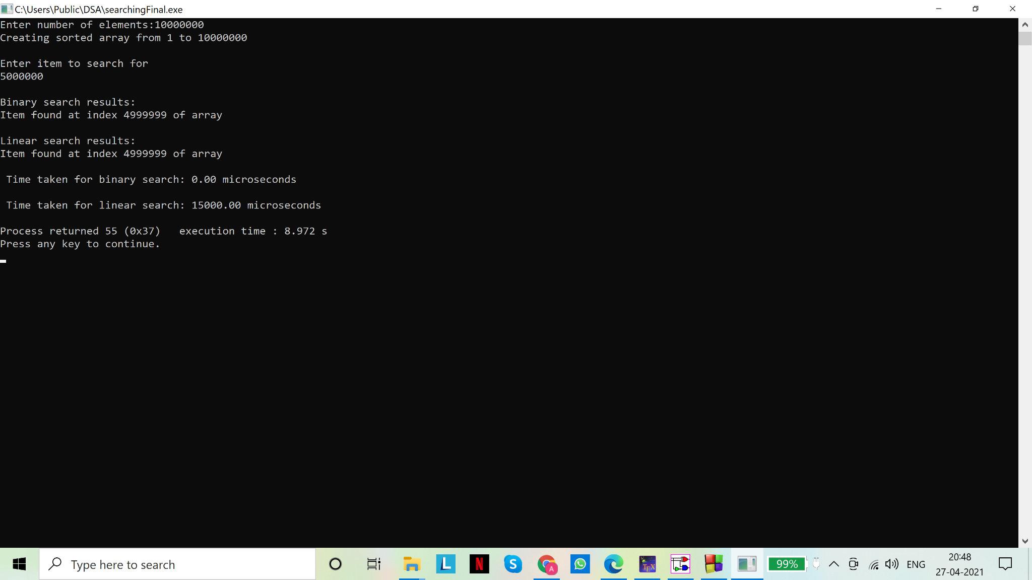

Worst case (item not present in the array):

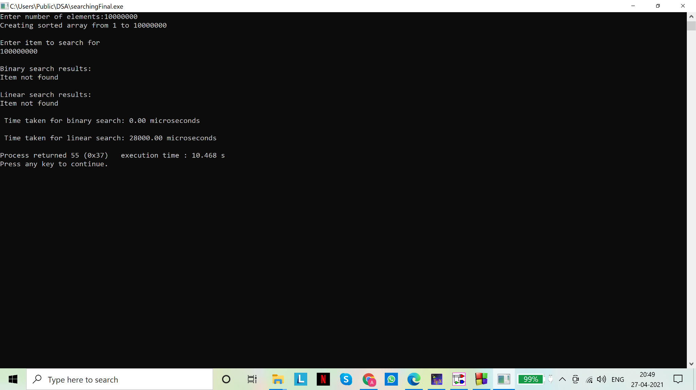

Graphical comparison of the algorithms with change in input size:

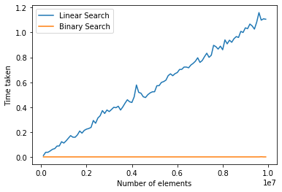

Assignment - 07

1. Test whether a binary tree is a) strictly binary and ii) complete. You can experiment with different sets of nodes (integers or characters).
2. Obtain a) pre-order, b) in-order and c) post-order traversals of a binary search tree.  You can experiment with different sets of nodes (integers or characters).
3. Based on a random set of inputted integers create a binary search tree with the integers as the nodes. Delete at least a) one leaf node, b) a node with one child and c) a node with two children from the tree you have created.

Solution(s)

1.

Code(s):

# include <stdio.h>

# include <stdlib.h>

//a structure 'node' is defined for a binary tree: a binary tree node has data, a pointer to left child and a pointer to right child

struct node

{

int data;

struct node* left;

struct node* right;

};

typedef struct node snode;//making variable declaration easier

//function that allocates a new node with the given data and sets left and right pointers to NULL

//returns the created node to the calling function

snode* newNode(int data)

{

snode* node=(snode*)malloc(sizeof(snode));//memory allocation

node->data=data;

node->left=NULL;

node->right=NULL;

return node;

}

//end of newNode()

//function to check whether the binary tree is strict or not

int isStrict(snode* root)

{

/*

A strict binary tree is one where every node has either two or zero number of children

This function recursively checks whether the given binary tree is strict or not

*/

//case 1: empty tree is strictly binary (base case 1)

if (root==NULL)

return 1;

//case 2: leaf node is strictly binary (base case 2)

if (root->right==NULL && root->left==NULL)

return 1;

//case 3: if both left and right are non empty, recursive call on the left and right subtrees

//to ensure they are BOTH strict binary trees

if ((root->left) && (root->right))

return (isStrict(root->left) && isStrict(root->right));

//none of the above are satisfied: i.e. the node has one child

return 0;

}

//end of isStrict()

//helper function to determine the depth of the binary tree passed as parameter

unsigned int depth(snode* root)

{

if (root == NULL)//empty tree: depth is 0

return 0;

//'1' is added for the present level

//recursive call on the left and right subtrees of the tree to find and compare their depths(using ternary operator :?)

//whichever subtree is "deeper" determines the final depth of the tree

unsigned int m=(depth(root->left)>depth(root->right))?depth(root->left):depth(root->right);

return 1 + m;

}

//end of depth()

//helper function to count the number of nodes in a binary tree

unsigned int countNodes(snode* root)

{

if (root == NULL)//empty tree: not a node, does not increase count

return 0;

//'1' is added for the current, non empty node (checked by the 'if' statement earlier)

//recursive call on the left and right subtrees to count their respective number of nodes

return (1 + countNodes(root->left) + countNodes(root->right));

}

//end of countNodes()

//function to check whether binary tree is complete

int isComplete (snode* root)

{

/*

A complete binary tree is one where the tree is at "full capacity"

Every node except the nodes on the last level has exactly two children

Every node on the last level is a leaf node (zero children)

Every complete binary tree is a strict binary tree but every strict binary tree is not necessarily complete

*/

//we use unsigned int as number of nodes and depth can never be negative integers

unsigned int no_nodes=countNodes(root);//number of nodes in the tree

unsigned int d = depth(root);//depth of the tree

int maxnodes=pow(2,d)-1;//maximum number of nodes in a tree of depth 'd'

printf("\nDepth of tree is %d, thus maximum nodes %d\n",d,maxnodes);

printf("\nNumber of nodes in the tree: %d\n",no_nodes);

//if number of nodes in the tree = maximum number of nodes the tree can accommodate, with it's depth

//i.e. the tree is at "full capacity", it is said to be complete

return (no_nodes==maxnodes);

}

//end of isComplete()

//function to take input from user

snode* input(snode* root,int idx)

{

//we index the nodes of the tree, starting from zero (root node)

int ch;//user's choice

printf("Will node %d have data? yes(1), no(0)?\n",idx);

scanf("%d",&ch);

if(ch==0)//base case. For any value of ch that is not zero, function accepts input

return root;

int d;//variable for data entered by user

printf("Enter data for node %d \n",idx);

scanf("%d",&d);

root=newNode(d);

//left subtree of node at idx

printf("For left subtree..\n");

root->left=input(root->left,2*idx+1);//recursive call on left subtree with indexed nodes for user's convenience

//right subtree of node at idx

printf("For right subtree..\n");

root->right=input(root->right,2*idx+2);//recursive call on right subtree with indexed nodes for user's convenience

}

//end of input()

//main() to call the functions

void main()

{

snode* root = NULL;//pointer to represent the tree

root=input(root,0);

printf("\n************************************\n");

if (isComplete(root))

printf("\nComplete Binary Tree\n");

else

printf("\nNot a Complete Binary Tree\n");

if (isStrict(root))

printf("\nStrict Binary Tree\n");

else

printf("\nNot a Strict Binary Tree\n");

printf("\n************************************\n");

}

//end of main()

Output(s):

1. Neither strictly binary nor complete

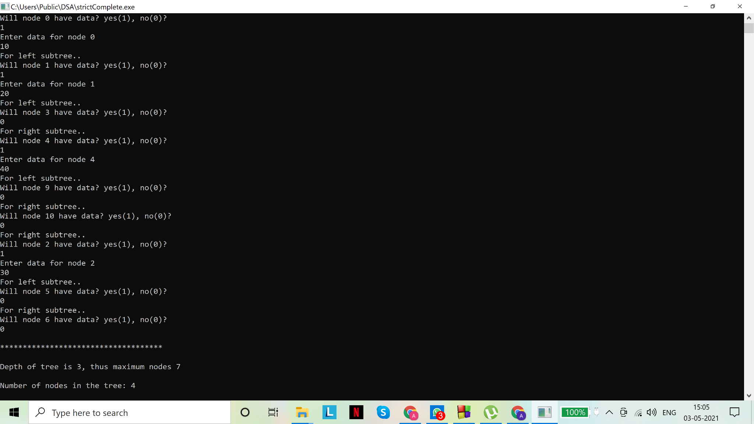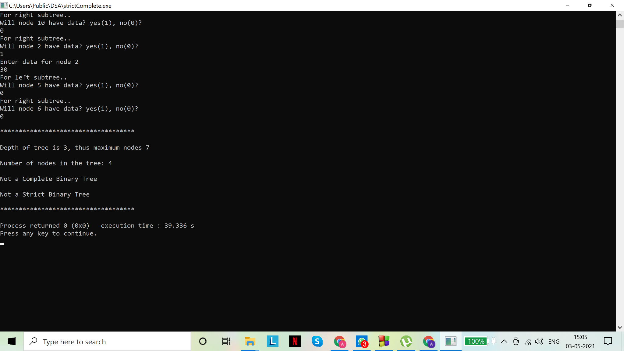

1. Strictly binary but not complete

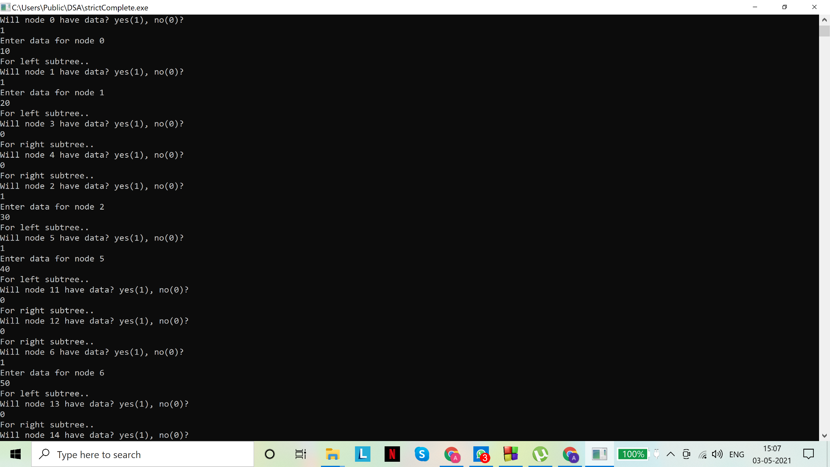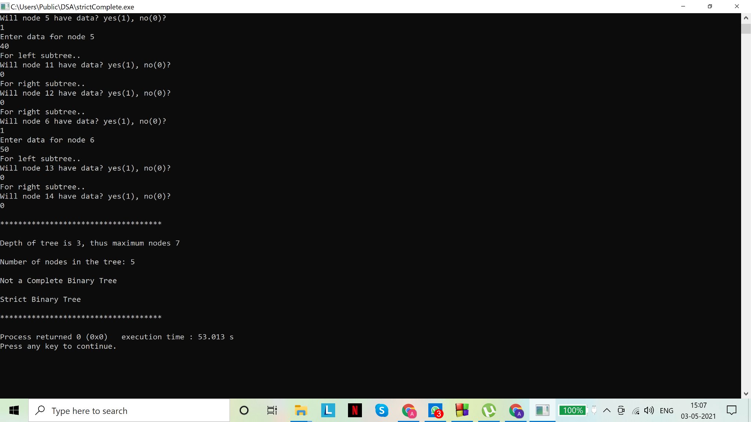

1. Complete (and strictly binary) tree

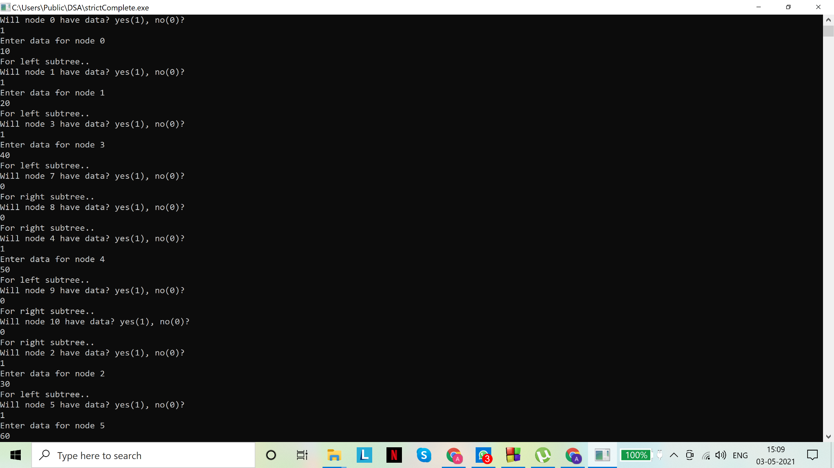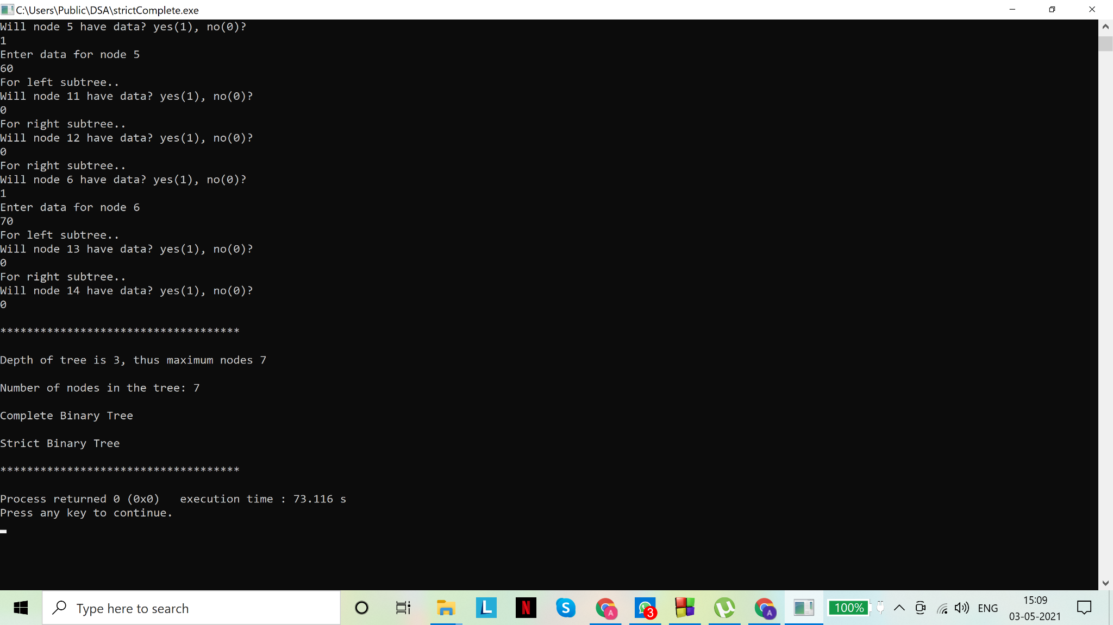

2.

Code(s):

# include <stdio.h>

# include <stdlib.h>

//a structure 'node' is defined for a binary tree: a binary tree node has data, a pointer to left child and a pointer to right child

struct node

{

int data;

struct node* left;

struct node* right;

};

typedef struct node snode;//making variable declaration easier

//function that allocates a new node with the given data and sets left and right pointers to NULL

//returns the created node to the calling function

snode* newNode(int data)

{

snode* node=(snode*)malloc(sizeof(snode));

node->data=data;

node->left=node->right=NULL;

return node;

}

//function to print inorder traversal of the binary tree passed as parameter

void inOrder(snode* node)

{

/*

Inorder traversal of a binary tree is a depth first traversal where the data is printed as

Left subtree-Data-Right subtree

*/

if(node==NULL)//base case: empty tree has nothing to print

return;

//recursion on left subtree to print inorder traversal of left subtree

inOrder(node->left);

//print the data in the node

printf("%d ",node->data);

//recursion on right subtree to print inorder traversal of right subtree

inOrder(node->right);

}

//end of inOrder()

//function to print preorer traversal of the binary tree passed as parameter

void preOrder(snode* node)

{

/*

Preorder traversal of a binary tree is a depth first traversal where the data is printed as

Data-Left subtree-Right subtree

*/

if(node==NULL)//base case: empty tree has nothing to print

return;

//print the data in the node

printf("%d ",node->data);

//recursion on left subtree to print preorder traversal of left subtree

preOrder(node->left);

//recursion on right subtree to print preorder traversal of right subtree

preOrder(node->right);

}

//end of preOrder()

//function to print postorder traversal of the binary tree passed as parameter

void postOrder(snode* node)

{

/*

Postorder traversal of a binary tree is a depth first traversal where the data is printed as

Left subtree-Right subtree-Data

*/

if(node==NULL)//base case: empty tree has nothing to print

return;

//recursion on left subtree to print postorder traversal of left subtree

postOrder(node->left);

//recursion on right subtree to print postorder traversal of right subtree

postOrder(node->right);

//print the data in the node

printf("%d ",node->data);

}

//end of postOrder()

//function to take input from user

snode* input(snode* root,int idx)

{

//we index the nodes of the tree, starting from zero (root node)

int ch;//user's choice

printf("Will node %d have data? yes(1), no(0)?\n",idx);

scanf("%d",&ch);

if(ch==0)//base case. For any value of ch that is not zero, function accepts input

return root;

int d;//variable for data entered by user

printf("Enter data for node %d \n",idx);

scanf("%d",&d);

root=newNode(d);

//left subtree of node at idx

printf("For left subtree..\n");

root->left=input(root->left,2*idx+1);//recursive call on left subtree with indexed nodes for user's convenience

//right subtree of node at idx

printf("For right subtree..\n");

root->right=input(root->right,2*idx+2);//recursive call on right subtree with indexed nodes for user's convenience

}

//main() to call the functions

void main()

{

snode* root=NULL;//pointer to represent the tree

root=input(root,0);

//we assume user inputs a binary search tree, in which case we will obtain the nodes in ascending order for inorder traversal

printf("\ntraversing the tree...\n");

printf("\nPreorder traversal:\n");

preOrder(root);

printf("\nInorder traversal:\n");

inOrder(root);

printf("\nPostorder traversal:\n");

postOrder(root);

}

//end of main()

Output(s):

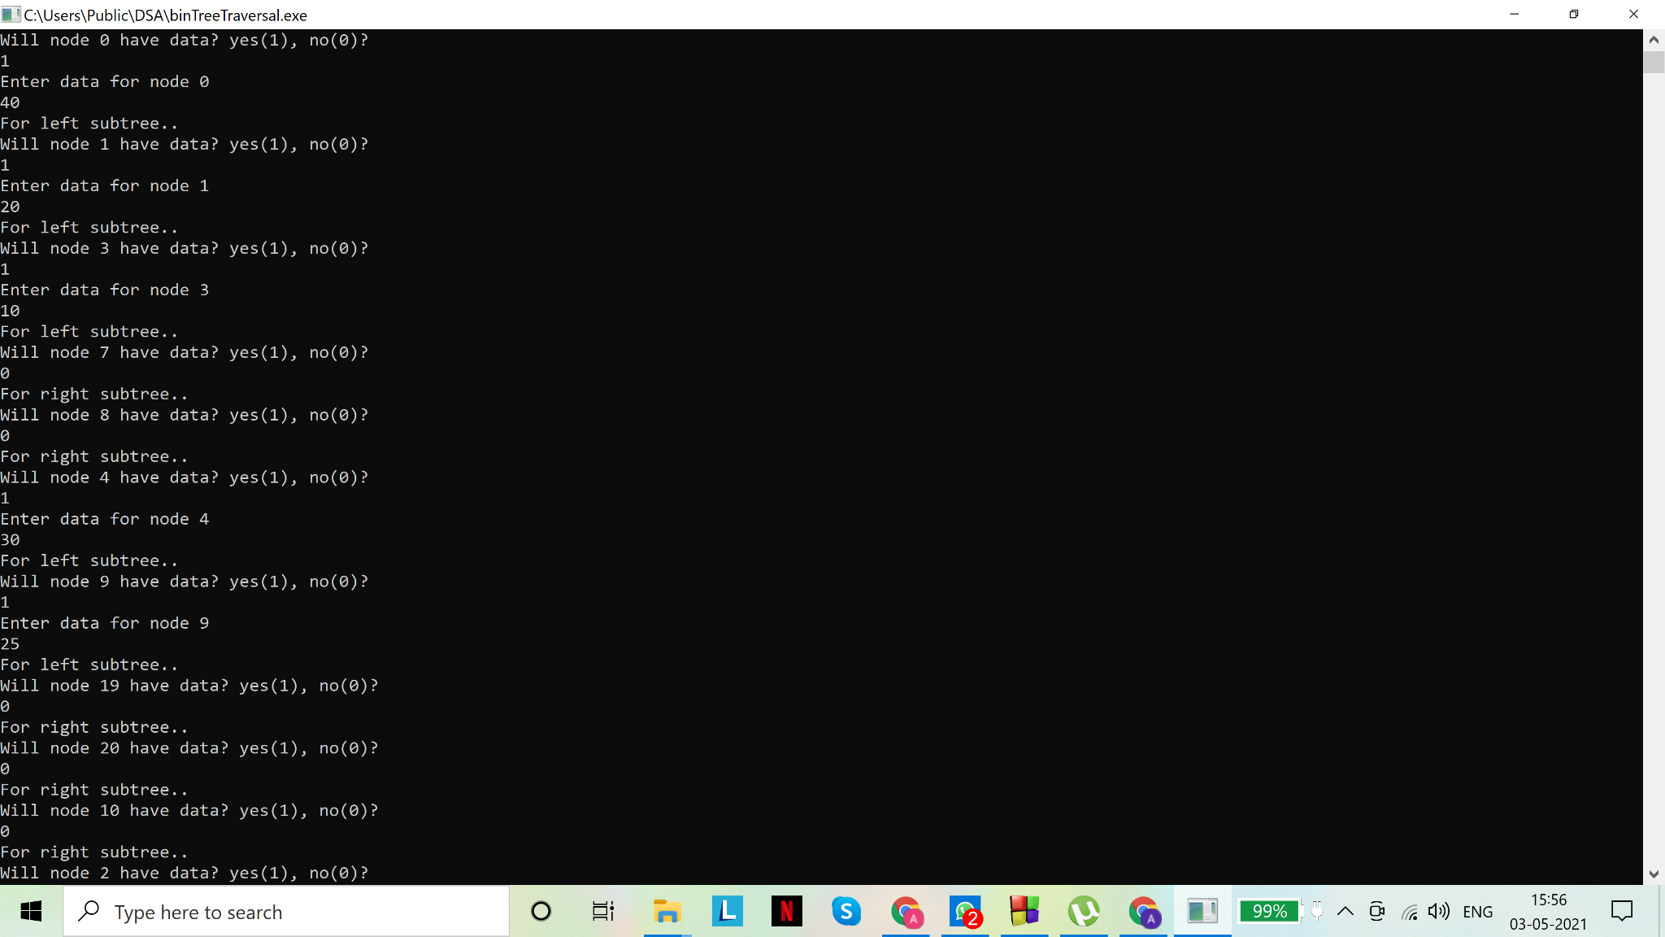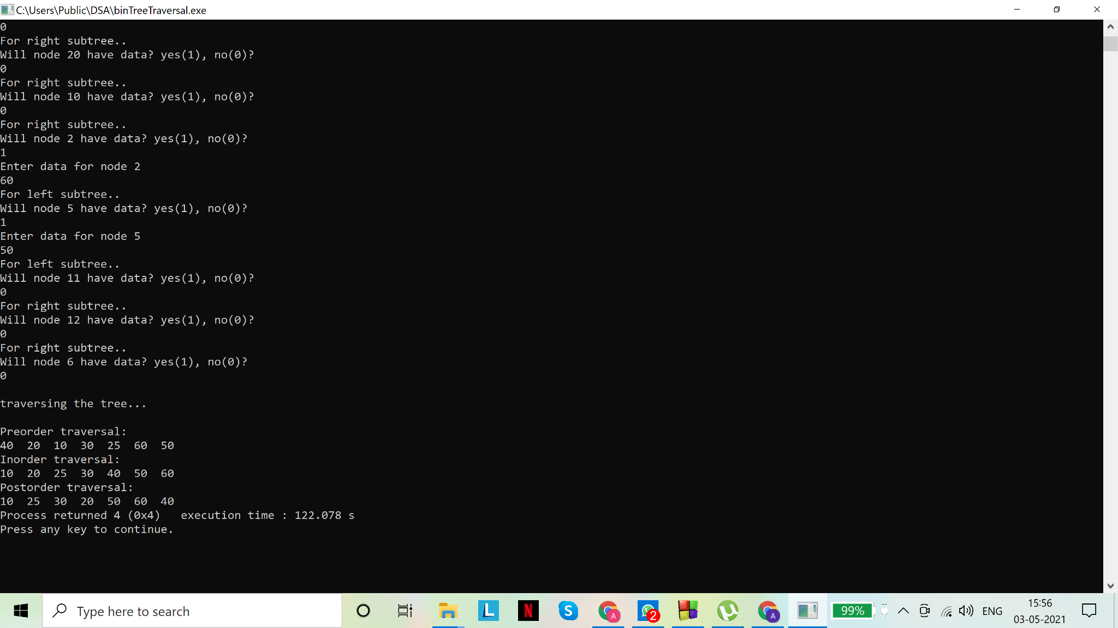

3.

Code(s):

# include <stdio.h>

# include <stdlib.h>

/*

Binary Search Tree is a node-based binary tree data structure which has the following properties:

The left subtree of a node contains only nodes with data lesser than the node’s data.

The right subtree of a node contains only nodes with data greater than the node’s data.

The left and right subtree each must also be a binary search tree.

There must be no duplicate nodes.

The above properties of Binary Search Tree provides an ordering among data so that the operations like search, minimum and maximum can be done fast.

If there is no ordering, then we may have to compare every data to search for a given data.

Inorder traversal of binary search tree displays the data in ascending order

*/

//a structure 'node' is defined for a binary tree: a binary tree node has data, a pointer to left child and a pointer to right child

struct node

{

int data;

struct node* left;

struct node* right;

};

typedef struct node snode;//making variable declaration easier

//function that allocates a new node with the given data and sets left and right pointers to NULL

//returns the created node to the calling function

snode* newNode(int data)

{

snode* node=(snode*)malloc(sizeof(snode));

node->data=data;

node->left=node->right=NULL;

return node;

}

//function to print inorder traversal of the binary tree passed as parameter

void inOrder(snode* node)

{

/*

Inorder traversal of a binary tree is a depth first traversal where the data is printed as

Left subtree-Data-Right subtree

*/

if(node==NULL)//base case: empty tree has nothing to print

return;

//recursion on left subtree to print inorder traversal of left subtree

inOrder(node->left);

//print the data in the node

printf("%d ",node->data);

//recursion on right subtree to print inorder traversal of right subtree

inOrder(node->right);

}

//end of inOrder()

//function to print preorer traversal of the binary tree passed as parameter

void preOrder(snode* node)

{

/*

Preorder traversal of a binary tree is a depth first traversal where the data is printed as

Data-Left subtree-Right subtree

*/

if(node==NULL)//base case: empty tree has nothing to print

return;

//print the data in the node

printf("%d ",node->data);

//recursion on left subtree to print preorder traversal of left subtree

preOrder(node->left);

//recursion on right subtree to print preorder traversal of right subtree

preOrder(node->right);

}

//end of preOrder()

//function to print postorder traversal of the binary tree passed as parameter

void postOrder(snode* node)

{

/*

Postorder traversal of a binary tree is a depth first traversal where the data is printed as

Left subtree-Right subtree-Data

*/

if(node==NULL)//base case: empty tree has nothing to print

return;

//recursion on left subtree to print postorder traversal of left subtree

postOrder(node->left);

//recursion on right subtree to print postorder traversal of right subtree

postOrder(node->right);

//print the data in the node

printf("%d ",node->data);

}

//end of postOrder()

//function to return the minimum value in the tree passed as parameter

snode* minValue(snode* node)

{

snode* current = node;

// loop down to find the leftmost leaf: by property of a binary search tree, the leftmost element is the minimum

while (current && current->left != NULL)

current = current->left;

return current;

}

//function to insert data 'd' into correct location in the binary search tree, such that it's property is preserved

//return type must be *snode to reflect the changes to the tree. Had we passed a pointer to the root, this would not be necessary

snode* insert_node(snode* root, int d)

{

if (root==NULL)//base case: empty tree(/subtree): insert data at root node

{

root=newNode(d);

return root;

}

if(d<root->data)

//'d' is less than the data in root: must be inserted in left subtree

//location of insertion is determined recursively by now sending left subtree as argument

root->left= insert_node(root->left,d);

else if(d>root->data)

//'d' is greater than the data in root: must be inserted in right subtree

//location of insertion is determined recursively by now sending right subtree as argument

root->right= insert_node(root->right,d);

else

//the remaining case: if 'd' is equal to data in root node, duplicate condition is reached and no insertion must be performed

return root;

}

//end of insert_node()

//function to delete data 'd' from the tree, if found, while maintaining the property of binary search tree

//return type must be *snode to reflect the changes to the tree. Had we passed a pointer to the root, this would not be necessary

snode* delete_node(snode* root, int d)

{

// base case

if (root == NULL)

{

printf("\ndeletion failed\n");

return root;

}

// If the item to be deleted is smaller than the root's data, then it lies in left subtree

//recursive call on the left subtree to find and delete the data from there

if (d < root->data)

root->left = delete_node(root->left, d);

// If the item to be deleted is larger than the root's data, then it lies in right subtree

//recursive call on the rught subtree to find and delete the data from there

else if (d > root->data)

root->right = delete_node(root->right, d);

// if 'd' is same as root's data, then this is the node to be deleted

else

{

//case 1: node with only one child or no child

//if node has one child: it is set to that child

//if node has no children: node is set to NULL

if (root->left == NULL) //left is empty=> right is empty or non-empty. In any case,

//assigning the value of right subtree to the root works

{

snode* temp = root->right;//NULL, if node has no children

free(root);//free memory

return temp;//essentially: root is now set to the root of its right subtree

}

else if (root->right == NULL) //in this case, left==NULL was not satisfied, so left subtree must be non empty

{

snode* temp = root->left;

free(root);//free memory

return temp;//essentially: root is now set to the root of its left subtree

}

//we observe that 'return' keyword terminates the if-else blocks if satisfies

//so we do not need an 'else' block for this case

//case 2: node with two children: Get the inorder successor (smallest in the right subtree)

snode* temp = minValue(root->right);

//copy the inorder successor's content to this node

root->data = temp->data;

//once data has been copied, delete the inorder successor by recursively calling delete_node() on the right subtree

root->right = delete_node(root->right, temp->data);

}

return root;//return the modified root to the calling function

}

//end of delete_node()

//main() to call functions

void main()

{

snode* root = NULL;//pointer to represent the tree

printf("\n1. Insert\n");

printf("2. Delete\n");

printf("3. Display\n");

printf("4. Exit\n");

int ch=0;//for storing user's choice

int d=0;//for storing data entered by user

while(ch!=4)//while loop runs till user asks to exit

{

printf("\nEnter choice\n");

scanf("%d",&ch);

switch(ch)

{

case 1:

printf("Enter data to insert:\n");

scanf("%d",&d);

root=insert_node(root,d);

break;

case 2:

printf("Enter data to delete:\n");

scanf("%d",&d);

root=delete_node(root,d);

break;

case 3:

//in order to display the tree, we use traversals.

//The set of 3 traversals is unique to every tree and can help us reconstruct the tree

printf("\ndisplaying...\n");

printf("\inorder\n");

inOrder(root);

printf("\n*****************\n");

printf("preorder\n");

preOrder(root);

printf("\n*****************\n");

printf("postorder\n");

postOrder(root);

printf("\n*****************\n");

break;

case 4:

printf("\nEnding program...\n");//loop is exited after switch case block

break;

default:

printf("\nInvalid choice. Enter again\n");

break;

}

}

}

//end of main()

Output(s):

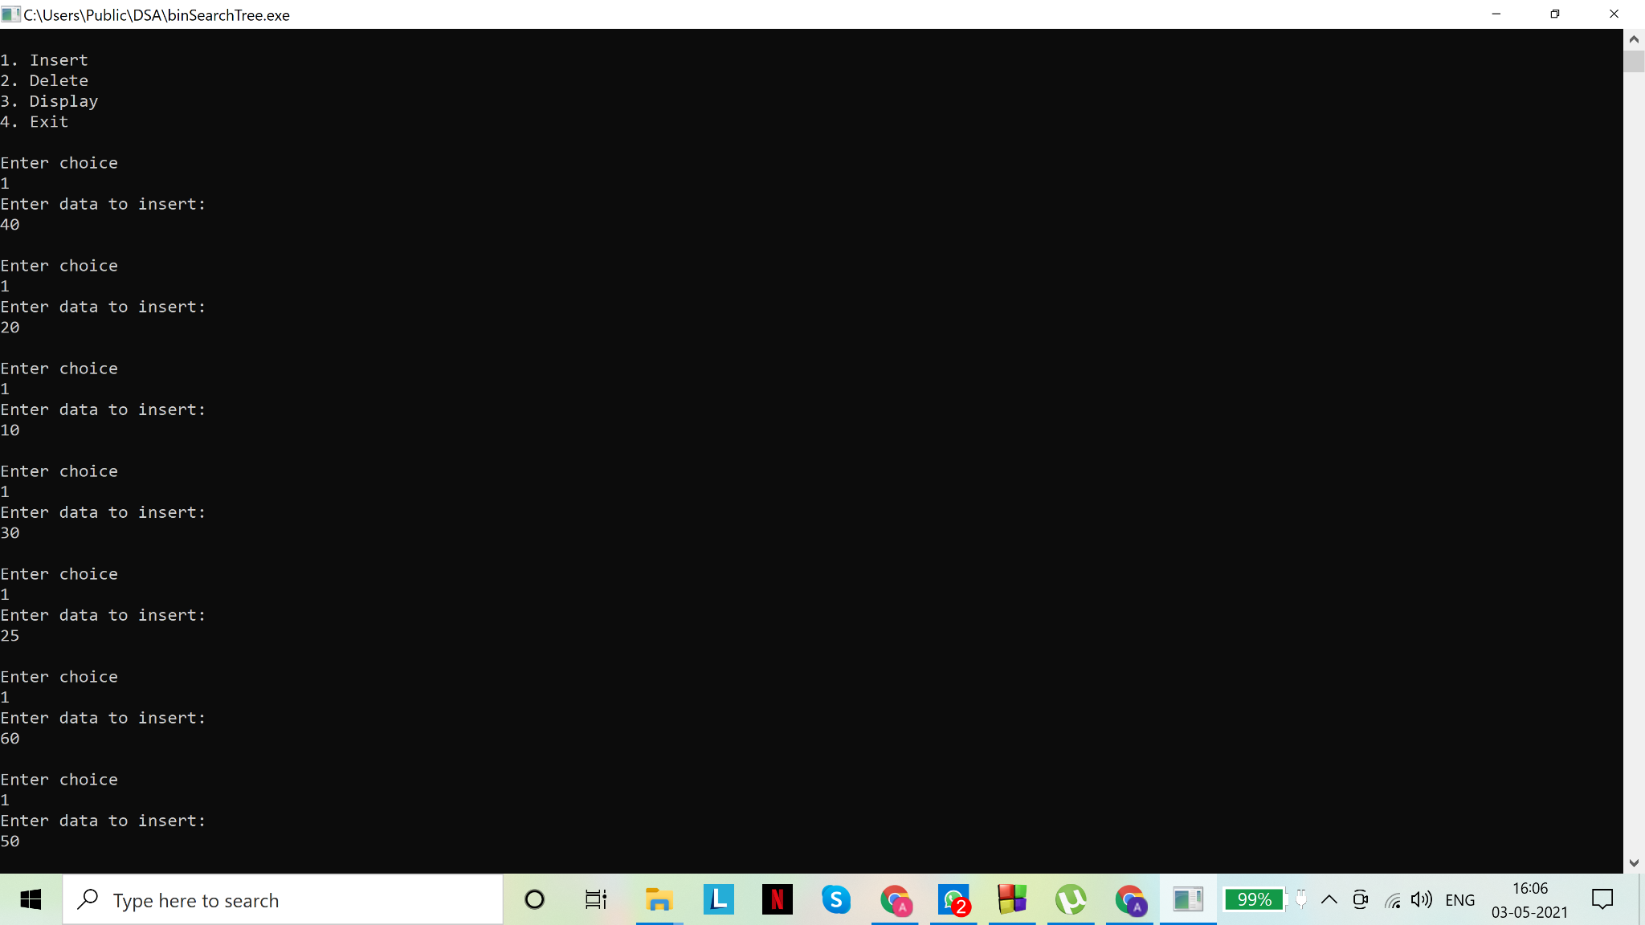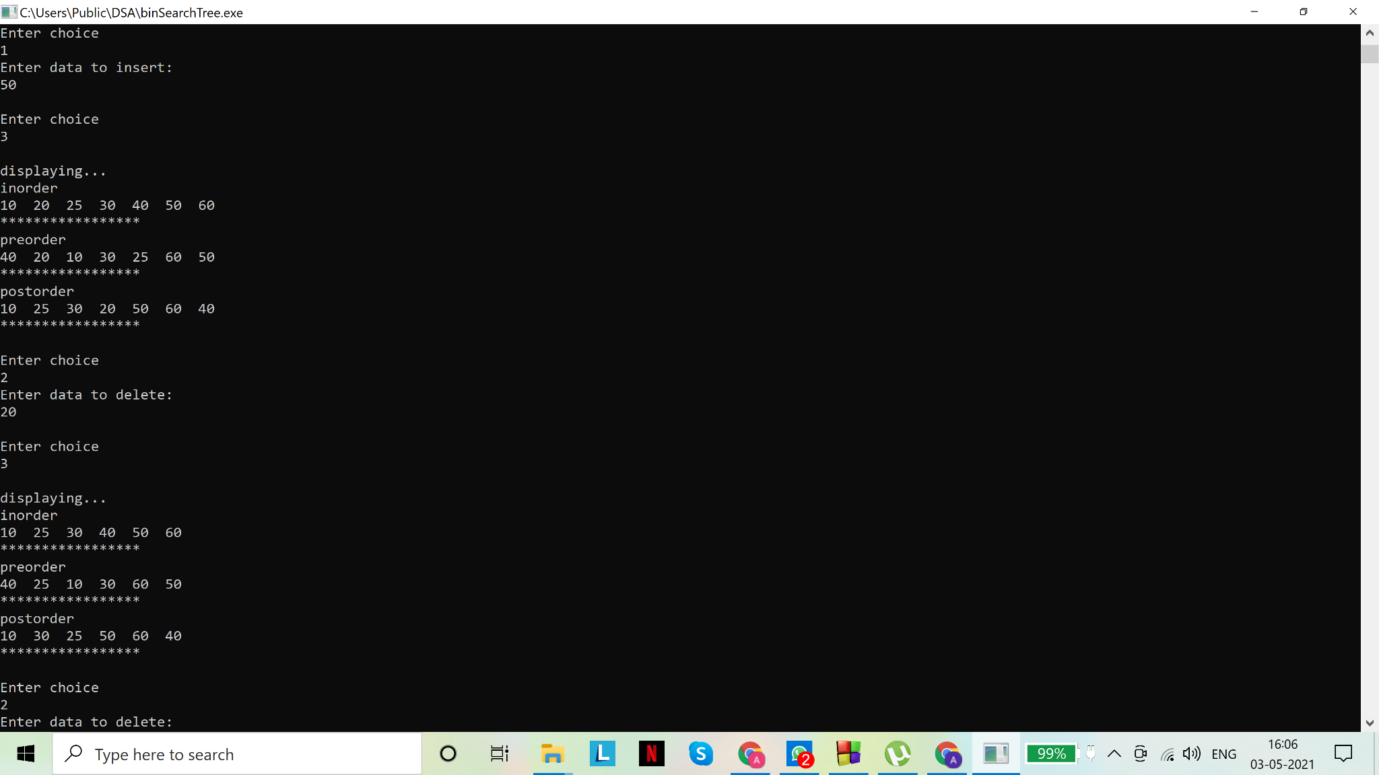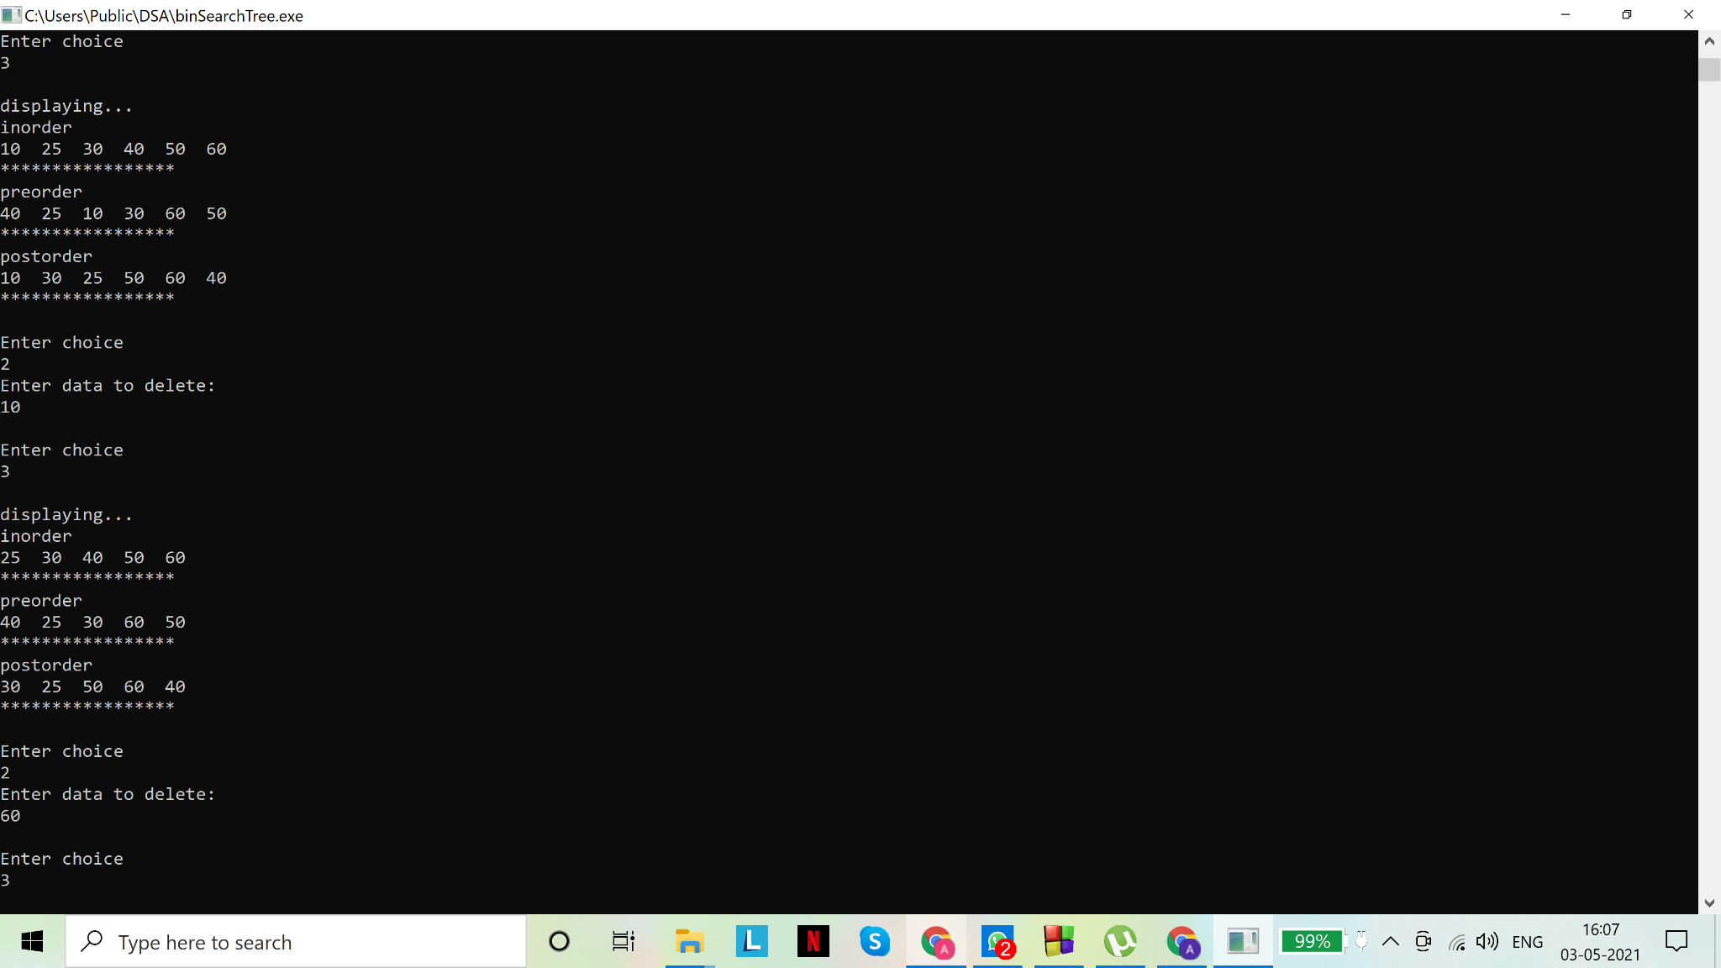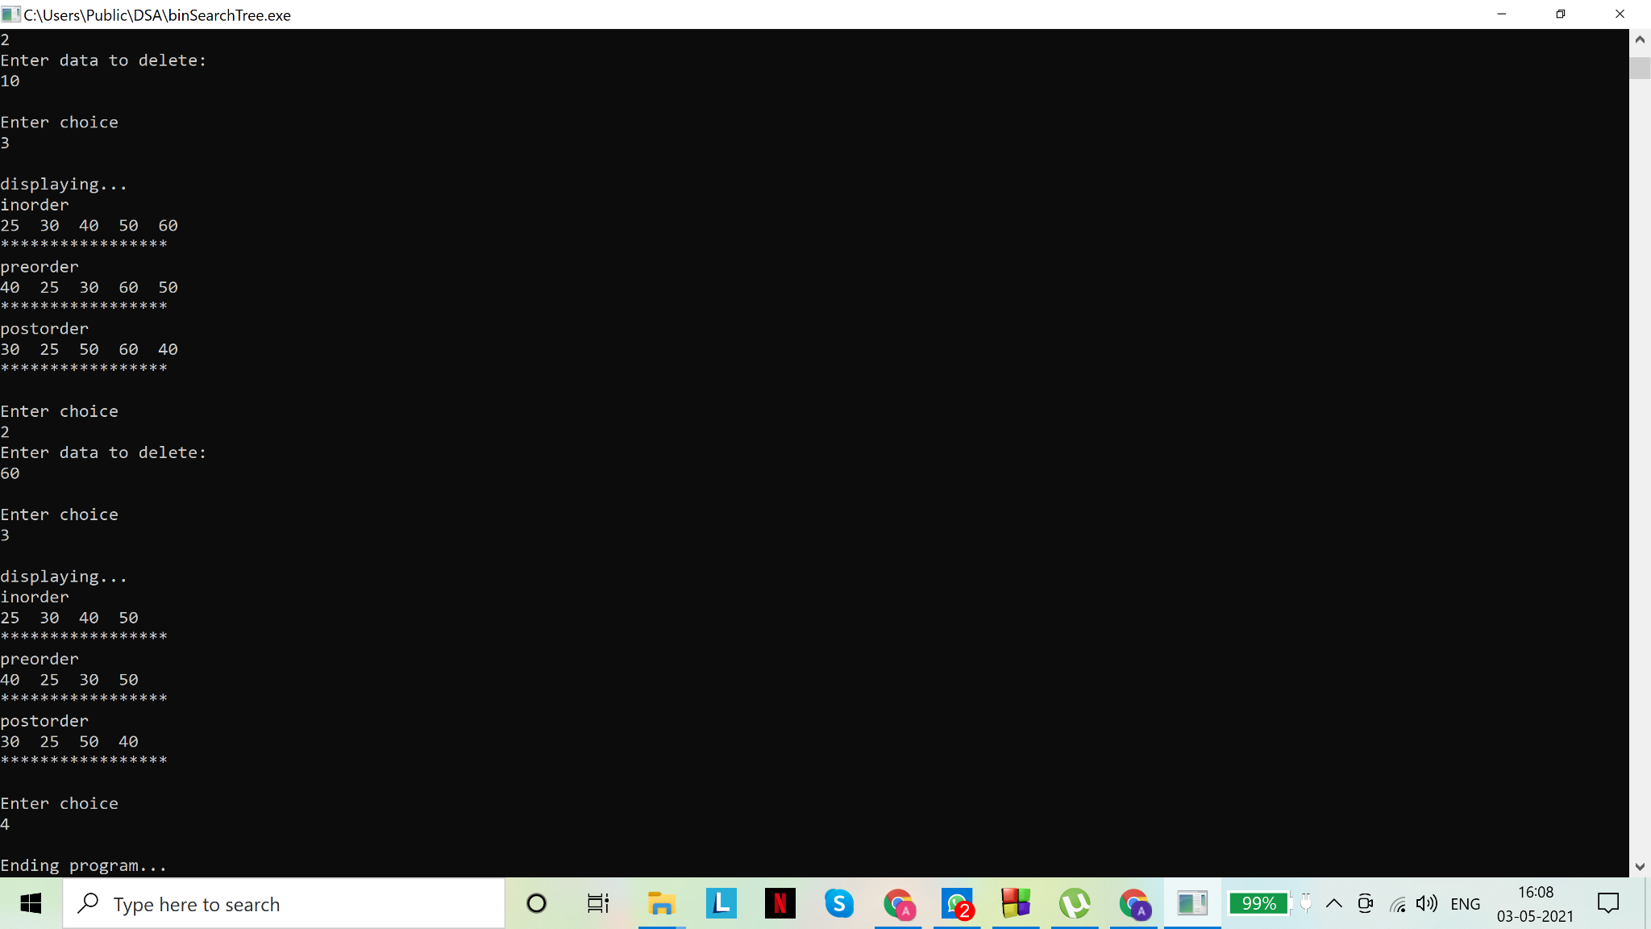

(delete 20: node with 2 children; delete 10: node with zero children;delete 60: node with one child)

Assignment - 08

1. Given a graph G= (V, E) and a source vertex s, implement Breadth-First-Search (BFS) and grow a BFS tree with root as s. Show some intermediate outputs as well.
2. Optional:

Given a directed graph G=(V, E), implement Depth-First-Search (DFS). Your program should invoke DFS_VISIT(u) for any vertex u.  Show some intermediate outputs as well.

Solution(s)

1.

Code(s):

# include <stdio.h>

# include <stdlib.h>

/*

Breadth First Search (BFS):

Given a graph G=(V,E) and a distinguished source vertex s, breadth first search explores the edges of G to find every vertex that is reachable from s

Principle: the algorithm discovers all vertices at distance k from s, before discovering any vertices at distance k+1

Strategy: BFS "colors" each vertex white, gray or black. Initially, all vertices are white. When a vertex is encountered (discovered) for the first

time, it becomes non-white. All vertices adjacent to a black vertex have been discovered, but this is not true for a gray vertex.

BFS Tree: whenever a white vertex v is discovered while scanning the adjacency list of an already discovered vertex u, the vertex v and the edge (u,v)

are added to the BFS tree. Parent of v is u.

The distance from the source to any vertex u is stored in d[u]

Complexity: O(V+E)

*/

//a series of helper functions to form the queue required to perform breadth first search on the given graph

//structure for a single node of the queue

struct node{

int data;//data of int type to be stored in the node. This may be char / float / etc depending on user preference

struct node *next;//pointer to the next node. Has datatype struct node as well

};

//end of struct node

typedef struct node snode;//to make declaration easier

//structure for user defined datatype: queue

struct Queue{

snode *f,*r;//front and rear pointers of user defined datatype 'snode'

};

//end of struct Queue

typedef struct Queue queue;//to make declaration easier

//user defined data type for undirected graph

struct Graph{

int V;//number of vertices

int *adj;//2D (symmetrical) adjacency matrix to store the information about the edges

};

typedef struct Graph graph;//to make declaration easier

int isEmpty(queue *pq)//function to check if queue is empty. Receives pointer to the queue as parameter

{

return ((pq->f==NULL)&&(pq->r==NULL));//if both front and rear pointers are NULL, the queue must be empty

}

//end of isEmpty()

//function that allocates a new node with the given data and sets next pointer to NULL

//returns the created node to the calling function

snode* newNode(int data)

{

snode* node=(snode*)malloc(sizeof(snode));//memory allocation

node->data=data;

node->next=NULL;

return node;

}

//end of newNode()

void enqueue(queue *pq,int d)//function for inserting data in queue. Receives pointer to the queue and data to be inserted

//as parameters

{

snode *s=newNode(d);//creating a temporary node to link to the queue

if(isEmpty(pq))//for empty queue, insert the node and assign 's' to front and rear

pq->r=pq->f=s;

else//non empty queue

{

pq->r->next=s;//insert at rear of queue

pq->r=s;//update rear pointer

}

}

//end of enqueue()

//function for removing data from queue

int dequeue(queue *pq)

{

//underflow check: if queue is empty

if (isEmpty(pq))

{

printf("Underflow\n");

return NULL;

}

else//non empty queue

{

int d=pq->f->data;//data must be removed from front

snode *s=pq->f;//node to be removed

pq->f=pq->f->next;//update front pointer

if(pq->f==NULL)//if front pointer is null, front has passed the rear pointer and

//queue must be empty, so we set rear to NULL

pq->r=NULL;

free(s);//freeing the memory

return d;

}

}

//end of dequeue()

void display(queue *pq)//function to print the queue

{

printf("\nDisplaying the queue\n");

if(isEmpty(pq))

printf("Empty queue\n");

else

{

int u=0;

snode *s=pq->f;

while (s!=pq->r)//traversing the queue from front to rear

{

printf("%d->",s->data);

s=s->next;

}

printf("%d\n",s->data);

}

}

//end of display()

//end of helper functions

void BFS(graph G, int s)//function to perform breadth first search for given number of vertices V

//and edges represented by adjacency matrix adj

//s is the root or starting point

{

//for ease of computation we assume the vertices are 0,1,2,...,V

int *color=(int*)calloc(G.V,sizeof(int));//int array to store color of each vertex

//white:0

//gray:1

//black:2

int *d=(int*)calloc(G.V,sizeof(int));//int array to store distance of each vertex from root

//d=0 for s, 1 for next adjacent vertex and so on

int *parent=(int*)calloc(G.V,sizeof(int));//int array to store parent of each vertex

int *bfs=(int*)calloc(G.V,sizeof(int));//for the final search result

int pos=-1;//to keep track of the position till which bfs has been filled

//initialization

//initialization of all vertices besides the root

for(int i=0;i<G.V;i++)

{

if(i!=s)

{

color[i]=0;//white

d[i]=G.V+1;//initialize with a large distance which is not feasible

parent[i]=G.V+1;//parent is not known yet, hence we assign an out of bounds value

}

}

//initialize root

color[s]=1;//gray: it has been visited as we begin at root

d[s]=0;

parent[s]=G.V+1;//has no parent so we store a large value- outside of array bounds- in it

//initialize the queue

queue Q;//declare a variable of queue type

Q.f=Q.r=NULL;//initialize pointers

//end of initialization

int u=0,v=0;

enqueue(&Q,s);//insert root into queue

printf("\n\n");

while(!isEmpty(&Q))

{

display(&Q);//display the queue

u=dequeue(&Q);//delete first element from queue (FIFO): this vertex will be explored

//print the details for the vertex being explored

printf("\nExploring vertex: %d \n",u);

if(parent[u]==(G.V+1))

printf("Parent: NIL\n");

else

printf("Parent: %d\n",parent[u]);

printf("Distance from root: %d\n",d[u]);

if(color[u]==0)

printf("Color: White\n");

else if(color[u]==1)

printf("Color: Gray\n");

else

printf("Color: Black\n");

pos+=1;

bfs[pos]=u;//final output has a new entry

for(v=0;v<G.V;v++)//exploring all columns in row ‘u’

{

if(*(G.adj+u*G.V+v)!=0)//edge (u,v) exists

{

if(color[v]==0)//if white, ie undiscovered

{

color[v]=1;//assign gray

d[v]=d[u]+1;//distance from root

parent[v]=u;//assign parent

enqueue(&Q,v);//insert into queue

}

}

}

color[u]=2;//assign black, as all adjacent vertices have now been discovered

}

//print the final result

printf("\n***********************************\n");

printf("\nFinal BFS result:\n");

for(int i=0;i<pos;i++)

printf("%d, ",bfs[i]);

printf("%d\n",bfs[pos]);

printf("\n***********************************\n");

printf("\nBreadth first search tree:\n\n");//printing the search tree with levels to denote the parents of vertices

for(int i=0;i<=d[u];i++)//d[u] currently stores the maximum distance from the root

{

printf("Level %d: ",i);

for(int j=0;j<=pos;j++)

{

if(d[bfs[j]]==i)

printf("%d ",bfs[j]);

}

printf("\n");

}

printf("\n***********************************\n");

}

//end of BFS()

//main for function calls

void main()

{

graph G;//declare a variable G of user defined datatype graph

printf("Enter number of vertices:\n");

scanf("%d",&G.V);

G.adj=(int*)calloc(G.V*G.V,sizeof(int));//memory allocation

int ch=0;//user's choice for whether or not an edge will exist

//fill in values for

for(int i=0;i<G.V;i++)

{

*(G.adj+i*G.V+i)=0;//no edge from i to i th vertex

for(int j=i+1;j<G.V;j++)

{

printf("Edge (%d,%d)? (Y:1/N:0)\n",i,j);

scanf("%d",&ch);

//ch==0 means there is no edge between i and j th vertices

//any non zero value of ch implies that an edge exists between the i and j th vertices and it will store '1'

//irrespective of the user entry, as shown below

*(G.adj+i*G.V+j)=*(G.adj+i+j*G.V)=(ch!=0);//symmetrical matrix

}

}

printf("\nDisplaying the adjacency matrix\n\n");

for(int i=0;i<G.V;i++)

{

for(int j=0;j<G.V;j++)

printf("%d ",*(G.adj+i*G.V+j));

printf("\n");

}

int s;

printf("\nEnter root node\n");//the starting point of the graph: take input from user

scanf("%d",&s);

BFS(G,s%G.V);//in case user enters a value out of bounds, we will still get a valid output if we take the remainder on dividing

//user entry 's' by 'V'. If 0<=s<V, s%V==s

}

//end of main()

Output(s):

Input graph:

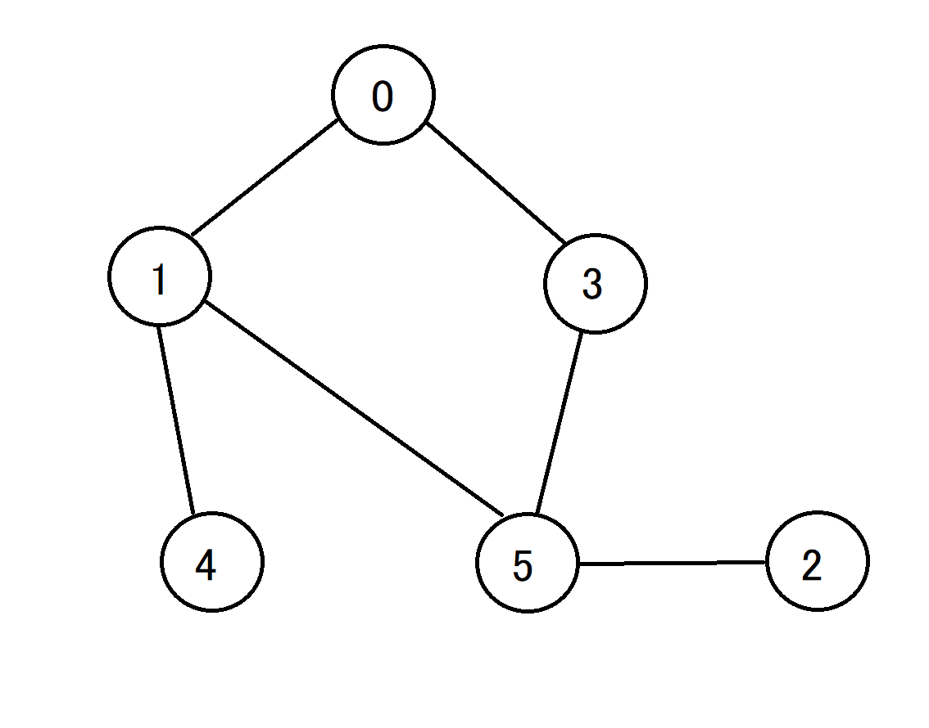

Output tree (root=0):

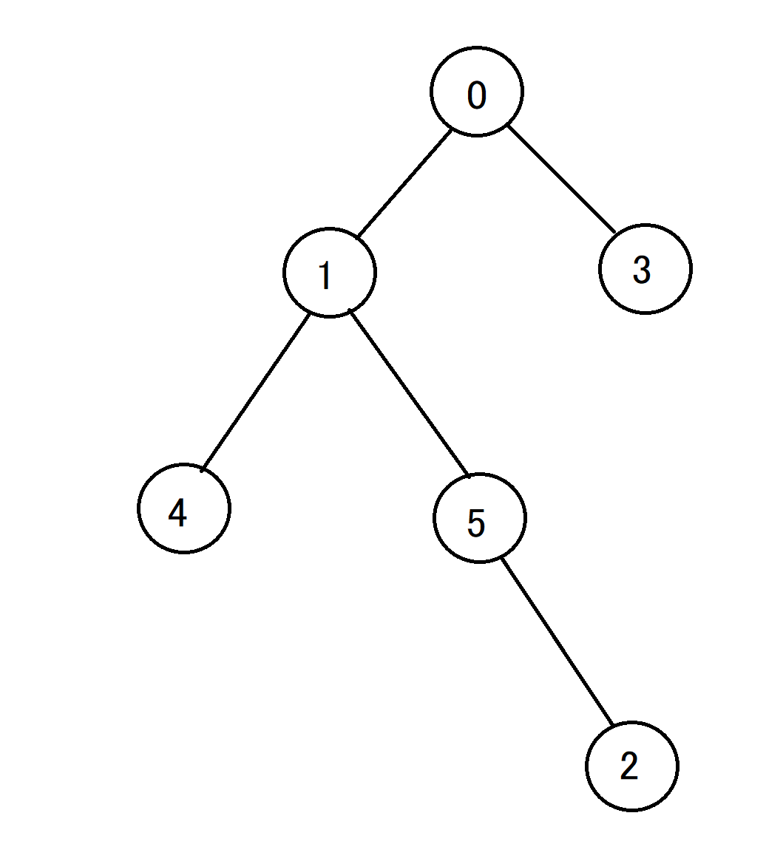

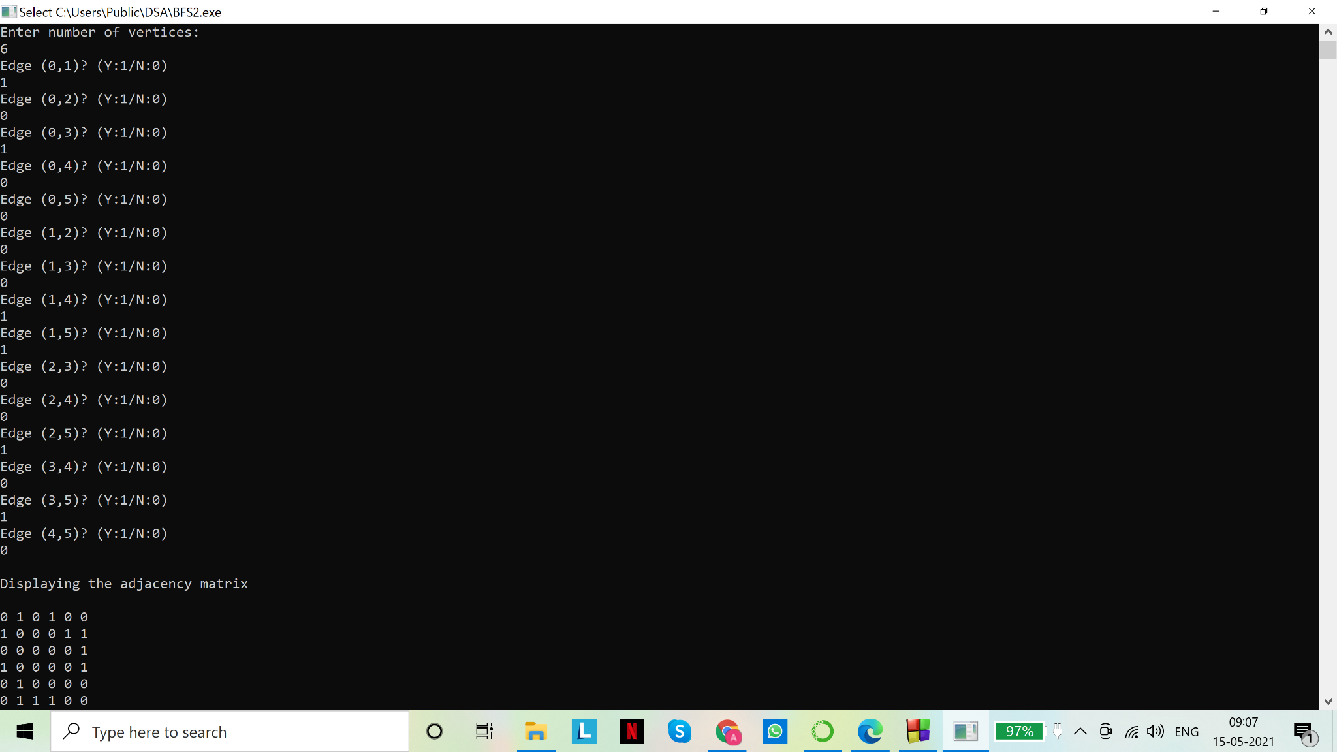

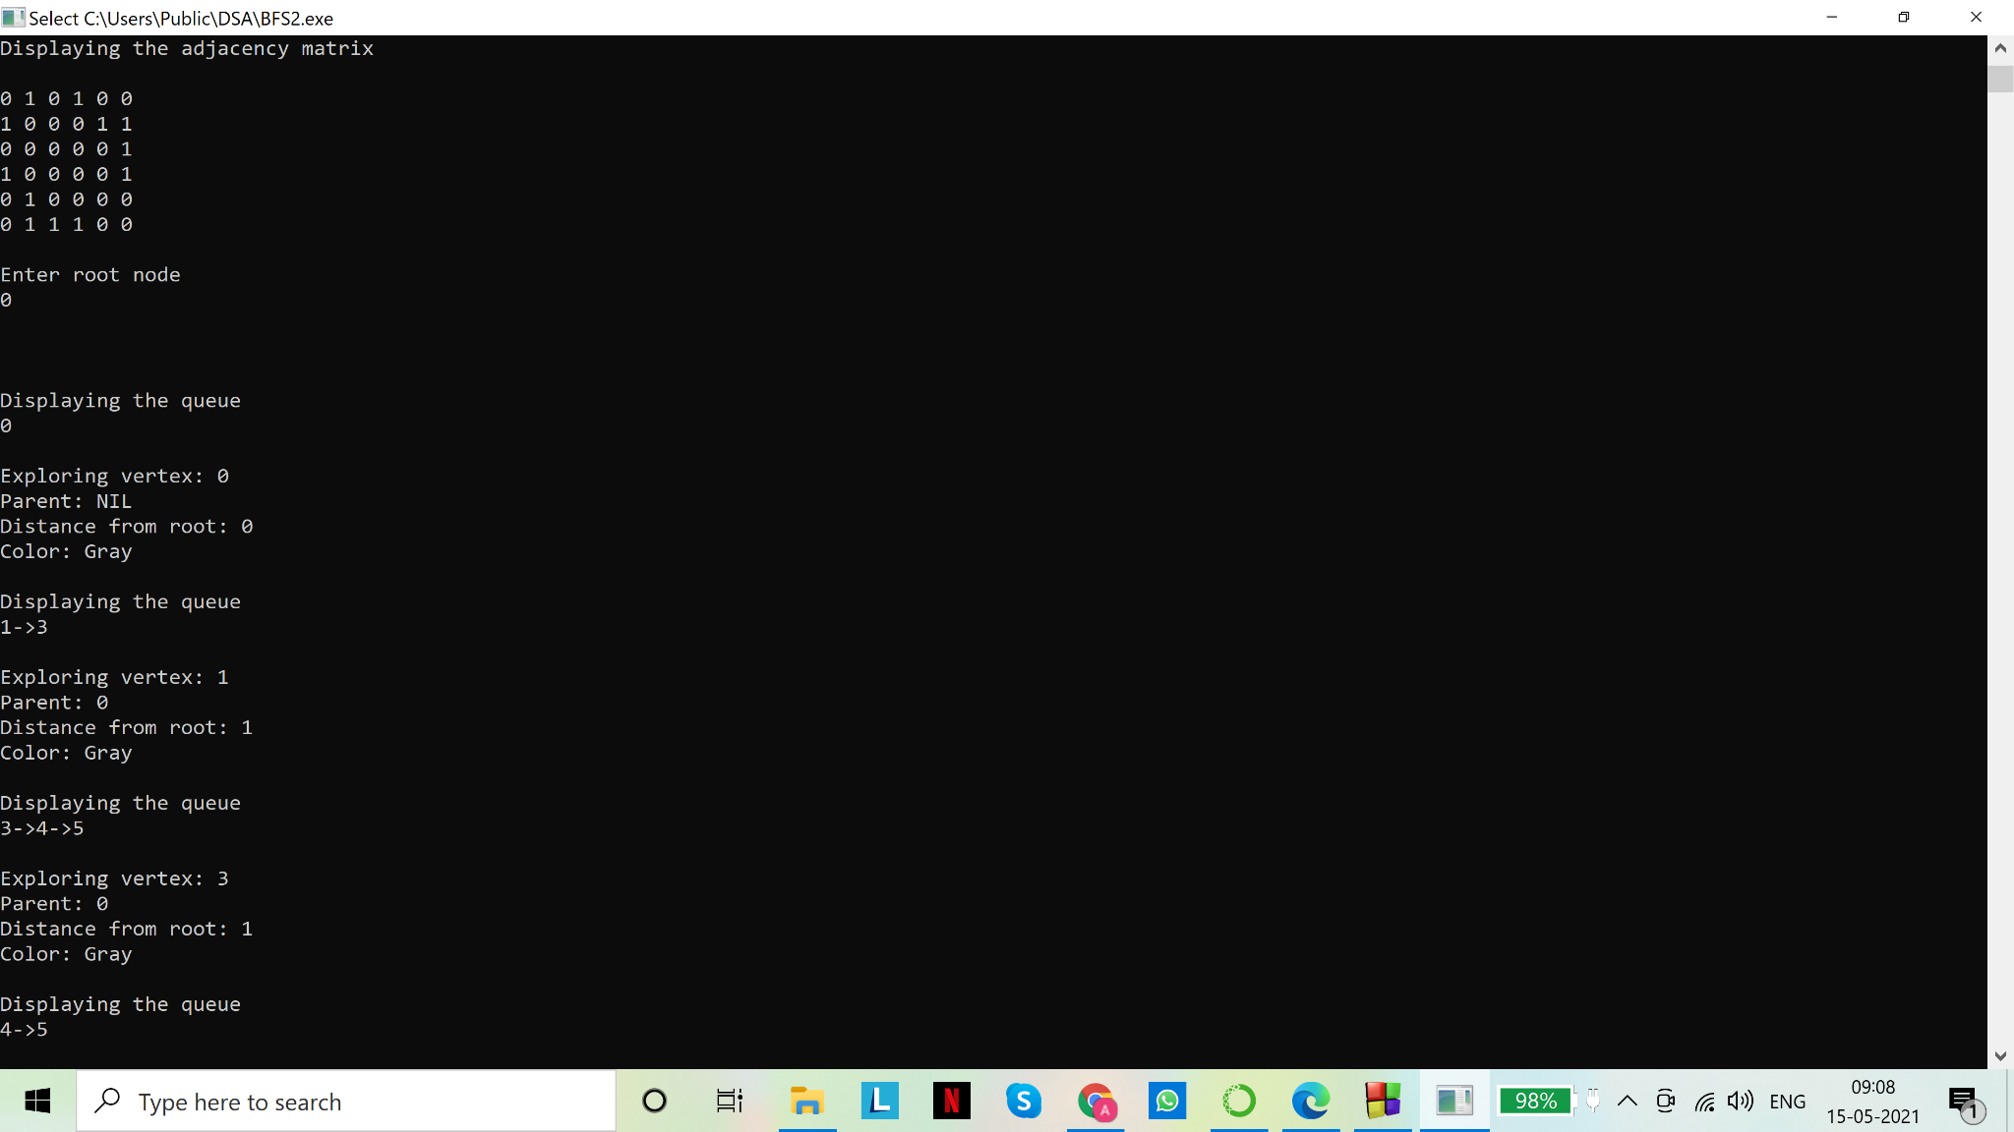

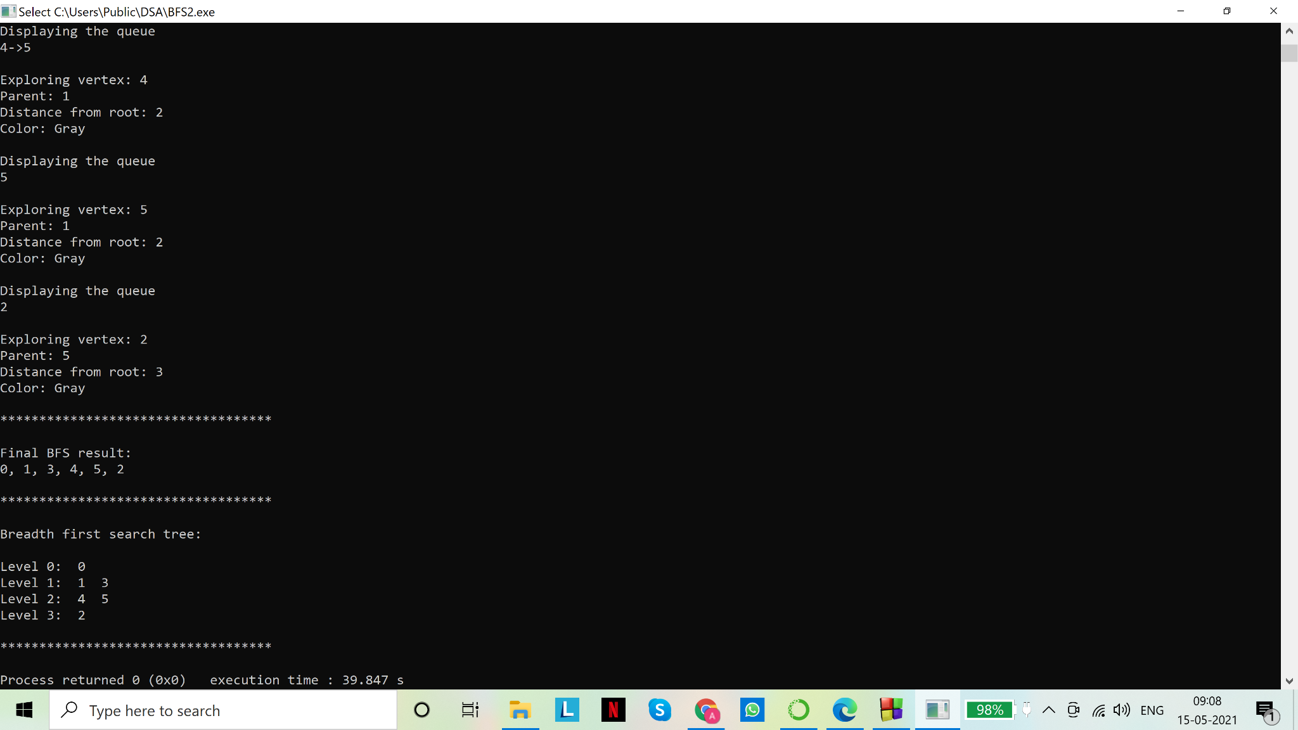

2.

Code(s):

# include <stdio.h>

# include <stdlib.h>

/*

Depth First Search:

Given a graph G=(V,E) and a distinguished source vertex s, depth first search explores the edges of G to find every vertex that is reachable from s

Principle: the algorithm discovers edges out of most recently discovered vertex v that still has unexplored edges leaving it. When all of

v's edges have been explored, the search "backtracks" to explore edges leaving the vertex from which v was discovered. The process

continues until we have discovered all the vertices that are reachable from the original source vertex.

Timestamps: Each vertex v has two timestamps:

-the first timestamp d[v] when v is first discovered (grayed)

-the second timestamp f[v] when the search finishes examining v's adjacency list (blackened)

d[v]<f[v]

Complexity: O(V+E)

*/

//a series of helper functions to form the queue required to perform breadth first search on the given graph

//user defined data type for graph

struct Graph{

int V;//number of vertices

int *adj;//2D adjacency matrix to store the information about the edges

};

typedef struct Graph graph;//to make declaration easier

//end of helper functions

void DFS(graph G)//function to perform depth first search for given graph G

{

//for ease of computation we assume the vertices are 0,1,2,...,V

int *color=(int*)calloc(G.V,sizeof(int));//int array to store color of each vertex

//white:0

//gray:1

//black:2

int *parent=(int*)calloc(G.V,sizeof(int));//int array to store parent of each vertex

int *d=(int*)calloc(G.V,sizeof(int));//int array to store entry time

int *f=(int*)calloc(G.V,sizeof(int));//int array to store exit time

//initialization

//initialization of all vertices: initially all are white

for(int i=0;i<G.V;i++)

{

color[i]=0;//white

parent[i]=G.V+1;//parent is not known yet, hence we assign an out of bounds value

}

//end of initialization

int t=0;//time of visit, to keep track of the sequence in which nodes were visited

printf("\n");

for(int i=0;i<G.V;i++)//scanning over all the vertices

{

if(color[i]==0)//if white (undiscovered)

t=DFS_VISIT(i,color,parent,d,f,G,t);//call DFS_VISIT() to explore the undiscovered vertex

}

printf("\n\n");

//final result:

printf("\n***********************************\n\n");

for(int i=0;i<G.V;i++)

printf("Vertex: %d, Entry time: %d, Exit time: %d\n",i,d[i],f[i]);

printf("\n***********************************\n");

}

//end of DFS()

//helper function to recursively explore vertices until all vertices have been explored

int DFS_VISIT(int u, int *color, int *parent, int *d, int *f, graph G, int t)

{

color[u]=1; //assign grey as it has been visited now

t+=1; //increase time stamp by 1

d[u]=t; //entry time

printf("\nExploring vertex: %d \n",u);

if(parent[u]==(G.V+1))//parent not allocated

printf("Parent: NIL\n");

else

printf("Parent: %d\n",parent[u]);

if(color[u]==0)

printf("Color: White\n");

else if(color[u]==1)

printf("Color: Gray\n");

else

printf("Color: Black\n");

for(int v=0;v<G.V;v++)

{

if(*(G.adj + u*G.V + v)!=0)//edge from u to v exists

{

if(color[v]==0)//v has not been explored yet

{

parent[v]=u;//assign parent

t=DFS_VISIT(v,color,parent,d,f,G,t);//recursive call to explore the child vertex v

}

}

}

color[u]=2;//assign black: at the end of this function, all adjacent vertices to u have been visited

f[u]=t=t+1;//increase t by 1 and assign to exit timestamp of the vertex u

return t;//return timestamp to calling function once vertex has been fully explored

}

//end of DFS_VISIT()

//main for function calls

void main()

{

graph G;//declare a variable G of user defined datatype graph

printf("Enter number of vertices:\n");

scanf("%d",&G.V);

G.adj=(int*)calloc(G.V*G.V,sizeof(int));//memory allocation

int ch=0;//user's choice for whether or not an edge will exist

//fill in values for edges

for(int i=0;i<G.V;i++)

{

for(int j=0;j<G.V;j++)

{

printf("Edge from %d to %d? (Y:1/N:0)\n",i,j);

scanf("%d",&ch);

//ch==0 means there is no edge from i to j th vertex

//any non zero value of ch implies that an edge exists from the i to j th vertex and it will store '1'

//irrespective of the user entry, as shown below

*(G.adj+i*G.V+j)=(ch!=0);

//adj[i][j]=1 implies there exists an edge from i to j th vertex

}

}

printf("\nDisplaying the adjacency matrix\n\n");

for(int i=0;i<G.V;i++)

{

for(int j=0;j<G.V;j++)

printf("%d ",*(G.adj+i*G.V+j));

printf("\n");

}

DFS(G);//call DFS() on graph G to perform depth first search on it

}

//end of main()

Output(s):

Input graph:

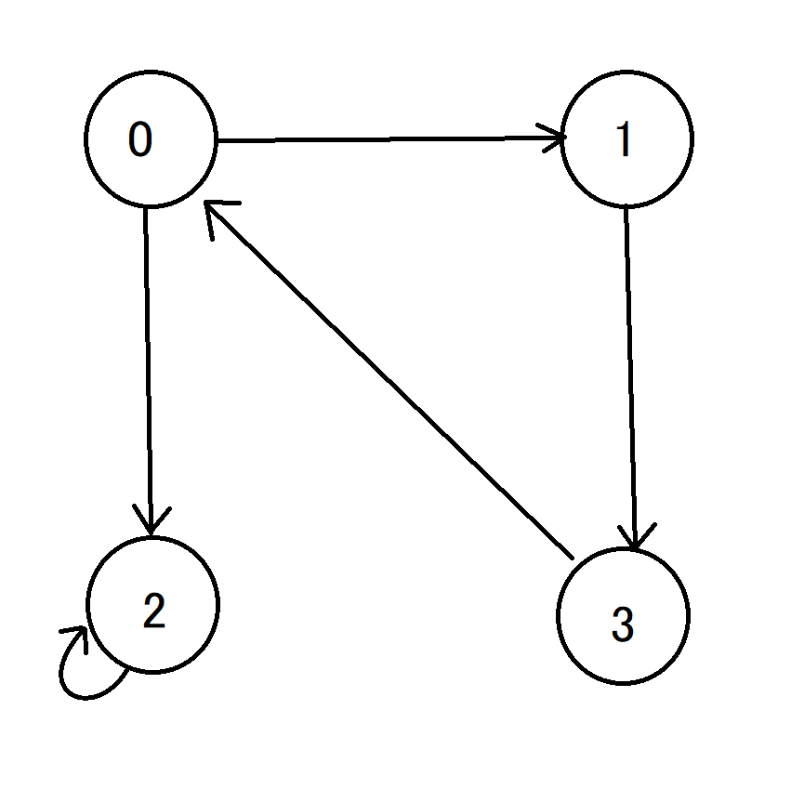

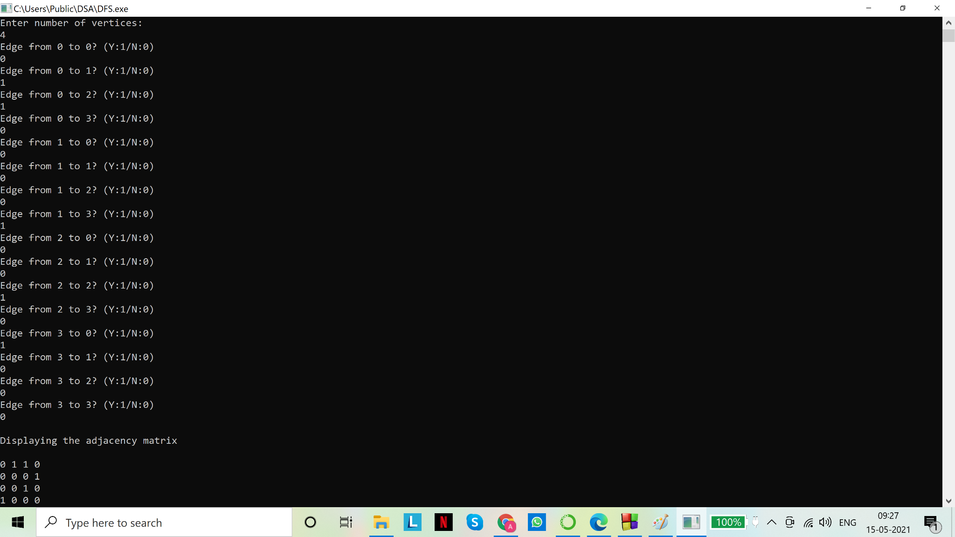

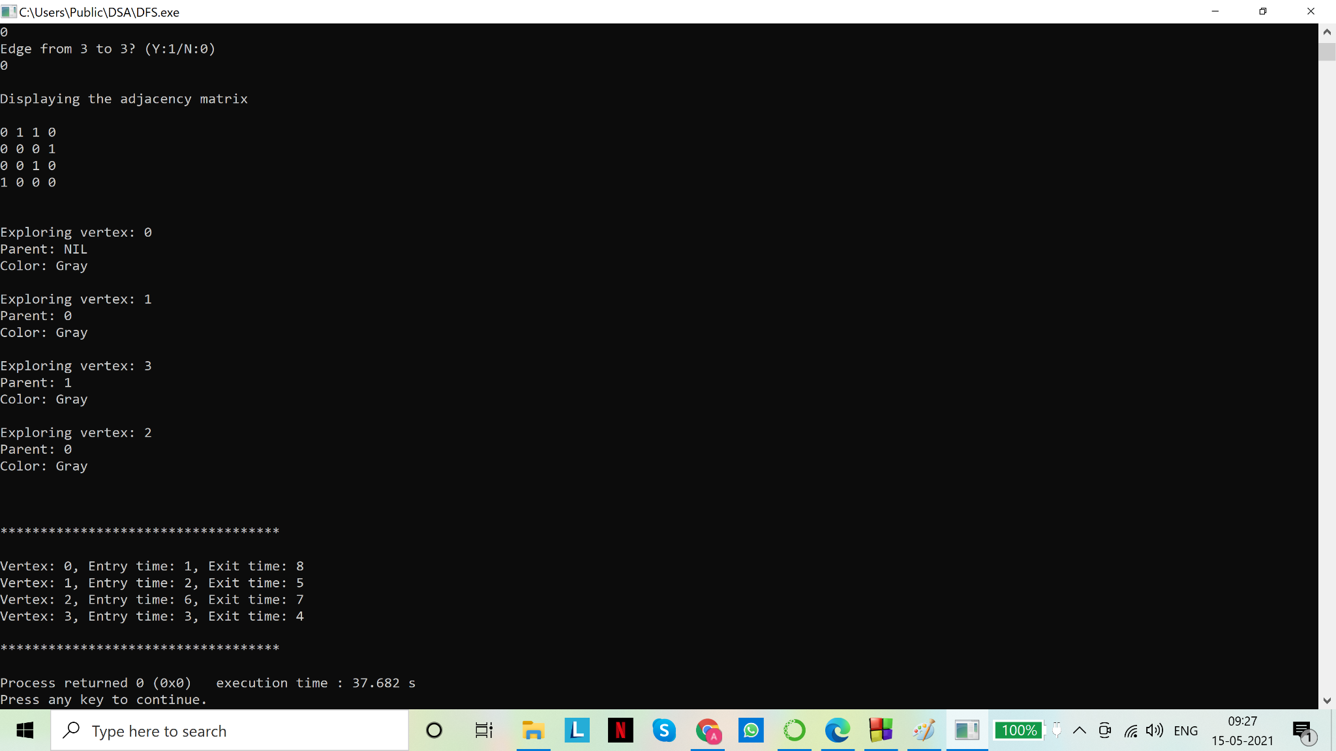

[from the entry and exit time, we can deduce the sequence of events]